 

**TASK DOCUMENTATION**

**Name -: Satvik Joshi**

**INDEX**

**Task1**

* Create a Vnet and set up a subnet on the created Vnet
* Create a VM on the subnet and access VM.

**Task 2**

* Create a Windows Virtual Machine.
* Install the IIS service on it.
* Make the website publicly accessible.

**Task3**

* Create an Ubuntu Virtual Machine.
* Install the Apache2 service on it.
* Make the website publicly accessible.

**Task4**

* Create a Virtual Machine
* Create a managed disk on azure portal
* Attach the managed disk to the Virtual Machine.

**Task5**

* Create a Virtual Network and two Subnets.
* Launch two Windows Virtual Machine in each subnet
* The Virtual Machines should be able to ping each other.

**Task6**

* Create a Virtual Machine and install Hyper-V role on that VM
* Inside Hyper-V install an windows server.
* Enable internet connectivity on the Hyper-V machine.

**Task7**

* Create two Virtual Network (VNet1 & VNet2)
* Deploy one VM on each Virtual Network.
* Do a Virtual Network Peering between VNet1 & VNet2
* Both the Virtual Machine should ping each other.

**Task8**

* Learning Load Balancers and its types.
* Create Internal and External load balancers and test it.

**Task9**

* Learn about Virtual Private Network (VPNs) and their types.
* Create a Point-to-Site(P2S) VPN gateway from your Virtual network to your individual computer.
* Test the connection while pinging.

**Task10**

* Learn about Site-to-Site VPN gateway.
* Create two Virtual Network (AzVnet & OnPremVnet)
* Deploy one Virtual Machine on each Virtual Network.
* Setup the Site-to-Site connectivity using RRAS.

**Task11**

* Learn about Hub & Spoke architecture.
* Create 3 Virtual Network (HubVnet, Spoke1Vnet, Spoke2Vnet).
* Do Virtual Network peering from Spokes to the HUB.
* Create User Defined Route for the hub and spoke architecture.
* Verify if its working by pinging both the SpokeVnet.

**Task12**

* Create 3 subnets
  + Web tier
  + App tier
  + DB tier
* Configure Network security Group
  + DB tier should not access any tier (Web & App)
  + App tier should access the DB tier and Web tier.
  + Web tier should only access App tier.
* Only web tier should have access to internet.

**Task13**

* Create a Virtual Machine.
* Create an Alert rule for VM CPU percentage using Azure Monitor.
* Condition: CPU more than 80%
* Action: Send email.

**Task14**

* Learn about Azure File share
* Create an Azure File Share
* Mount the File Share on your local computer.

**Task15**

* Create a Virtual Machine and install google chrome.
* Generalize the Virtual Machine and create managed image.
* Create VM from managed image.

**Task16**

* Create a Virtual Machine
* Install FTP server on the Virtual Machine
* Try to connect to it using FileZilla

**Task17**

* Install FTP server on the Virtual Machine
* Create a Logic app
* Trigger an Email notification.
* For each update happening in FTP server.

**Task18**

* Install Terraform on windows using PowerShell
* Verify if terraform is installed.
* Try to create a resource group using Terraform.

**Task19**

* Learn about terraform.
* Create a single tier architecture.
* Consisting of Virtual Network, Subnet, NSG, Virtual Machine.

**Task20**

* Learning Azure AD
* Enable Azure AD Multi Factor Authentication setup.
* When you login to Azure portal it should authenticate using MFA.

**Task 21**

* Create a Virtual Machine
* Install SQL server on the Virtual Machine
* Access the SQL Server using SSMS (SQL Server Management System).

**Task 1**

**Task1**

* Create a Vnet and set up a subnet on the created Vnet
* Create a VM on the subnet and access VM.

**Virtual network-:** Virtual networking is a technology that facilitates data communication between two or more virtual machines (VM). It is similar to traditional computer networking but provides interconnection between VMs, virtual servers and other related components in a virtualized computing environment.

**Step 1: Create a resource group and create a Virtual Network in it.**

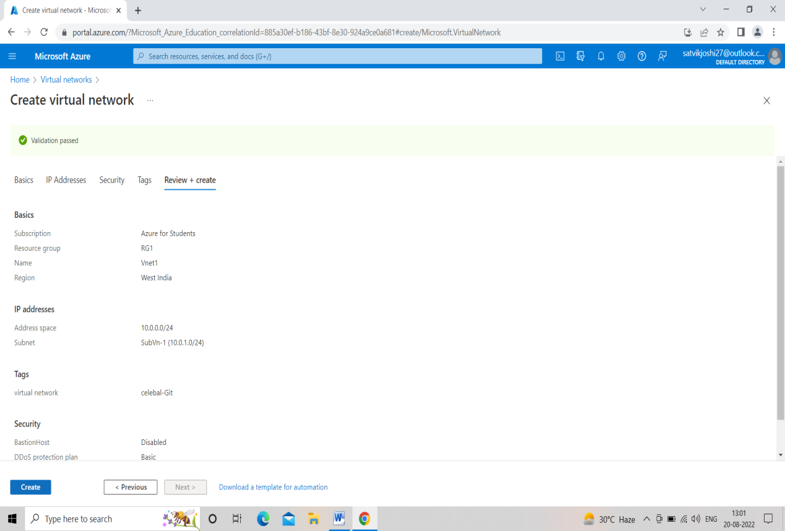

**Step 2: Create a Sub-net in the previously made Virtual network.**

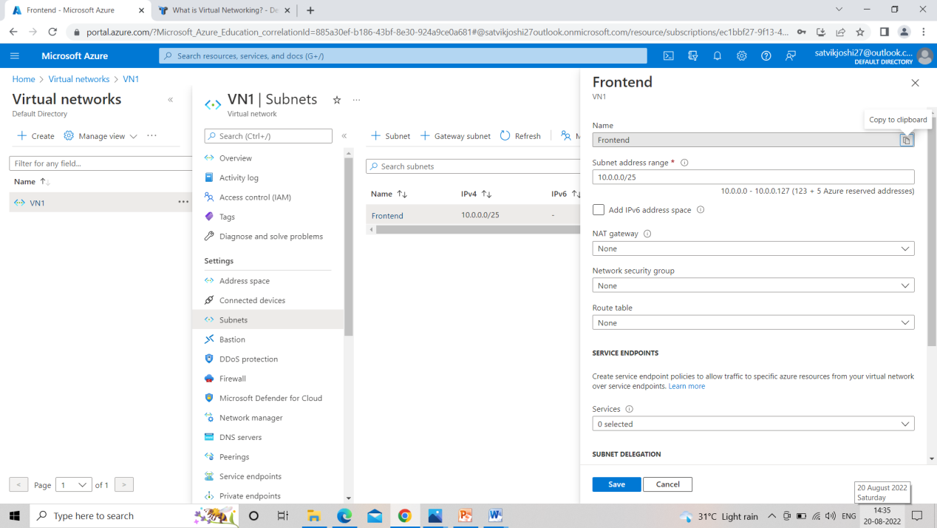

**NOTE: MAKE SURE THAT ADDRESS RANGE OF SUBNET LIES WITHIN THE RANGE OF IT’S PARENT VIRTUAL NETWORK**

**Step 3: Create a Virtual Machine.**

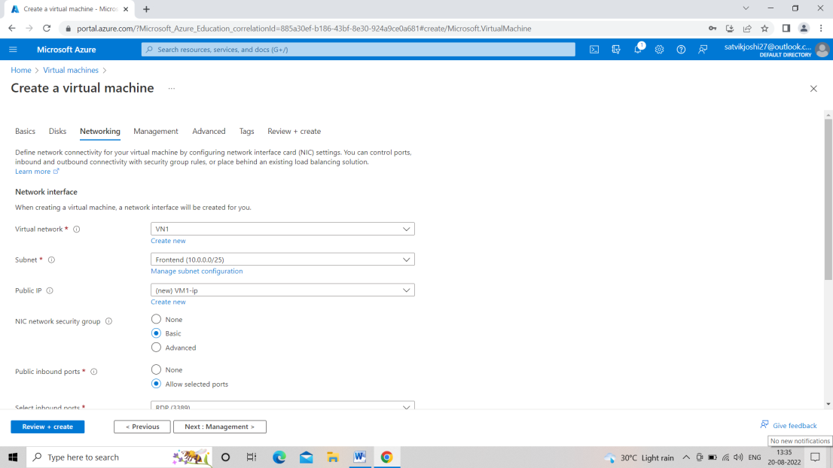

**Step 4: Virtual Machine successfully created.**

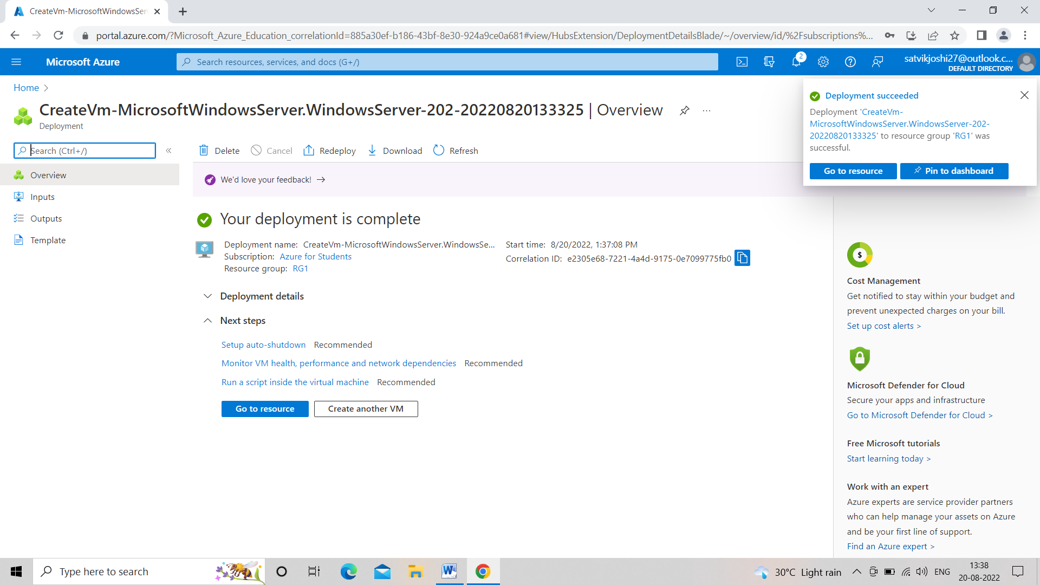

**Task 2**

**Task 2**

* Create a Windows Virtual Machine.
* Install the IIS service on it.
* Make the website publicly accessible.

**Virtual Machine -:** computer system with its own CPU, memory, network interface, and A virtual machine (VM) is a virtual environment that functions as a virtual storage, created on a physical hardware system (located off- or on-premises).

A Virtual Machine (VM) is a compute resource that uses software instead of a physical computer to run programs and deploy apps. One or more virtual “guest” machines run on a physical “host” machine

**Step 1: Create a Windows Virtual Machine.**

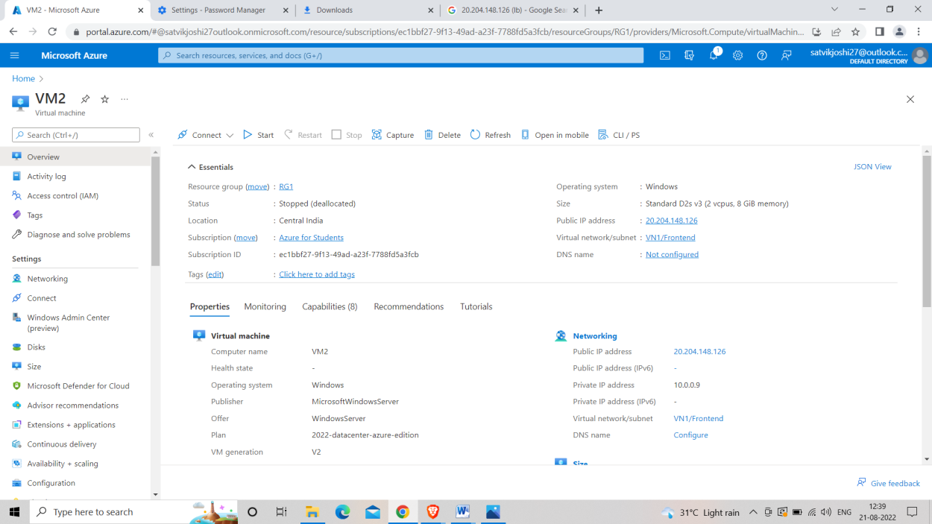

**Step 2: Adding IIS (Internet Information Services).**

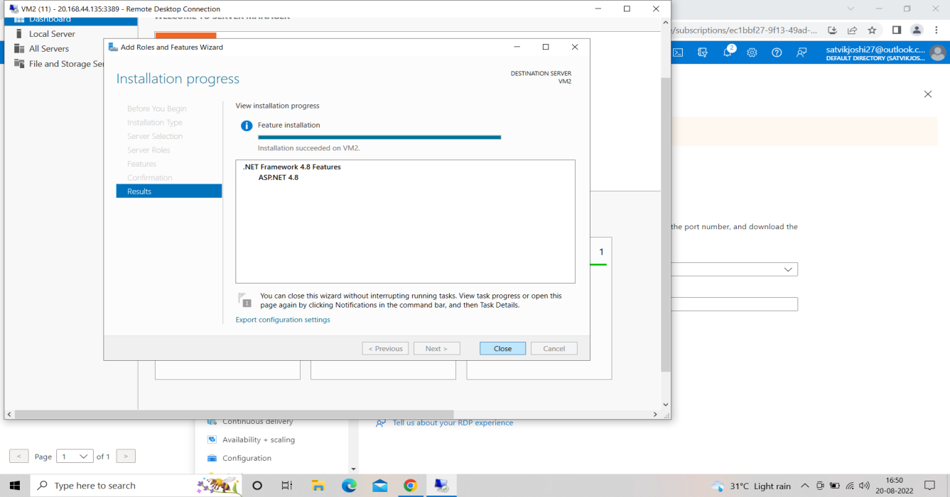

**Step 3 -: Website through IIS in created VM**

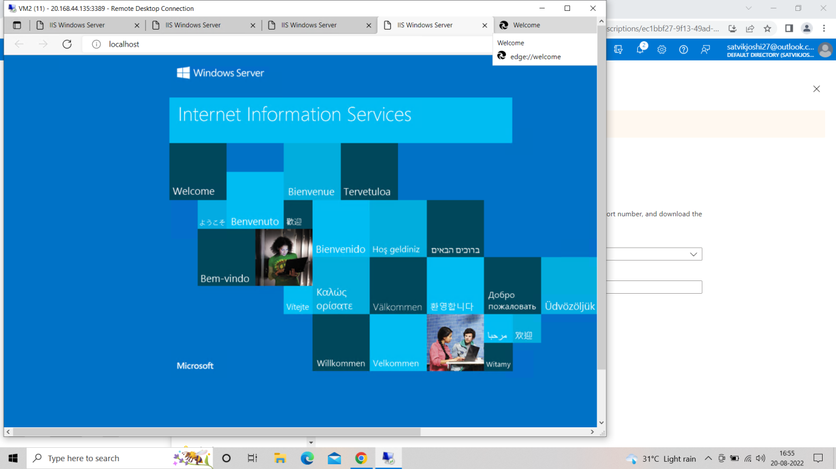

**Step 4 -: Now making Website publicly visible through INBOUND PORT RULES (Changing PORT 8080 to PORT 80)**

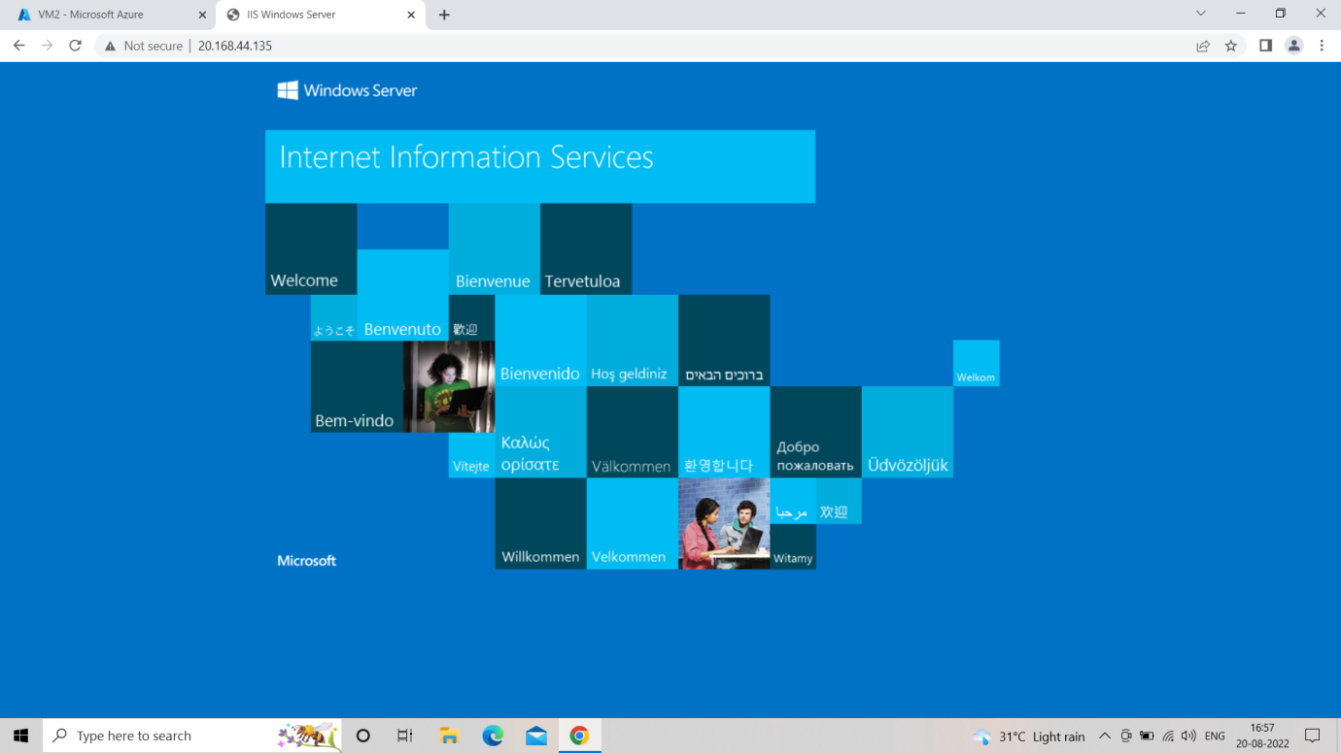

**Task 3**

**Task3**

* Create an Ubuntu Virtual Machine.
* Install the Apache2 service on it.
* Make the website publicly accessible.

**Step 1-: Create a virtual network and a virtual machine and choose Ubuntu linux as image .**

**Step 2-: Select RDP and HTTP while making the VM.**

**Step 3-: Open the cloud shell from the top right ribbon in the azure portal. Select BASH in that service.**

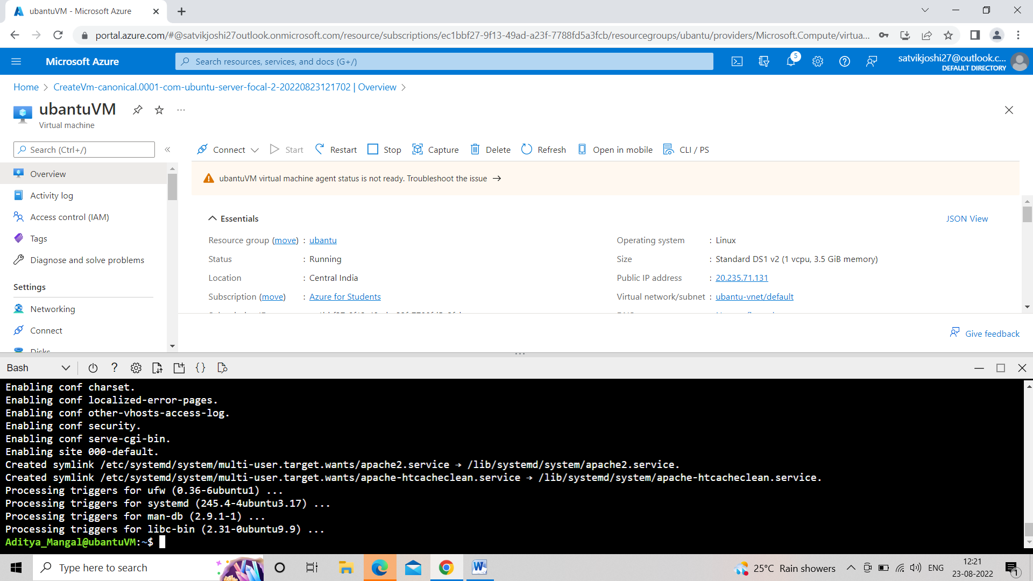

**Step 4-: Enter the following commands in BASH.**

1. **ssh –username@publicIP**
2. **Enter the password**
3. **sudo apt-get install apache2 –y.**

**Step 5-: Add the inbound rules to make website publically accessible**

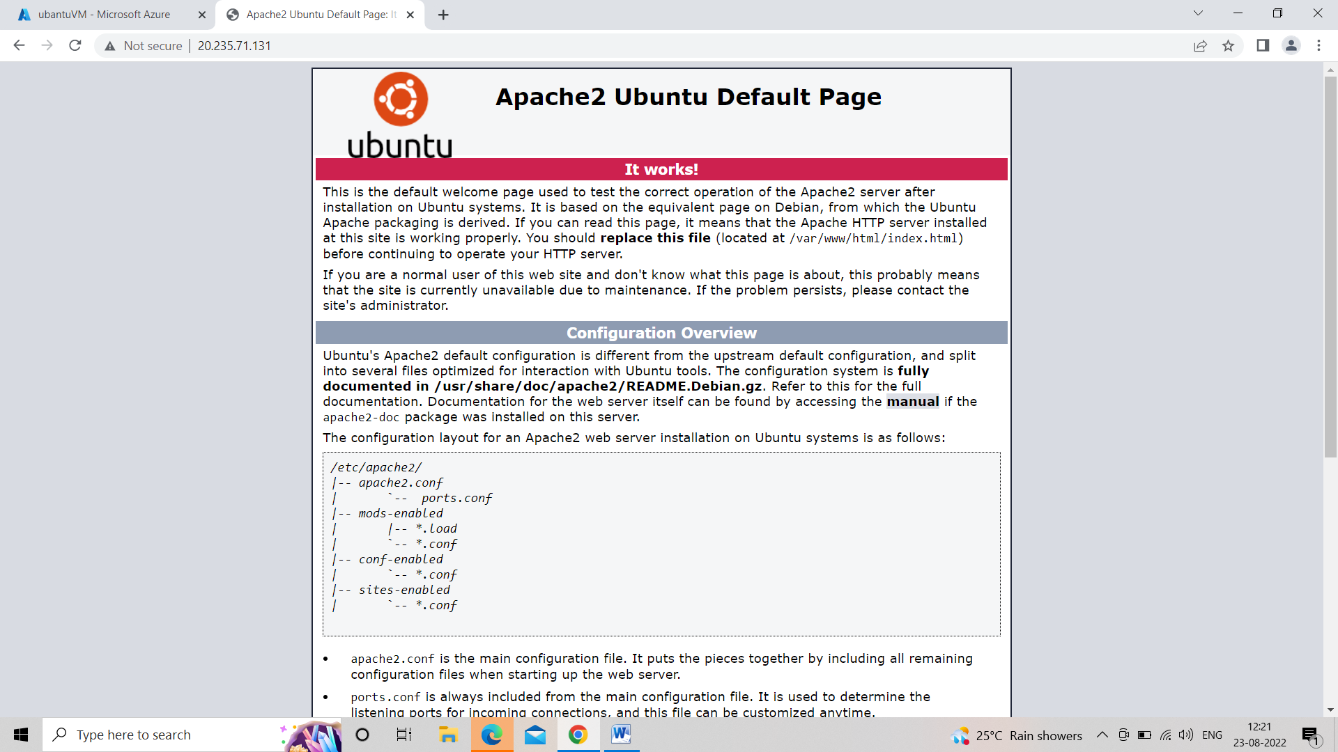

**Task 4**

**Task4**

* Create a Virtual Machine
* Create a managed disk on azure portal
* Attach the managed disk to the Virtual Machine.

**Step 1-: Create a windows virtual machine in azure portal with any favourable size.**

**Step 2-: After the creation of VM look at the left side of the portal and Select disks >> Create and attach a new disk.**

**Step 3:- Provide an appropriate name to the disk and add.**

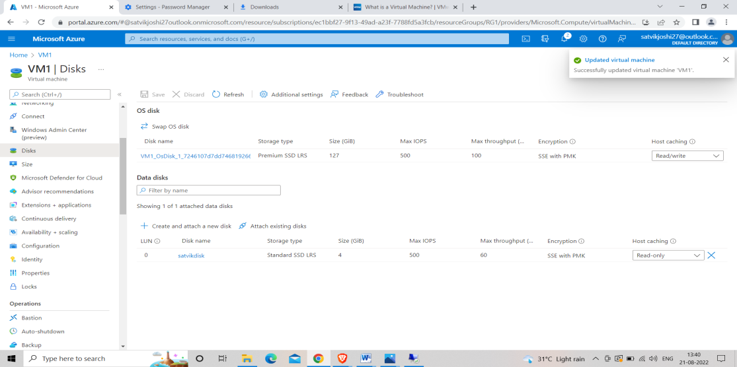

**Step 4:- Connect the VM through RDP.**

**Step 5:- Server manager<< tools<<Computer management <<Disk management .**

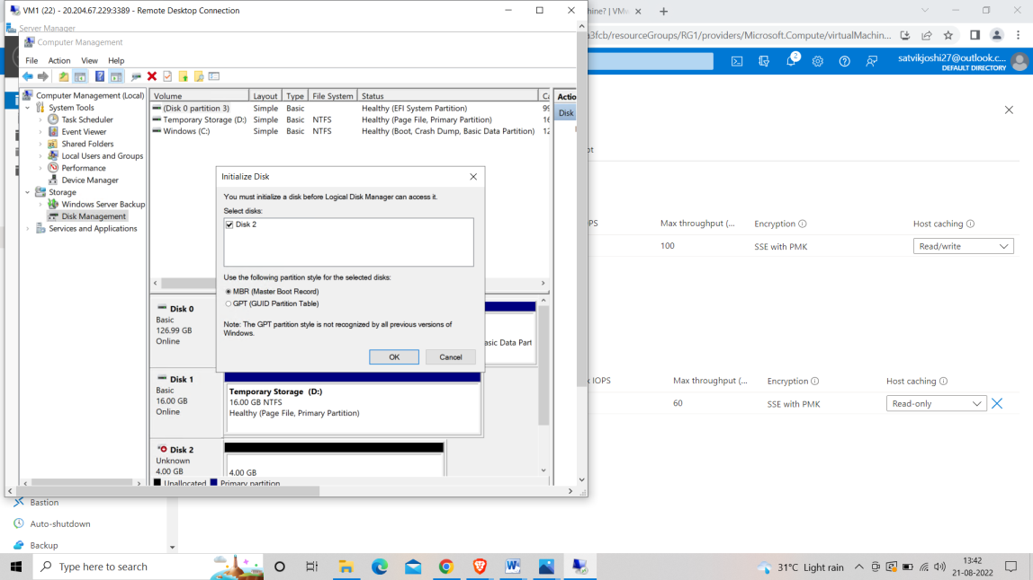

**Step 6:- Select Initialize Disk<<MRB and select other features like size and name of the Disk accordingly.**

**Step 7:- You can find your new Disk in file explorer<<this PC.**

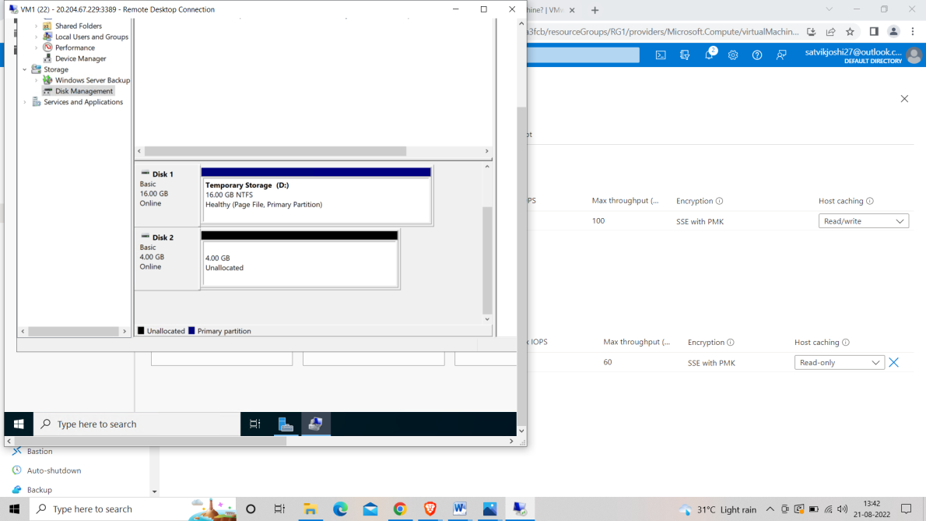

**New disk named new volume (E) appeared.**

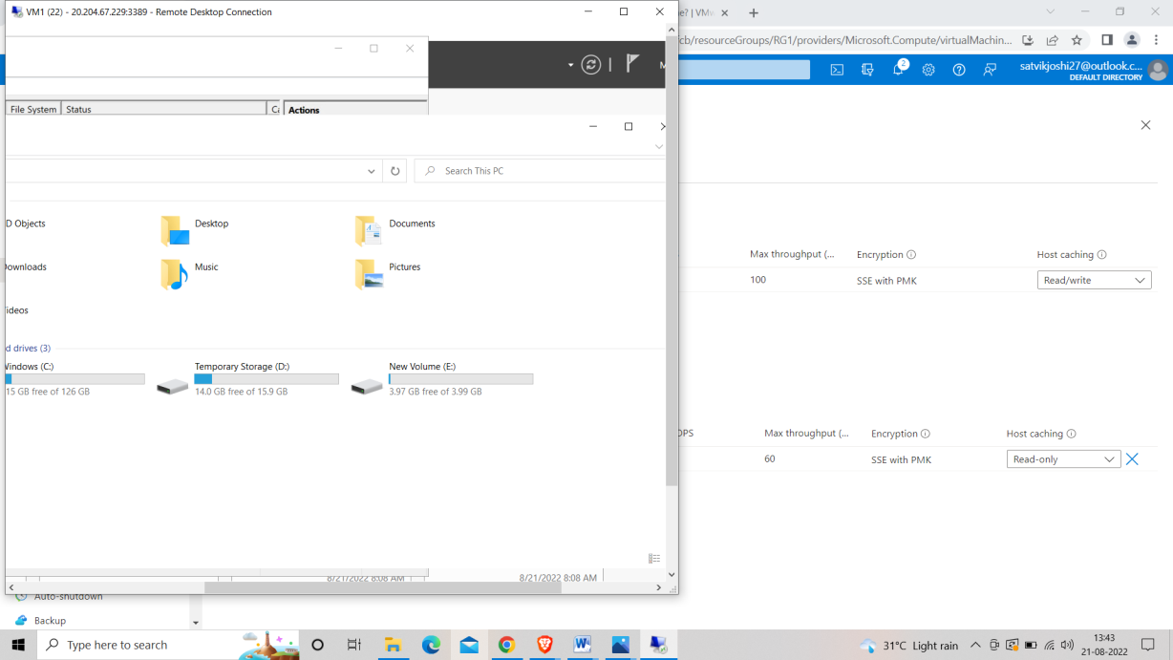

**Task 5**

**Task5**

* Create a Virtual Network and two Subnets.
* Launch two Windows Virtual Machine in each subnet
* The Virtual Machines should be able to ping each other.

**Step 1:- Create a Virtual Network in the Azure Portal.**

**Step 2:- Create 2 subnets of Different IPs in that Virtual Network.**

**Step 3:- Create 2 Virtual Machines with the same vnet and different Subnets.**

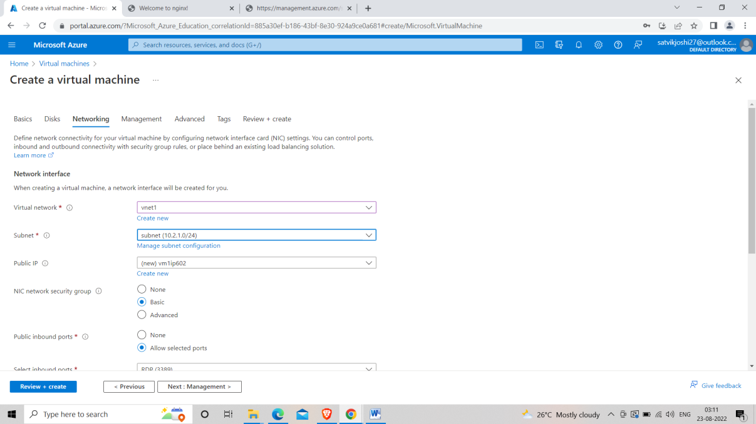

**VM1**

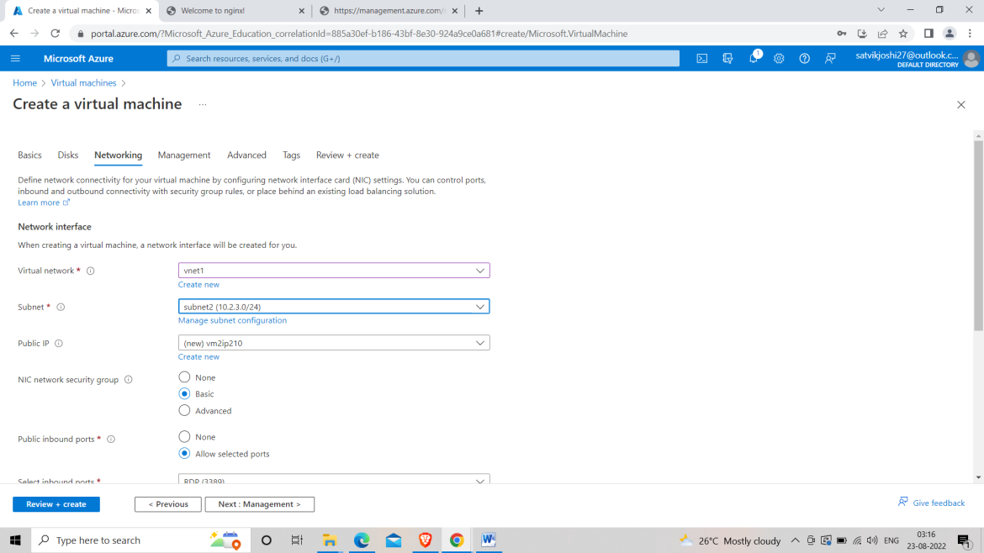

**VN-2**

**Step 4:- Connect both VMs through RDP**

**Step 5:- In the Remote desktop Disable the firewall of both VMs.**

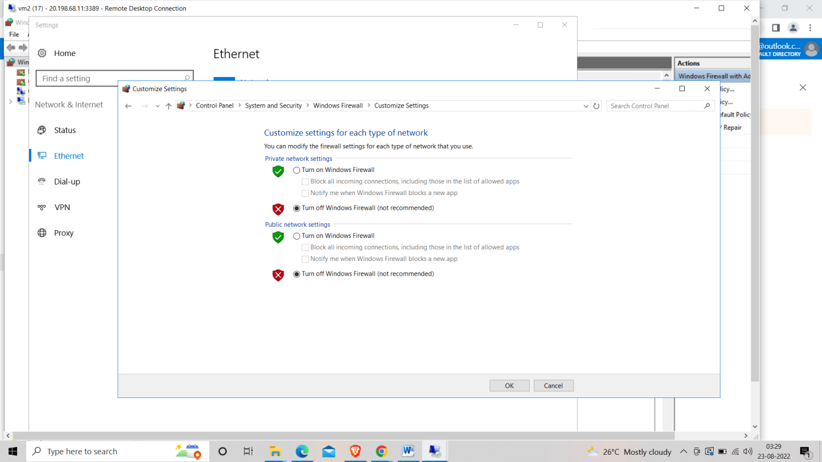

**Step 6:- Add the inbound rules in Advance Firewall Settings and enable the file and printer sharing rule.**

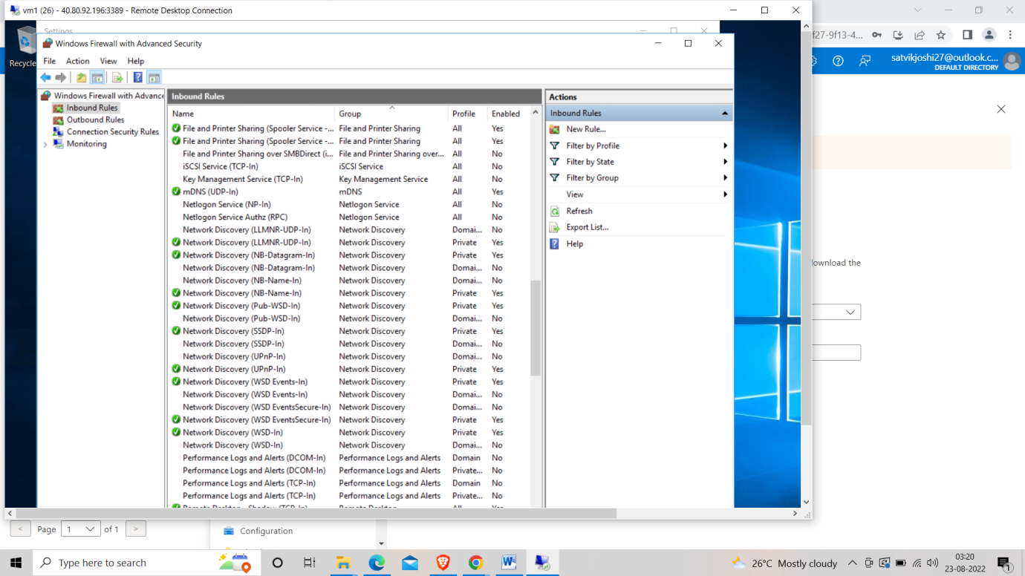

**Step 7:- Go to the CMD of any Remote desktop and write “ping ‘IPv4 address of another VM” and press ENTER.**

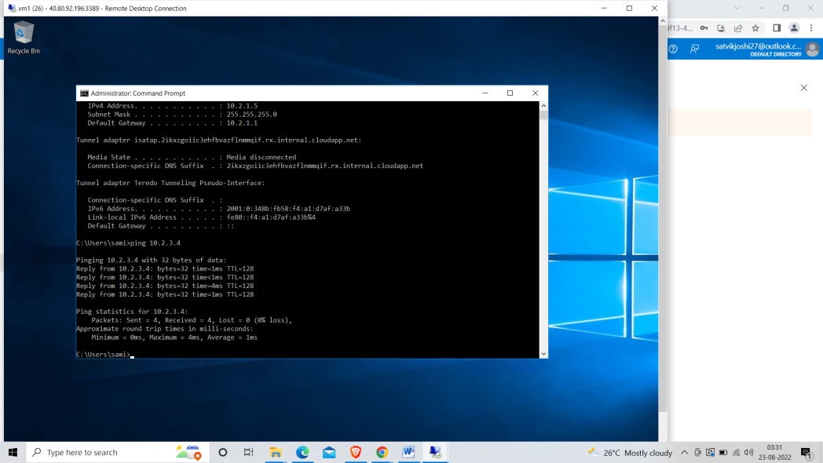

**Task 7**

**Task7**

* Create two Virtual Network (VNet1 & VNet2)
* Deploy one VM on each Virtual Network.
* Do a Virtual Network Peering between VNet1 & VNet2
* Both the Virtual Machine should ping each other.

**Step 1 -: Create Two Virtual Networks by searching Virtual Machine in the search bar of Azure portal.**

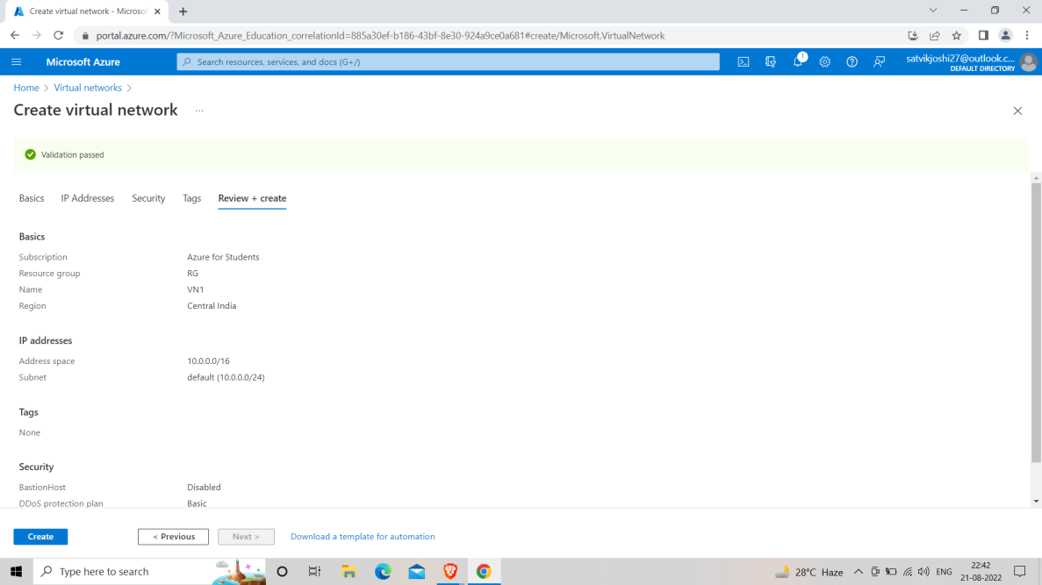

**IMAGE OF VIRTUAL NETWORK -1 BEING CREATED.**

**Step 2 -: Create 2 virtual machines of your favourable size. In VM1 choose VN1 virtual network in the networking segment and similarly choose VN2 in the second virtual machine.**

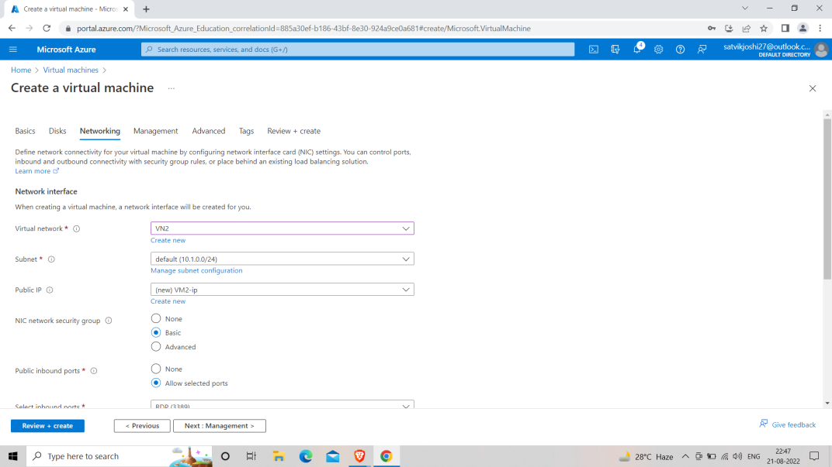

**DEPLOYMENT OF VIRTUAL MACHINE 2 HAVING V-NET 2.**

**Step 3 :- Go to any of the virtual network and search “PEERING” in the left column of the virtual network**

**Step 4 :- Add peering<< Give it a suitable name<< add the another virtual network in the peering section.**

**Step 5 :- Through RDP connect both the virtual machine and ping each other with IPV4 address of another VM in CMD.**

**{ IPV4 Address can be obtained by writing the command “ipconfig” in CMD of Remote Desktop}.**

**NOTE: DISABLE THE FIREWALL OF BOTH THE VMs AND CHANGE THE INBOUND RULES BY ENABLING FILE AND PRINTING SHARING RULE.**

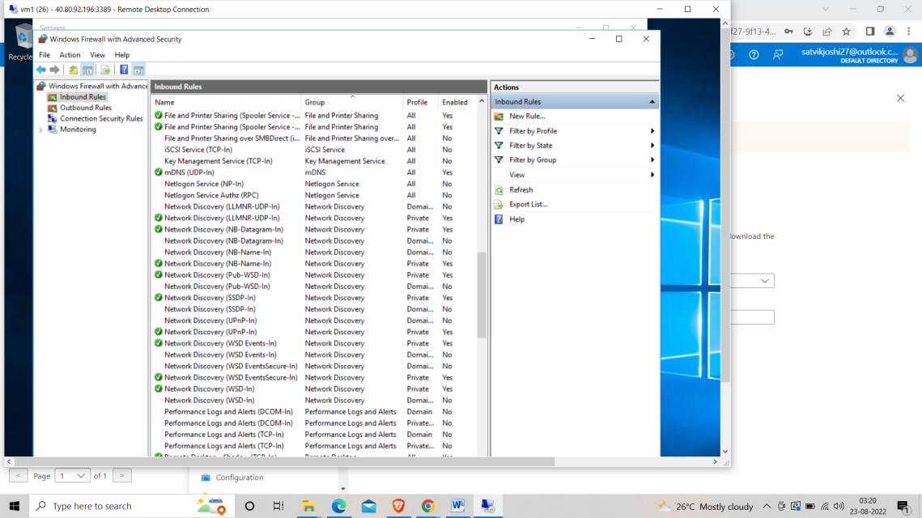

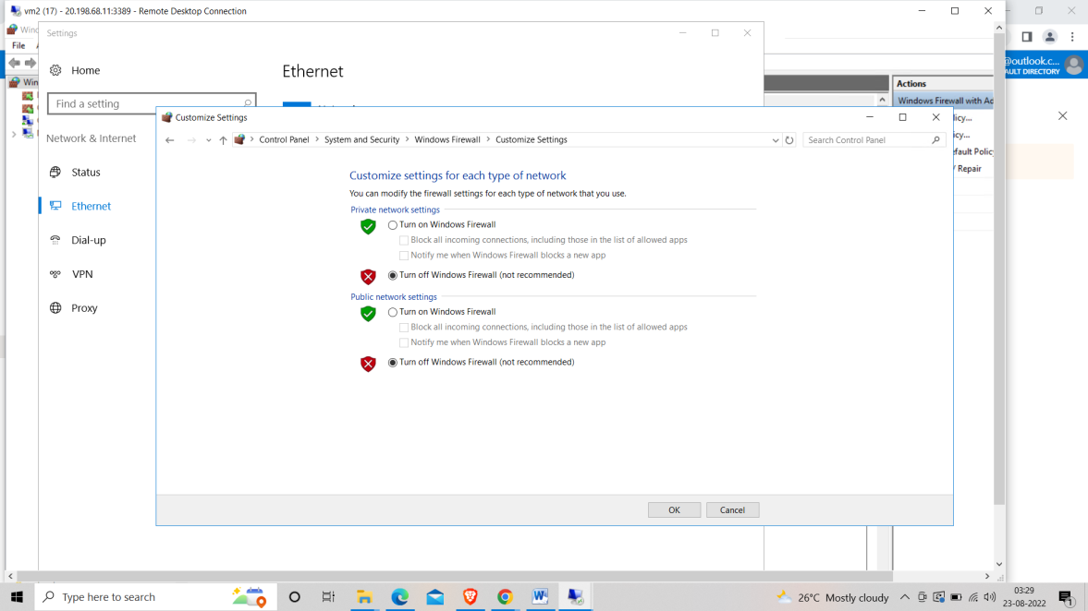

**Step 6 :- Both the Virtual Networks are successfully peered.**

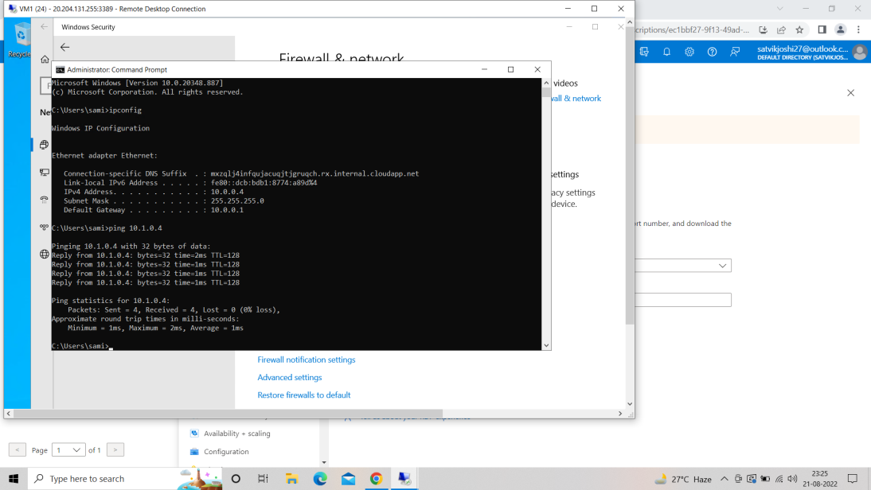

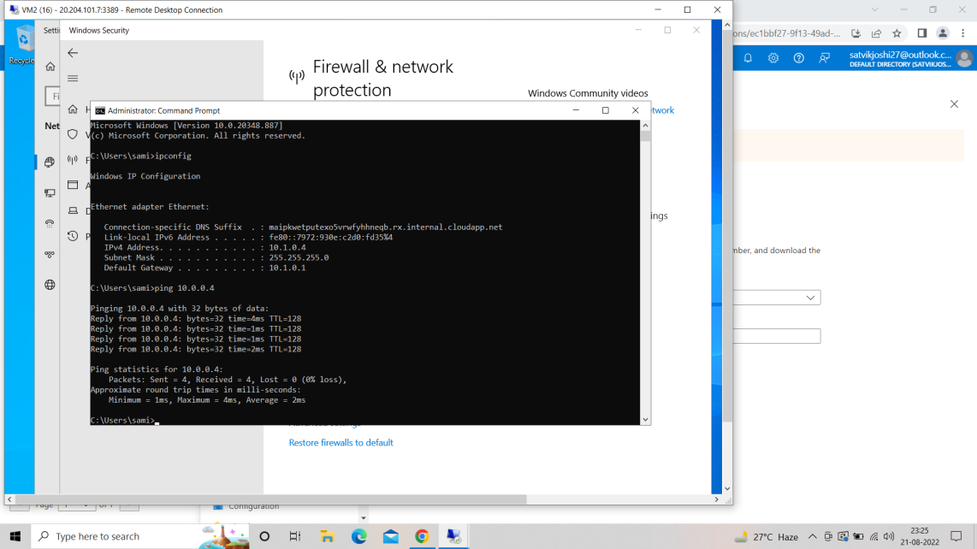

Both VNs are peered.

**Task 8**

**Task8**

* Learning Load Balancers and its types.
* Create Internal and External load balancers and test it.

**Load balancing :- Load balancing is the process of distributing workloads across computing resources in a cloud computing environment and carefully balancing the network traffic accessing those resources.**

**Load balancers are broadly classified into two types.**

1. **Public Load Balancer**
2. **Internal Load Balancer**

**Public Load Balancers: They serve as an intermediate between user and the VMs. If one of the VM crashes down due to any reason or there is excessive load on one VM then the Load balancer comes to play and divide the role between the existing VMs**

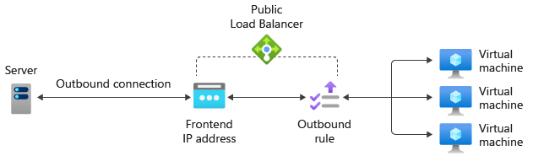

**Internal Load Balancer: it is used where private IPs are needed at the frontend only. Internal load balancers are used to load balance traffic inside a virtual network. A load balancer frontend can be accessed from an on-premises network in a hybrid scenario.**

**CREATING LOAD BALANCER.**

**Step 1:- Create 2 Virtual Machines in the same Vnet.**

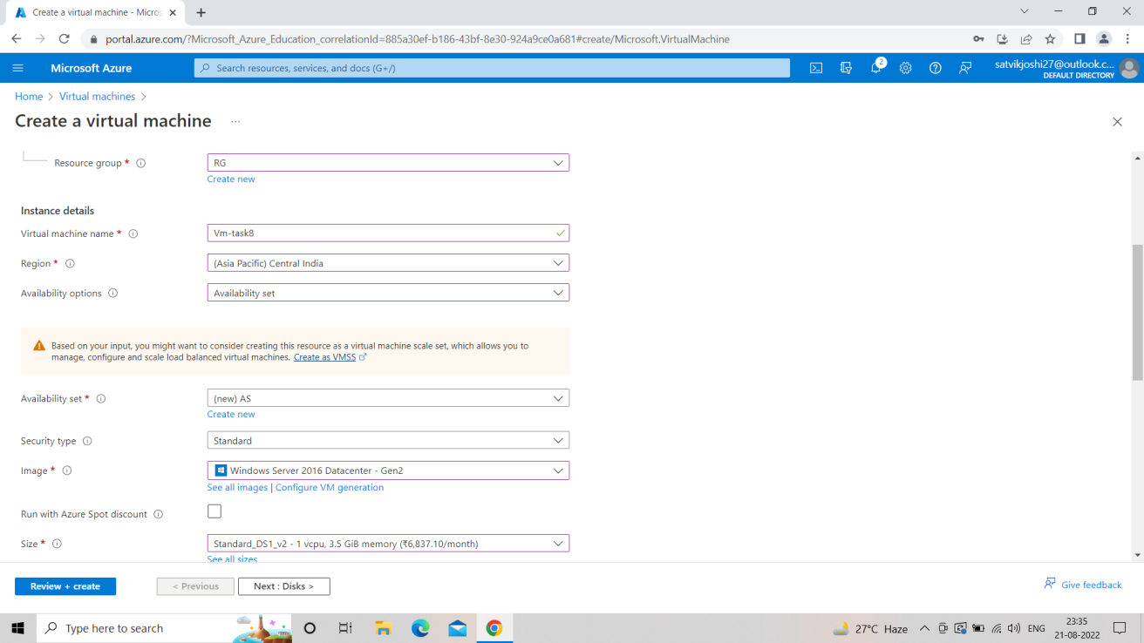

DEPLOYING VM-1.

**Step 2 :- Enable the IIS (Internet information services) in the Remote Desktop form RMD [Refer to task 2].**

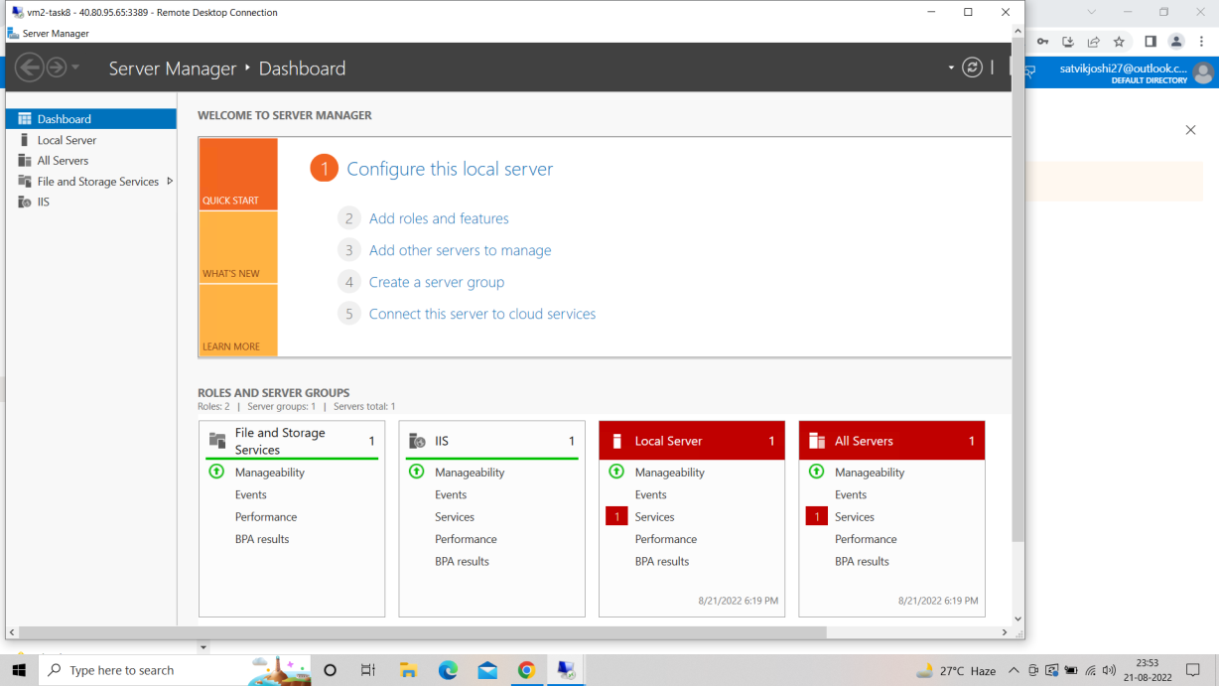

**Step 3 :- Go to C Folder<<iisstart and Write the name of respective virtual machine on the frontend interface of the websites.**

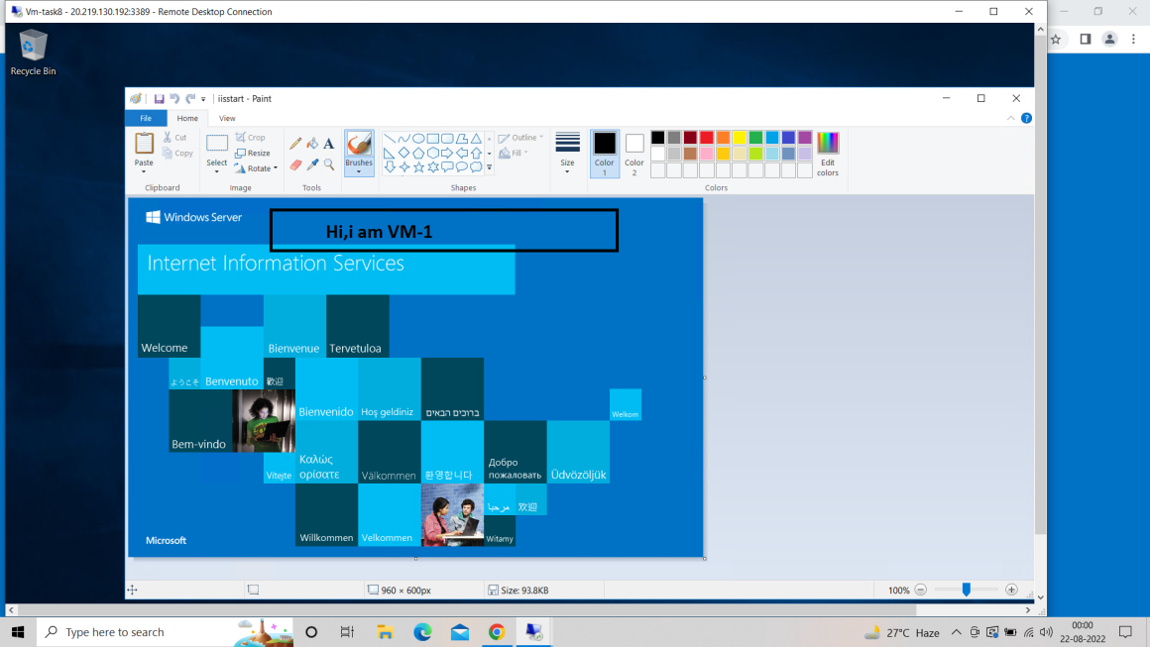

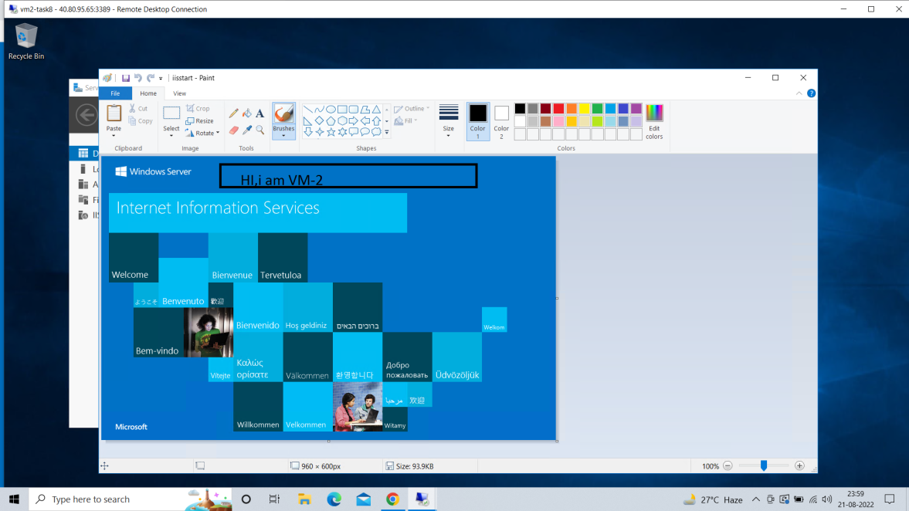

**Step 4 :- Go to azure portal and search for load balancer.**

**Step 5 :- Give basic details like name and resource group make a public type LB<< make a new public IP in Frontend IP configuration<< Add the 2 created VMs in the Backend pool<< Add inbound rules and make a health probe.**

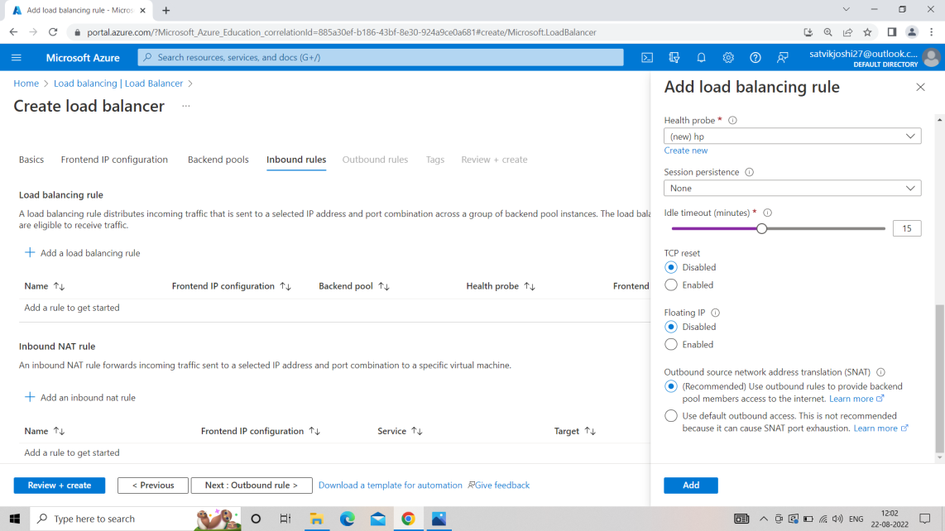

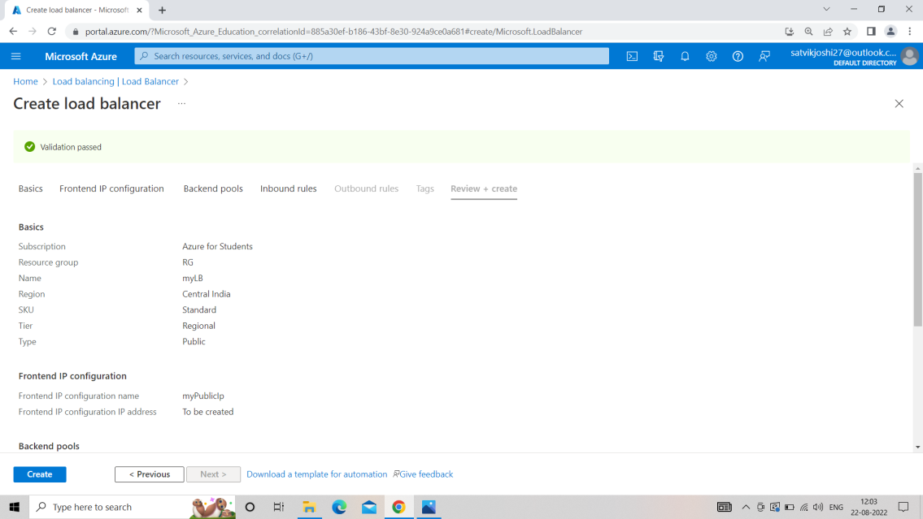

Load balancer Created

**Step 6 :- Copy the public IP of the load balancer and paste it on the browser.**

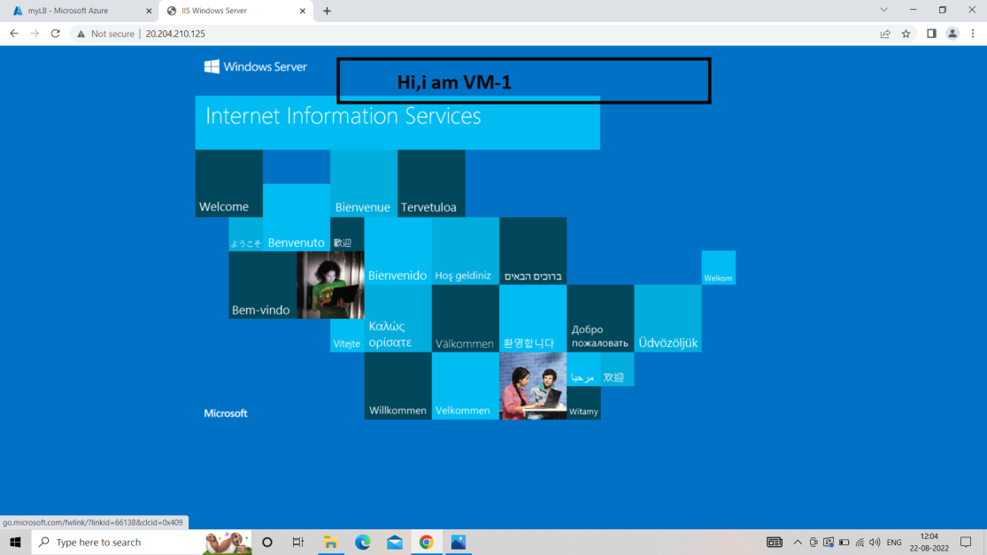

Response came from VM-1.

**Step 7 :- Stop the 1st Virtual Machine.**

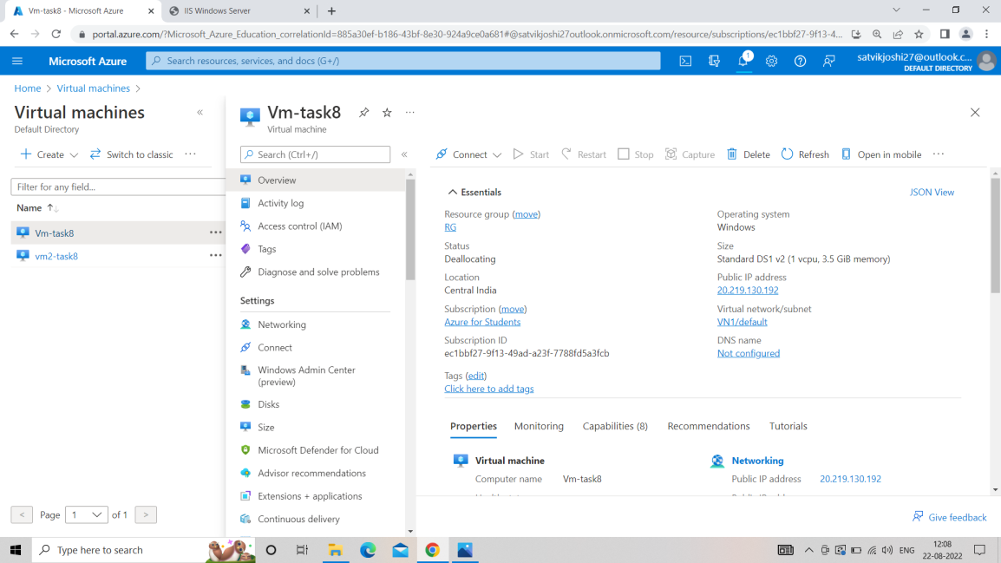

**Step 8 :- Again paste the public IP of the Load balancer in browser. This time response will be generated from the 2nd VM.**

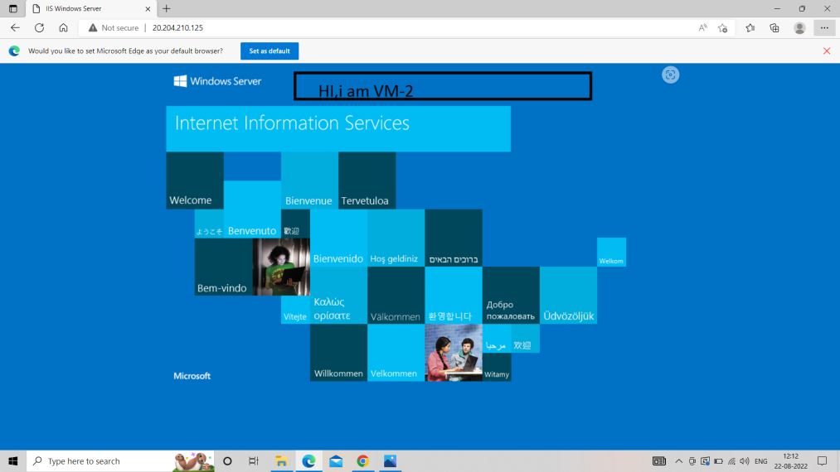

**Similarly we can generate an Internal Load Balance too.**

**Task 9**

* Learn about Virtual Private Network (VPNs) and their types.
* Create a Point-to-Site(P2S) VPN gateway from your Virtual network to your individual computer.
* Test the connection while pinging.

VPN stands for VIRTUAL PRIVATE NETWORK that allows a user to connect to a private network over the Internet securely and privately. VPN creates an encrypted connection that is called VPN tunnel, and all Internet traffic and communication is passed through this secure tunnel.

Virtual Private Network (VPN) is basically of 2 types:

1. Remote Access VPN:  
   Remote Access VPN permits a user to connect to a private network and access all its services and resources remotely. The connection between the user and the private network occurs through the Internet and the connection is secure and private. Remote Access VPN is useful for home users and business users both.
2. **Site to Site VPN:**  
   A Site-to-Site VPN is also called as Router-to-Router VPN and is commonly used in the large companies. Companies or organizations, with branch offices in different locations, use Site-to-site VPN to connect the network of one office location to the network at another office location.

**POINT TO SITE VPN GATEWAY**

**Step 1 :- Create a Virtual Network.**

**Step 2 :- In that VN create a Sub-Net**

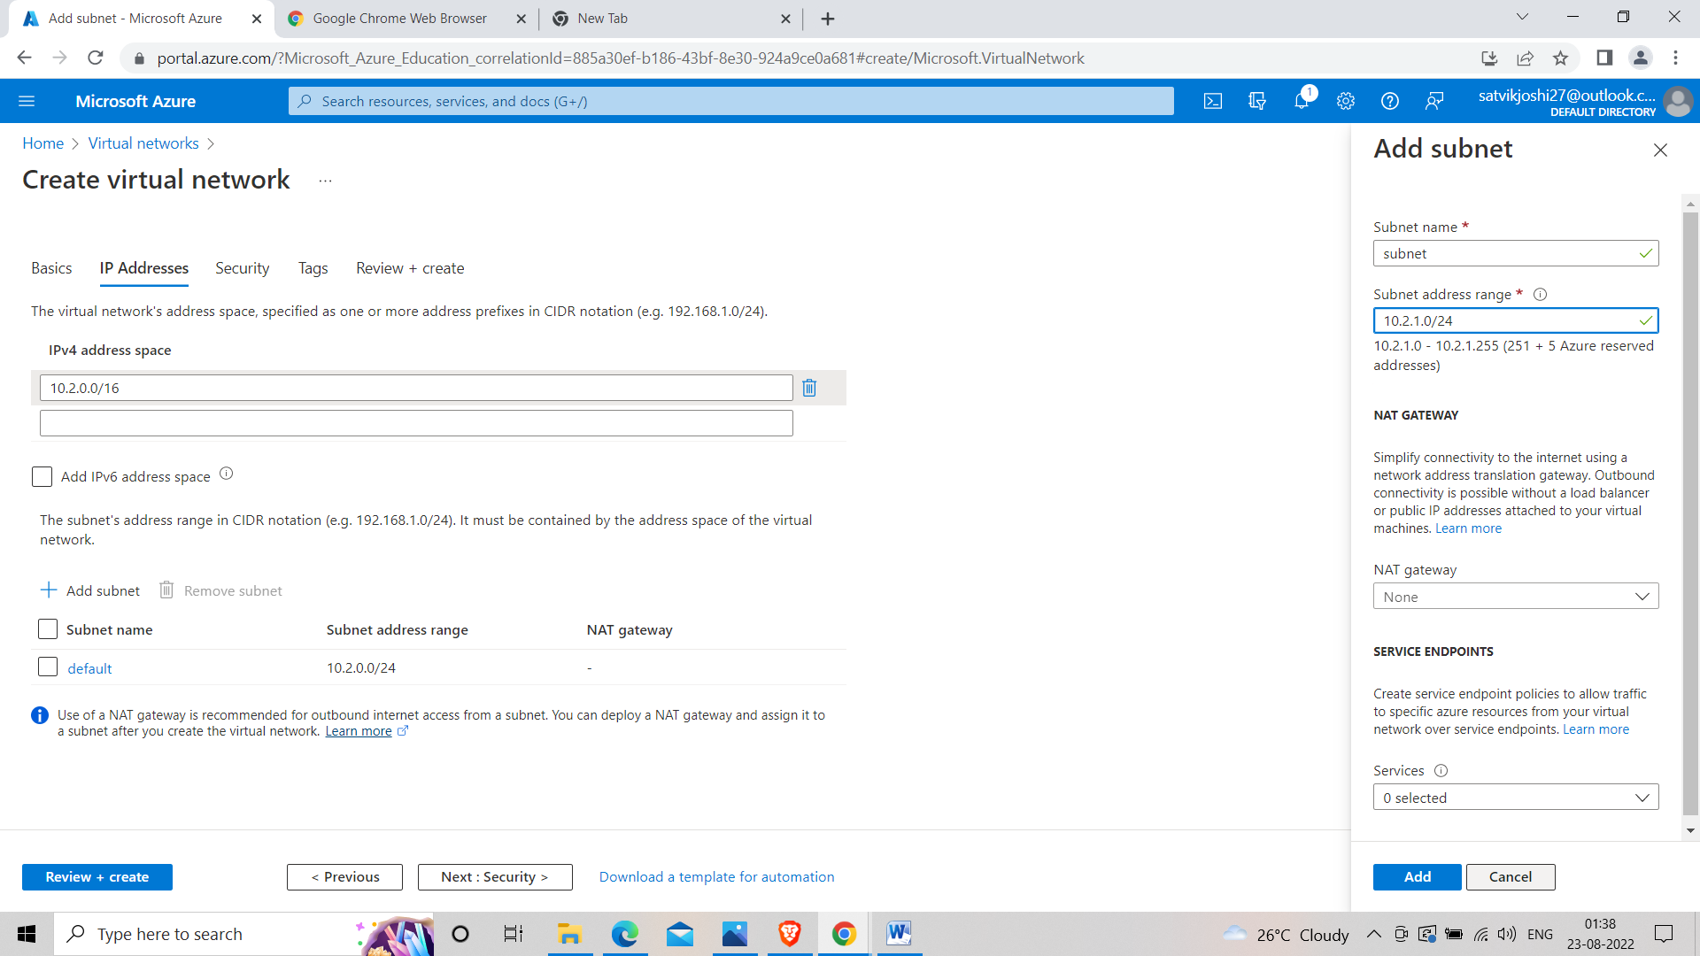

**Step 3 :- Create a Virtual Machine in the previously made Sub-Net.**



**Step 4 :- Create a Virtual Network Gateway by searching in search bar.**

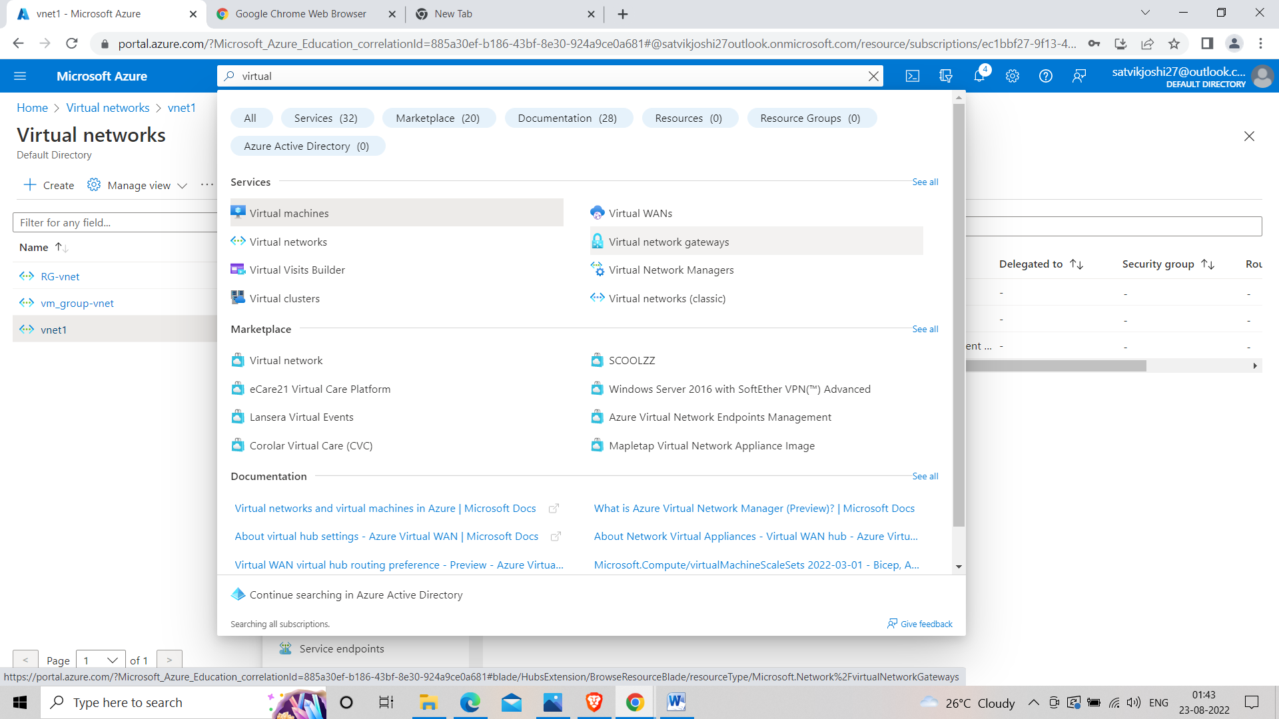

**Step 5 :- Create a Virtual network Gateway<<keep VPN type route based << Virtual network must be the same in which we created our subnet earlier in step 2.**

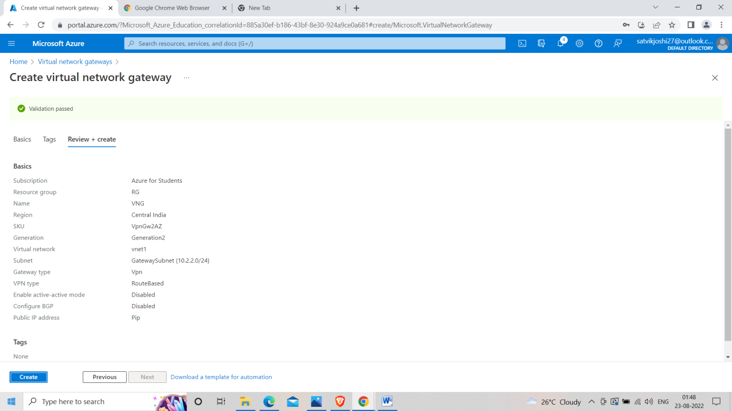

**Step 6 :- Generate the certificate by running the following commands in power shell of the windows in administrator mode.**

**Self signed root certificate.**

$cert = New-SelfSignedCertificate -Type Custom -KeySpec Signature `

-Subject "CN=P2SRootCert" -KeyExportPolicy Exportable `

-HashAlgorithm sha256 -KeyLength 2048 `

-CertStoreLocation "Cert:\CurrentUser\My" -KeyUsageProperty Sign -KeyUsage CertSign

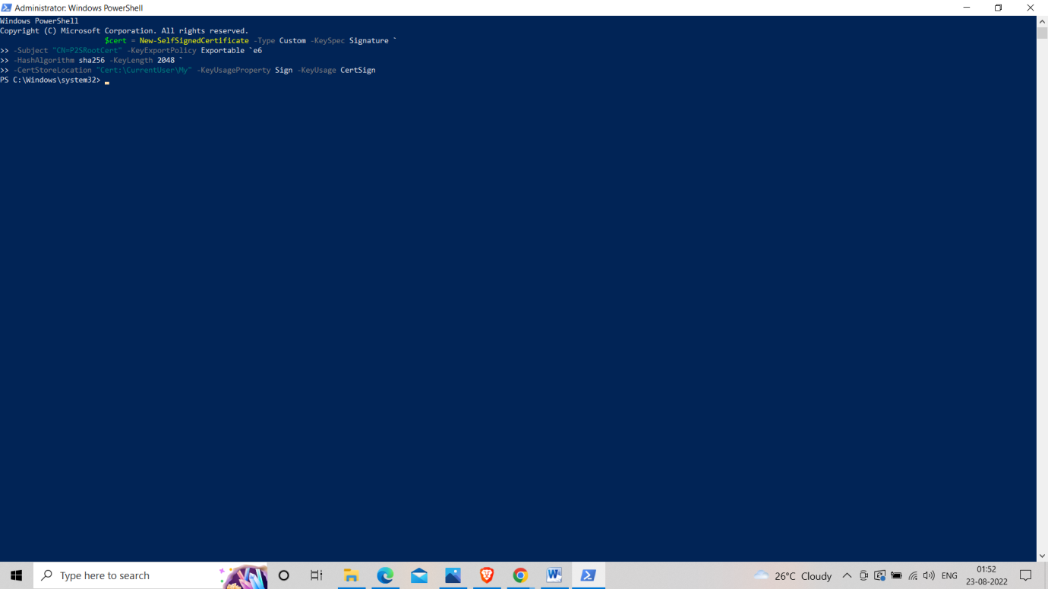

**Client certificate**

New-SelfSignedCertificate -Type Custom -DnsName P2SChildCert -KeySpec Signature `

-Subject "CN=P2SChildCert" -KeyExportPolicy Exportable `

-HashAlgorithm sha256 -KeyLength 2048 `

-CertStoreLocation "Cert:\CurrentUser\My" `

-Signer $cert -TextExtension @("2.5.29.37={text}1.3.6.1.5.5.7.3.2")

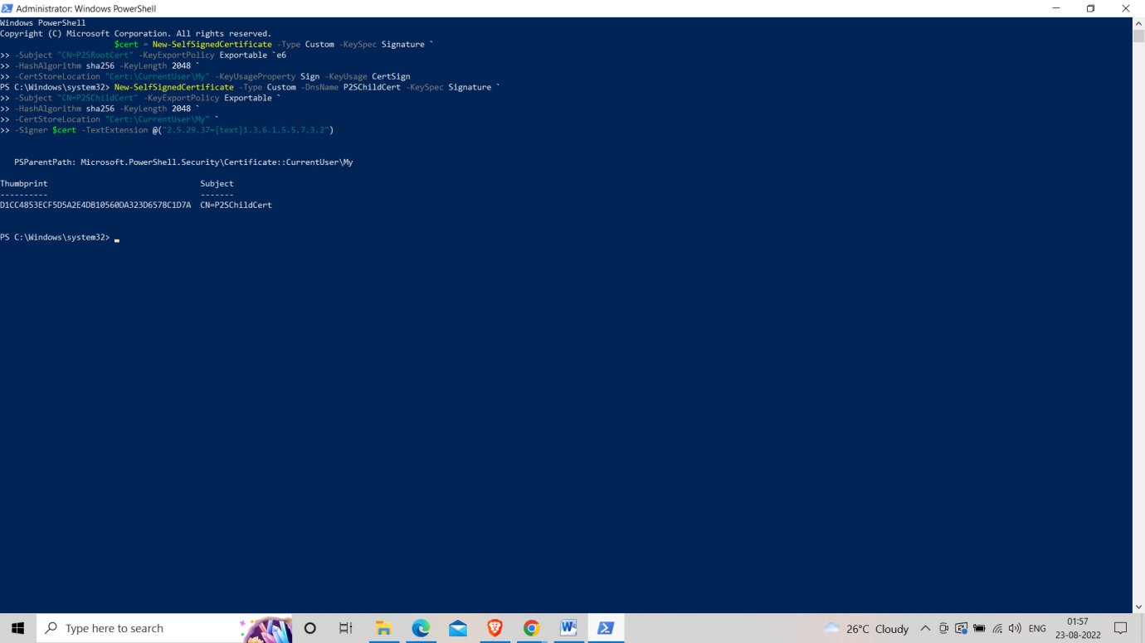

**Step 7 :- Export both the certificates.**

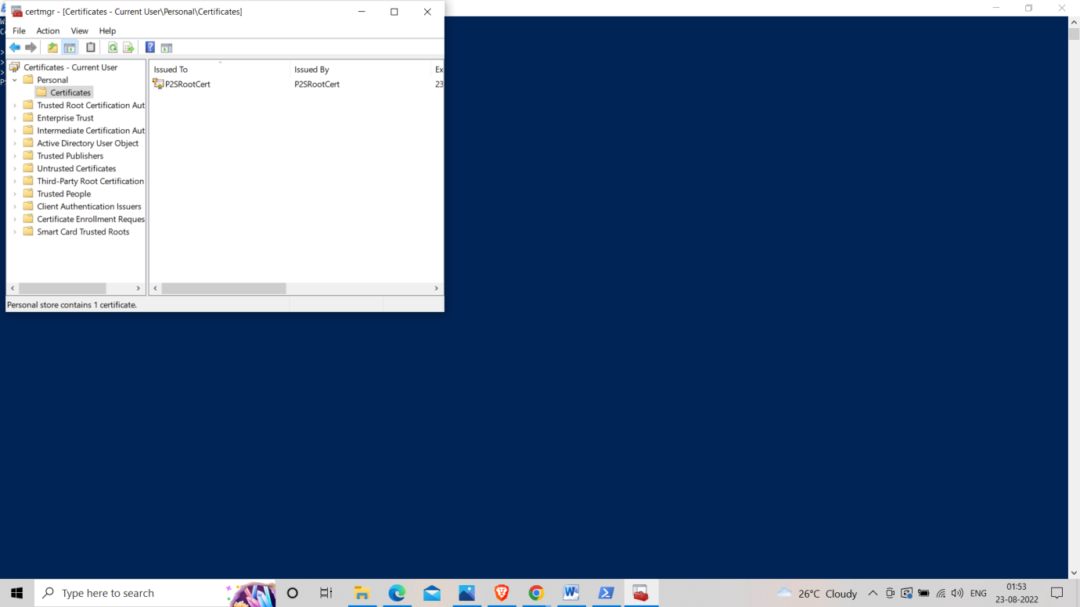

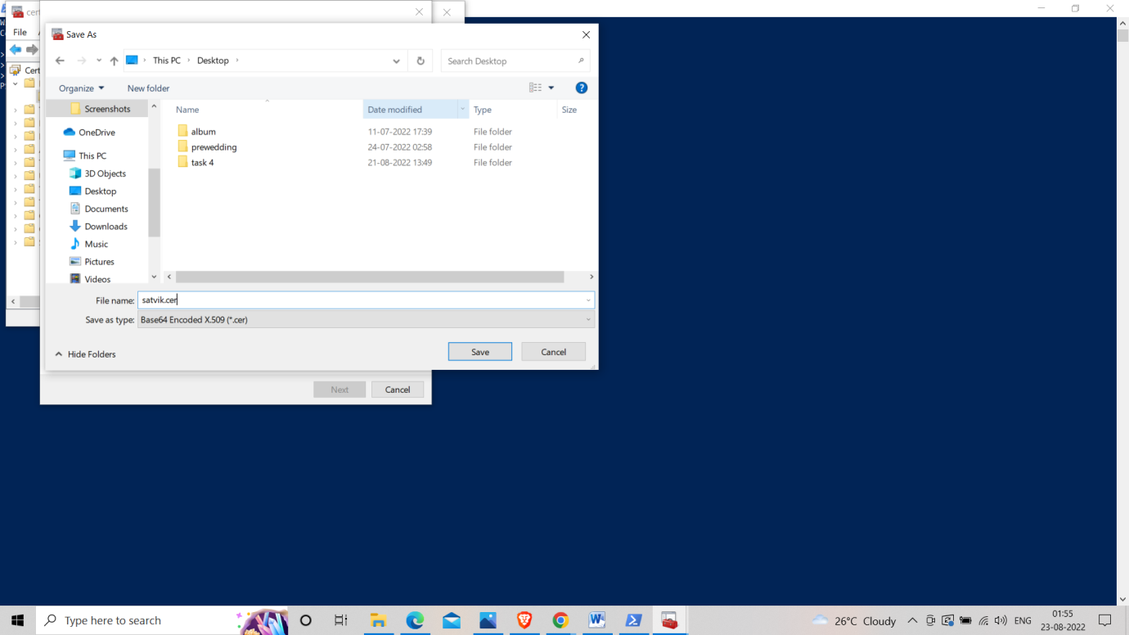

**Step 8:- Go to Azure Portal and Select Point-to-site Configuration**

**And paste the content of Root certificate in the given coloumn and name it decently.**

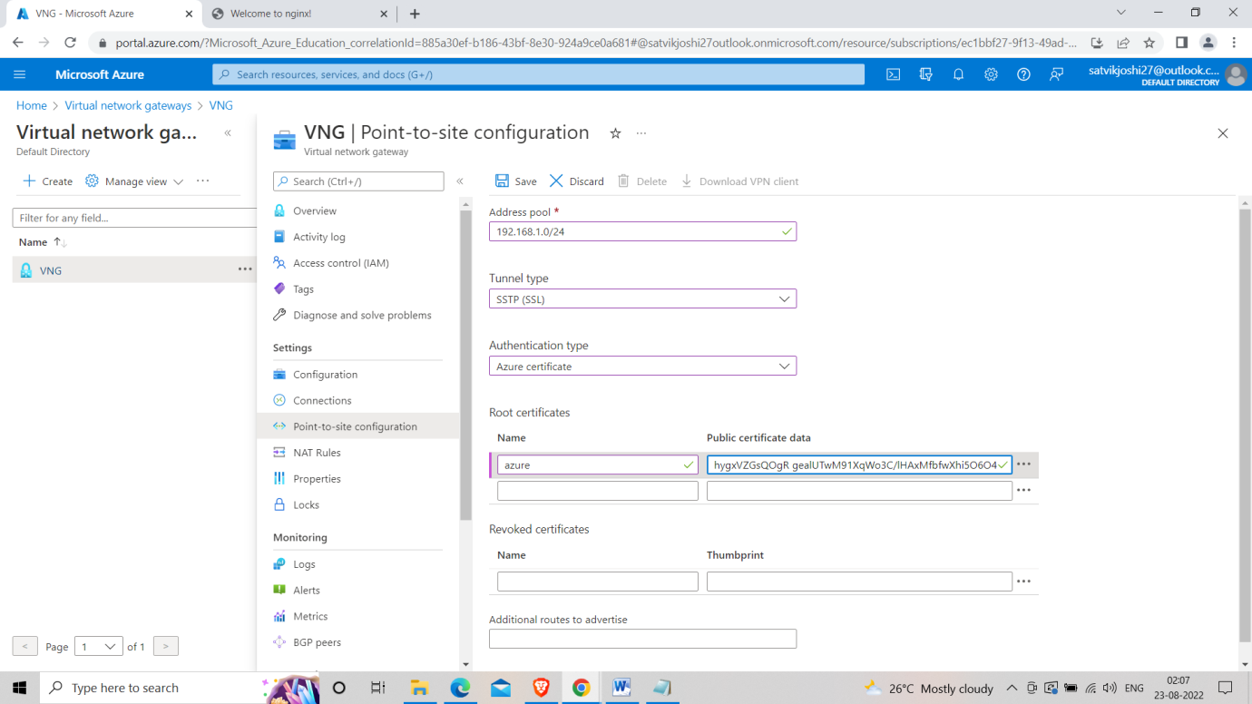

**Step 9 :- Download VPN client and run it as admin.**

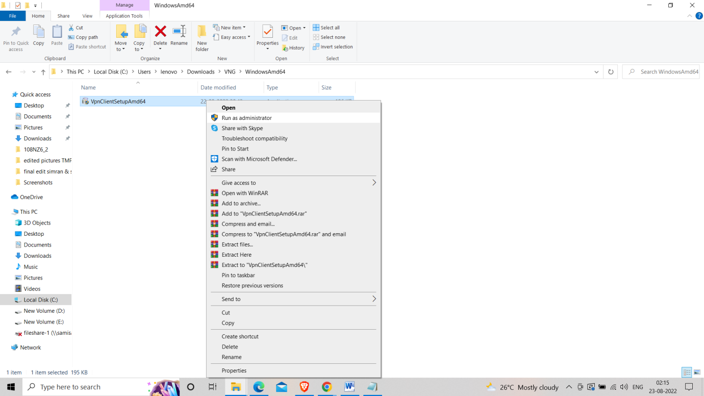

**Step 10 :- Connect to Vnet.**

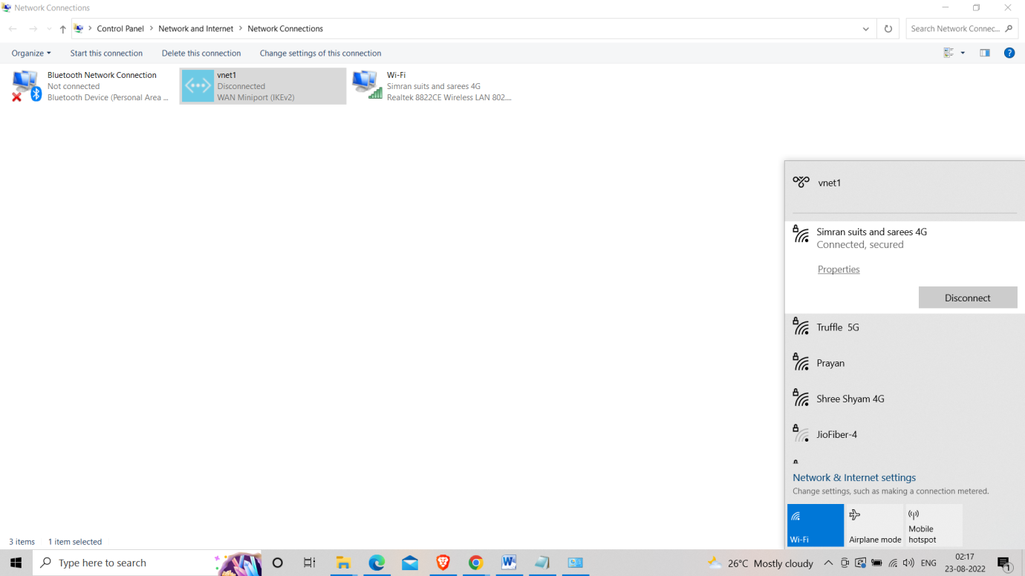

**Step 11 :- Connect VM through RDP and configure the IP in the CMD of Remote Desktop and ping it in the CMD of our desktop.**

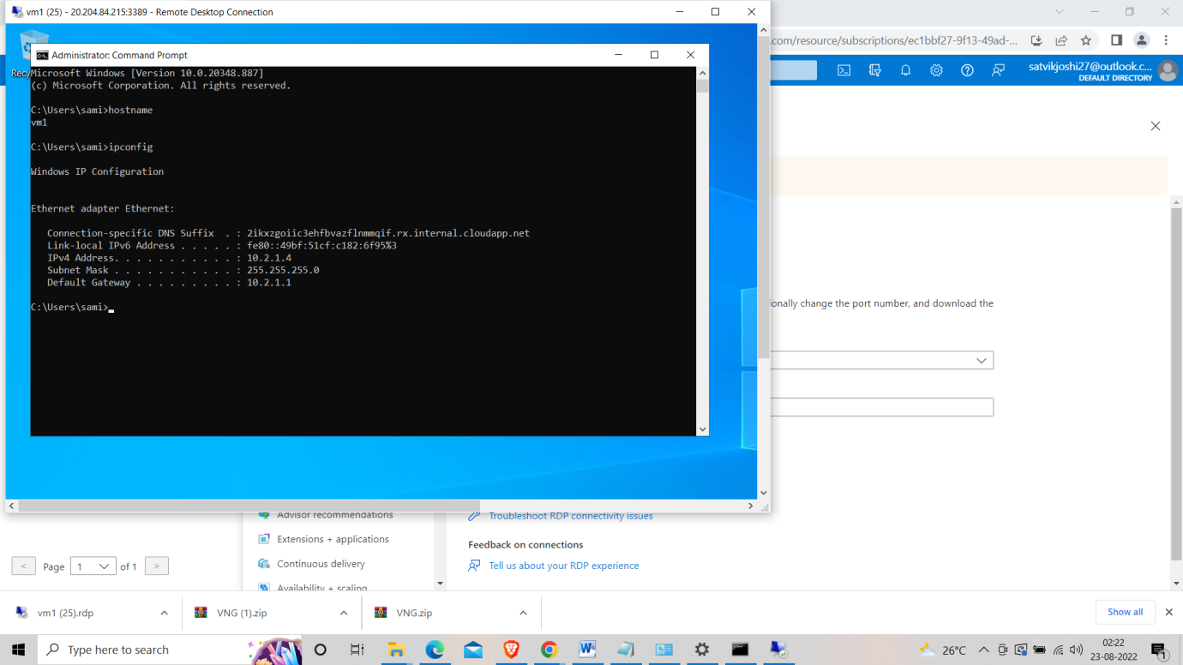

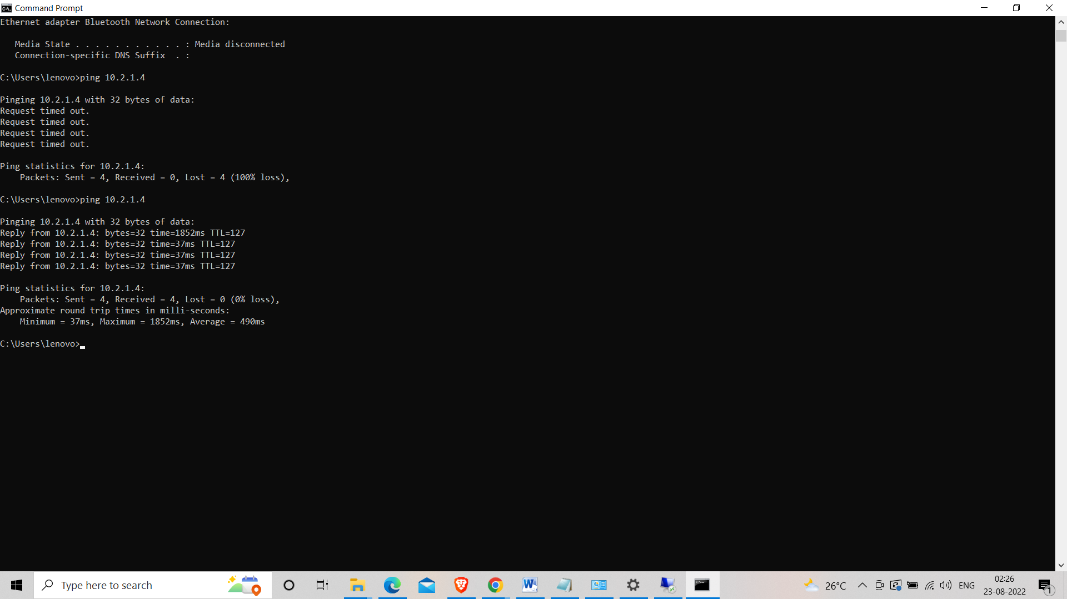

**Task 12**

**Step 1 :-Create a virtual network with three subnets and non-overlapping CIDR ranges.**

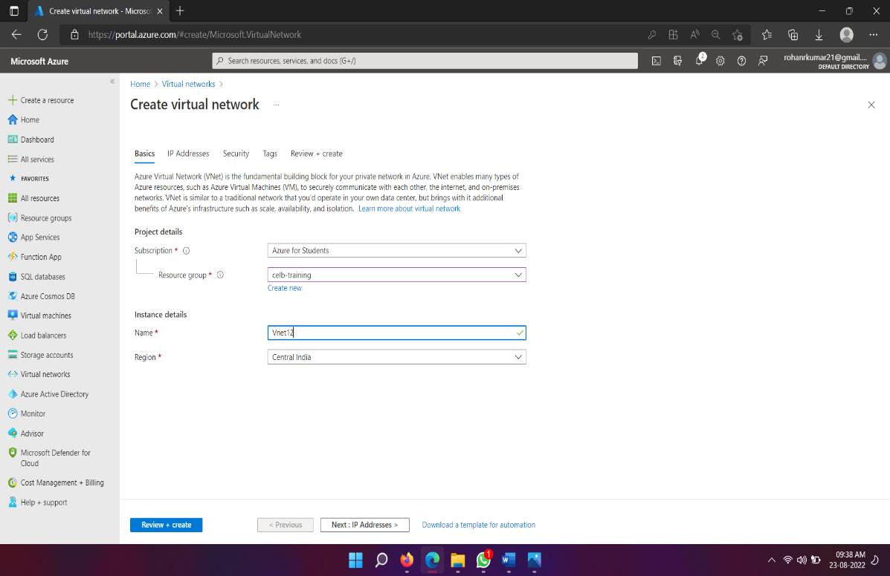

**Step 2 :-**

**Create Virtual Machines**

**For each subnet, we will be creating a basic virtual machine as shown.**

**The first is for the Web tier.**

**Task 13**

**Task13**

* Create a Virtual Machine.
* Create an Alert rule for VM CPU percentage using Azure Monitor.
* Condition: CPU more than 80%
* Action: Send email.

**Step 1 :- Create a windows Virtual machine with RDP port and your favorable size.**

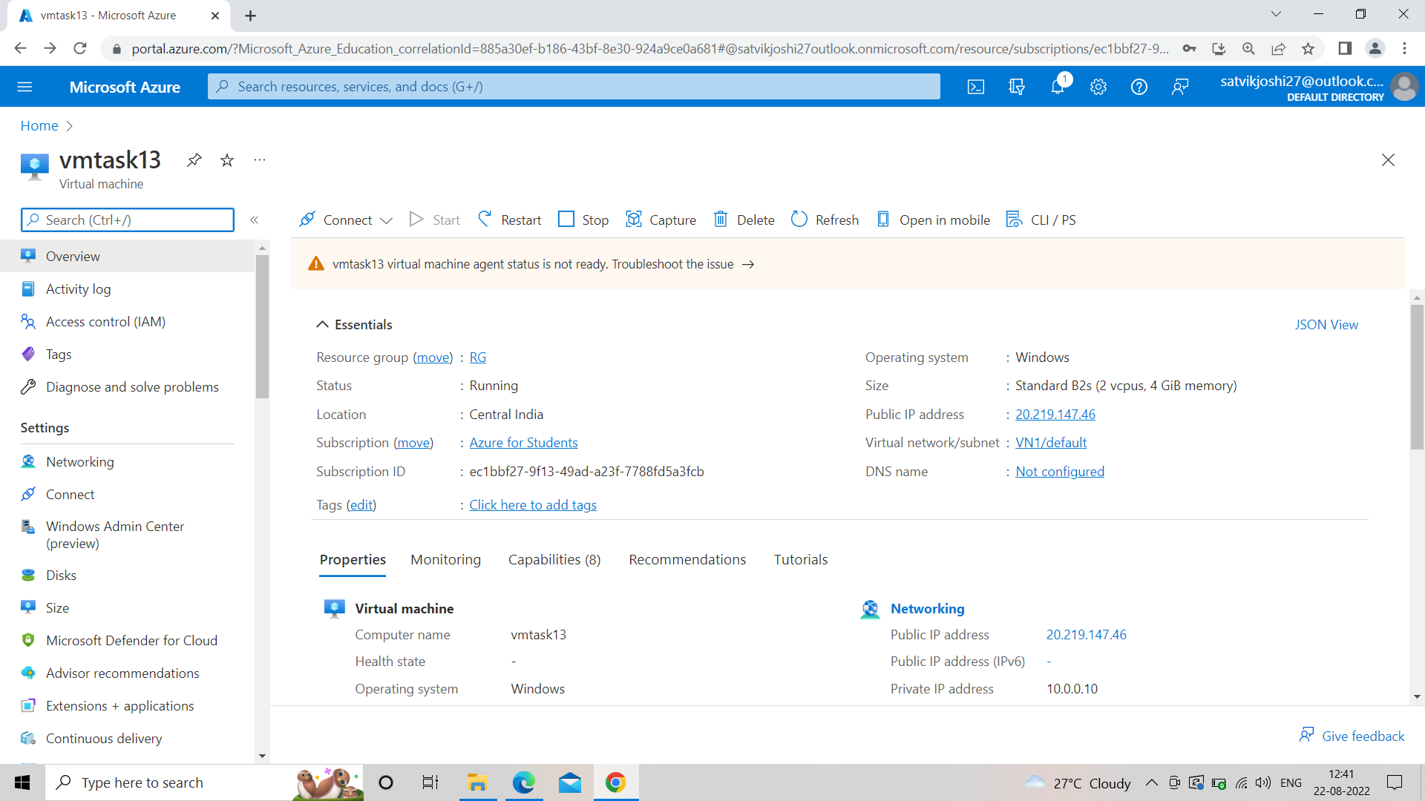

**Step 2 :- Go to search bar and search monitor.**

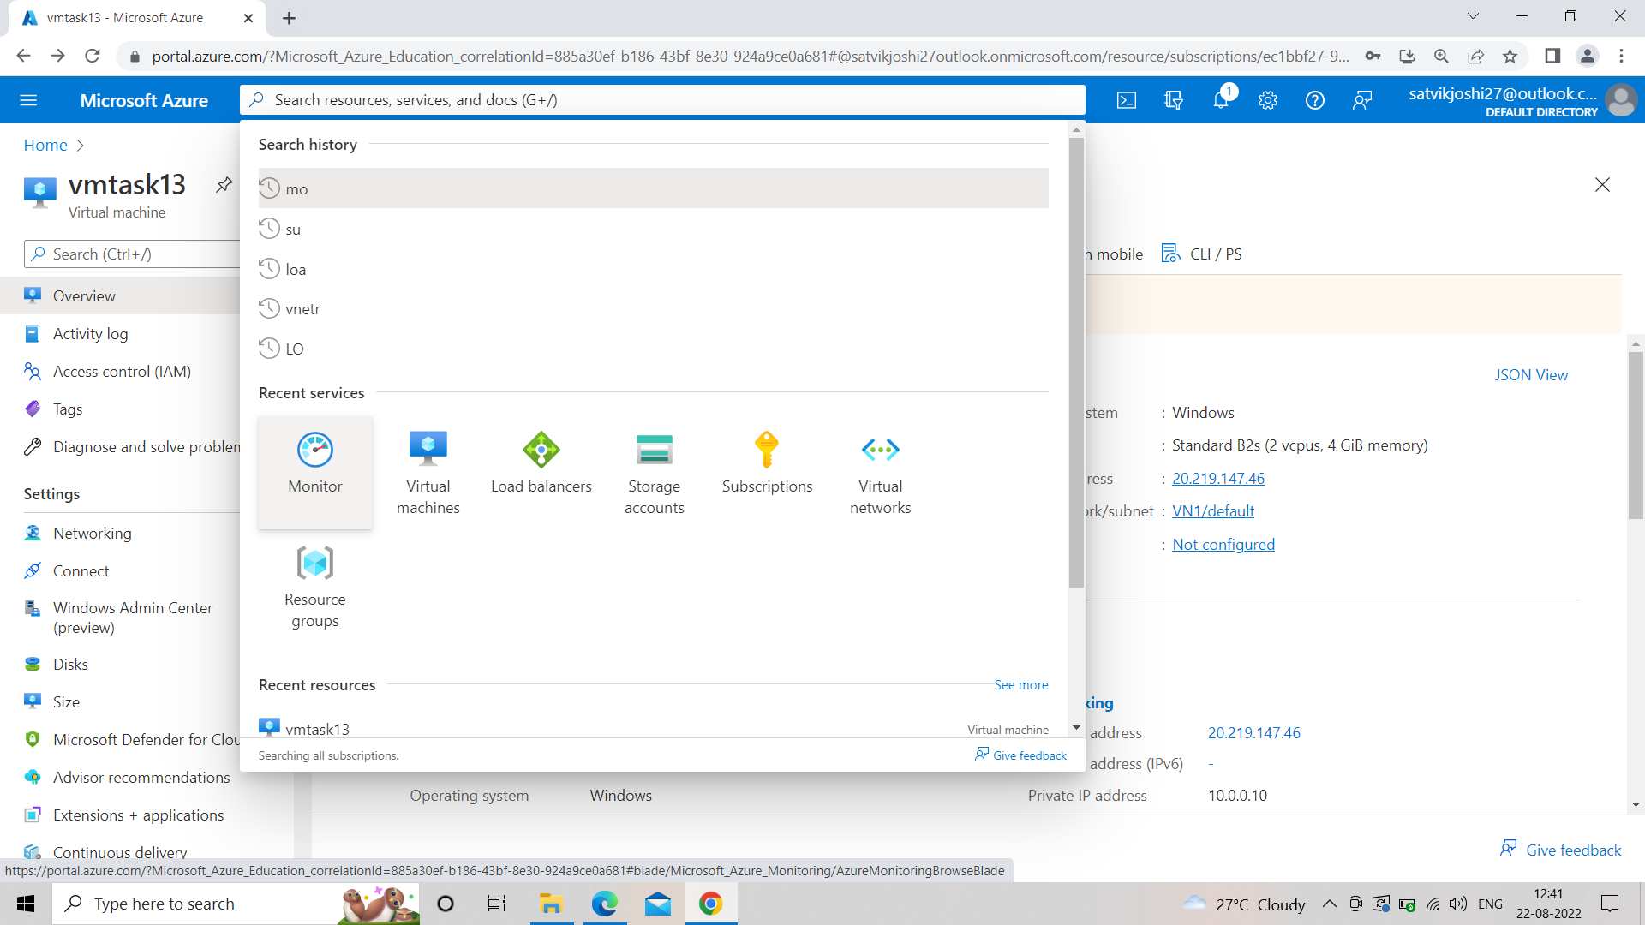

**Step 3 :- Moniter<<create an alert rule<<filter by resource type = virtual machine.**

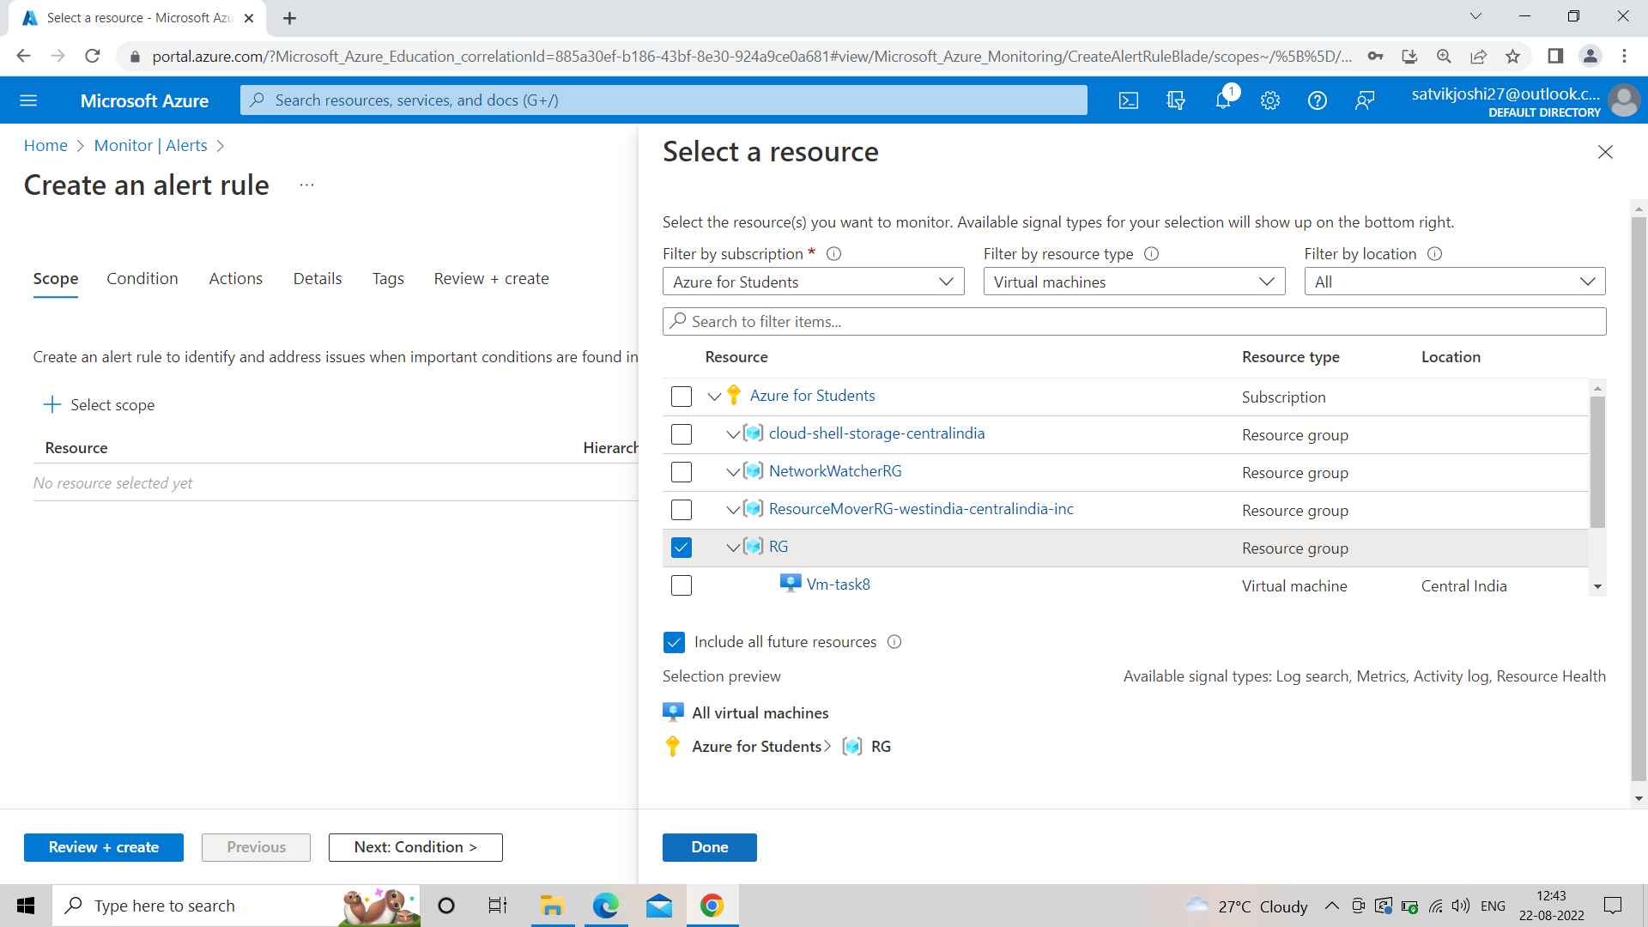

**Step 4 :- Go to conditions<<threshold=static<<threshold value=80.**

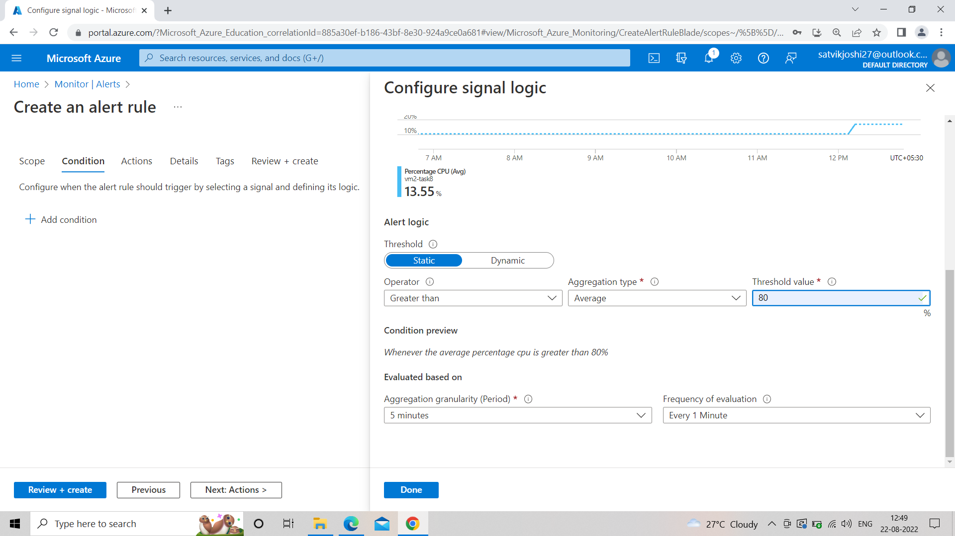

**Step 5 :- Create Action Group<<notification type+email<<name=satvik<<email_id=saatvik2710@gmail.com.**

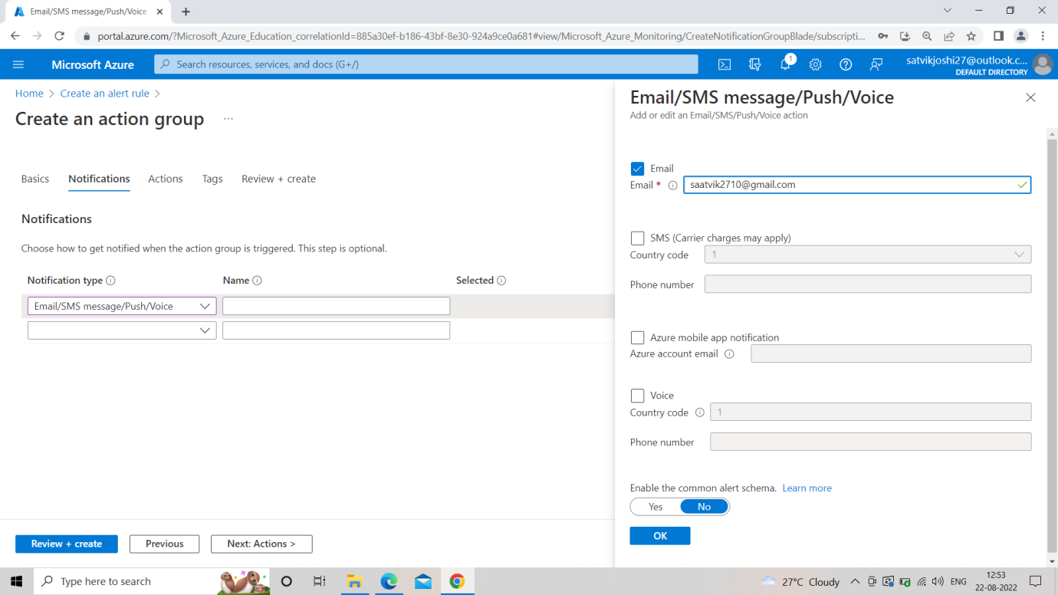

**Step 6 :- Review and Create an alert rule.**

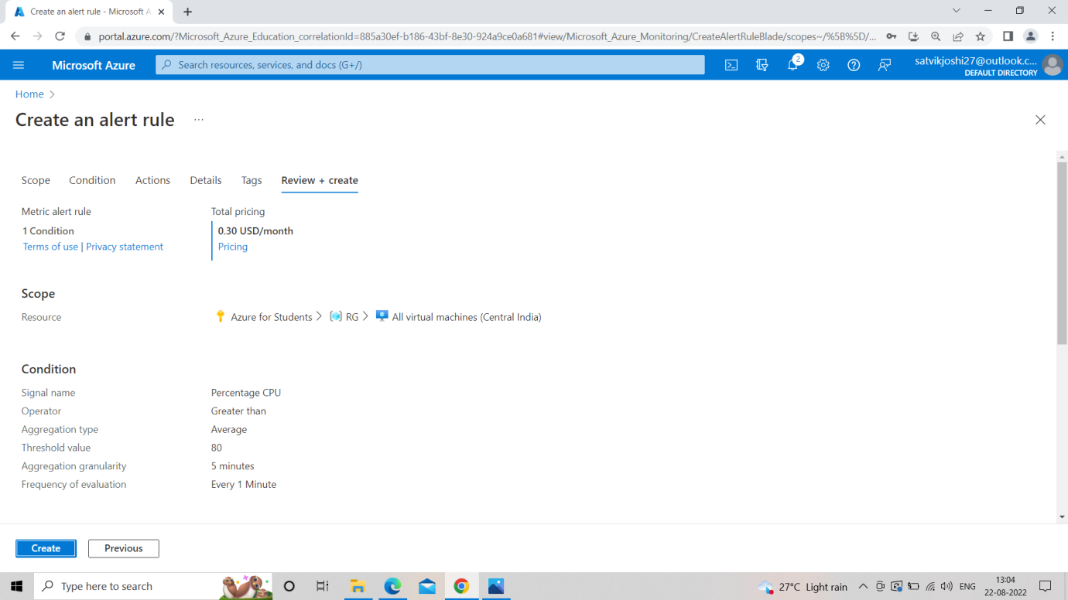

**Step 7 :- Check your email id.**

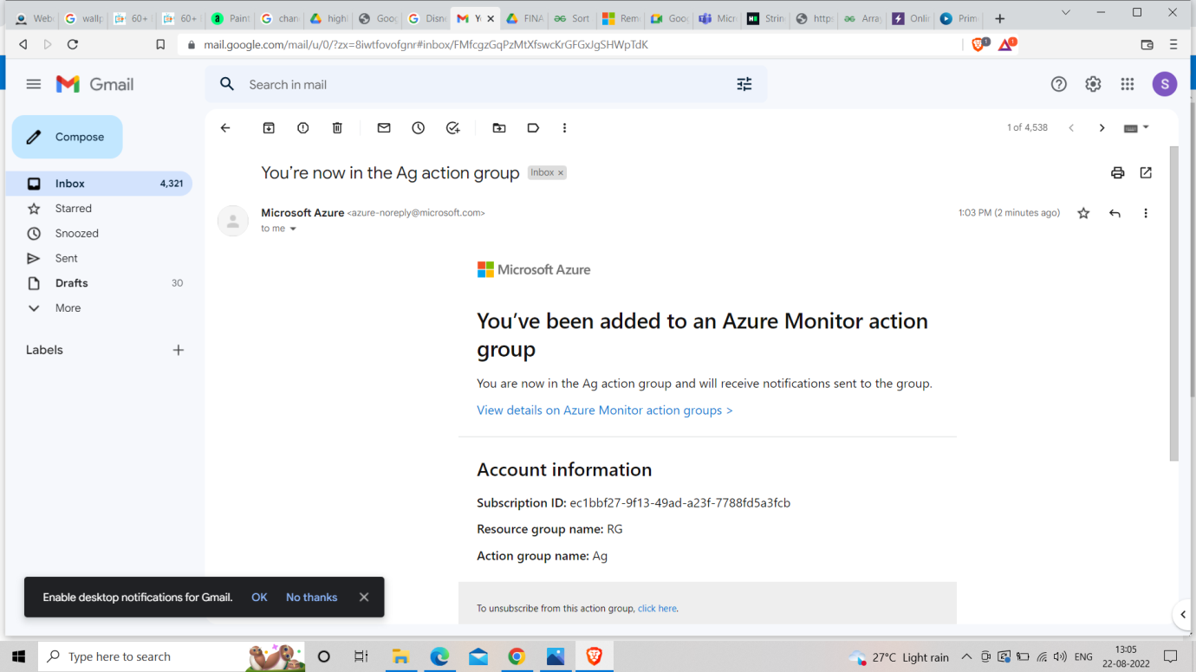

**Task 14**

**Task14**

* Learn about Azure File share
* Create an Azure File Share
* Mount the File Share on your local computer.

**AZURE FILE SHARE**

Azure Files offers fully managed file shares in the cloud that are accessible via the industry standard. Azure file shares can be mounted concurrently by cloud or on-premises deployments. SMB Azure file shares are accessible from Windows, Linux, and macOS clients. NFS Azure file shares are accessible from Linux or macOS clients.

**CREATE AN AZURE FILE SHARE**

**Step 1 :- Go to Azure Portal and search Storage Acoount in the search bar.**

**Step 2 :- Create a Storage account. Choose Resource group and location carefully. Set performance = Standard.**

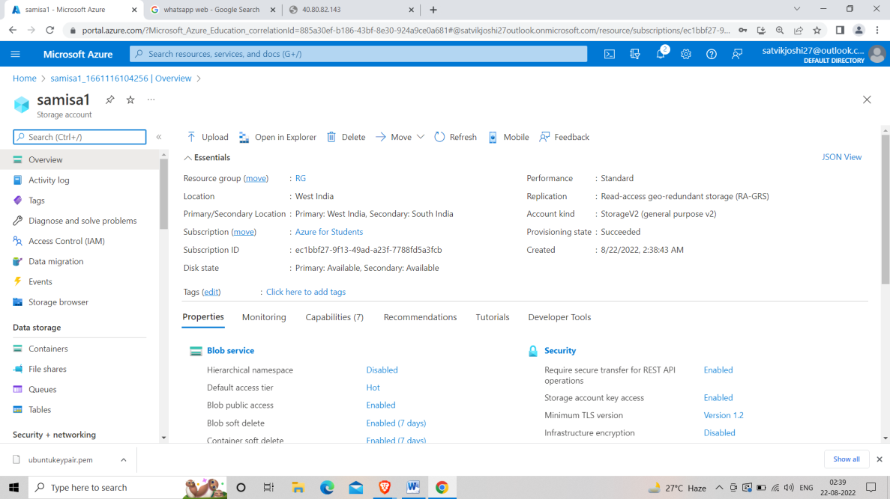

**Step 3 :- Data storage << File share << New file share << Name << Create.**

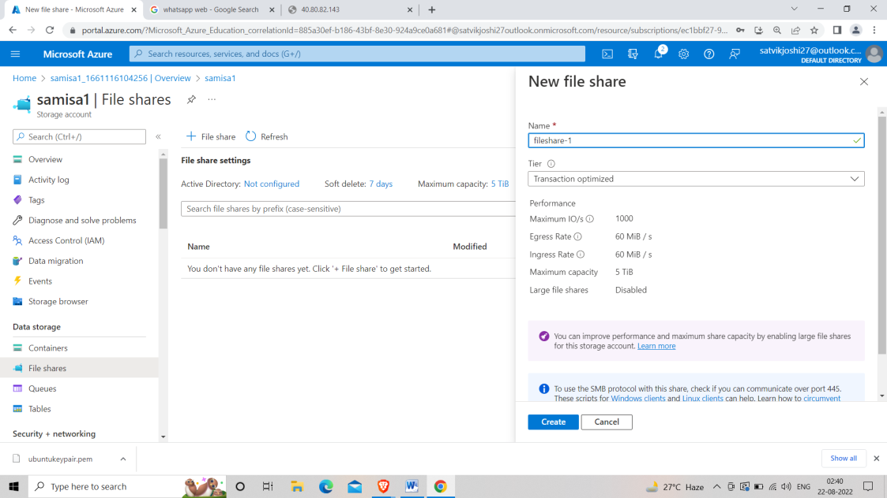

**Step 4 :- Upload a file in the file share by Browsing into the computer.**

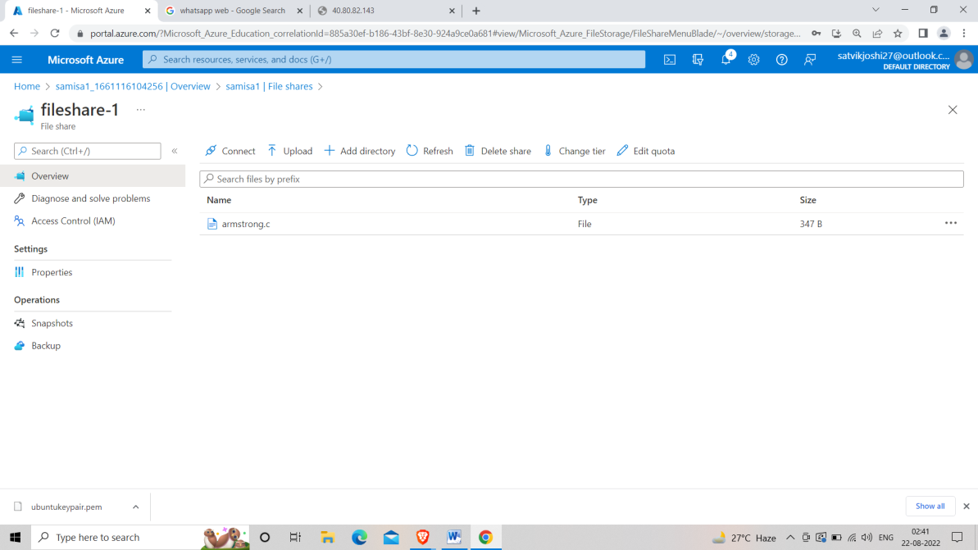

**Step 5 :- Go to connect and copy the content from there.**

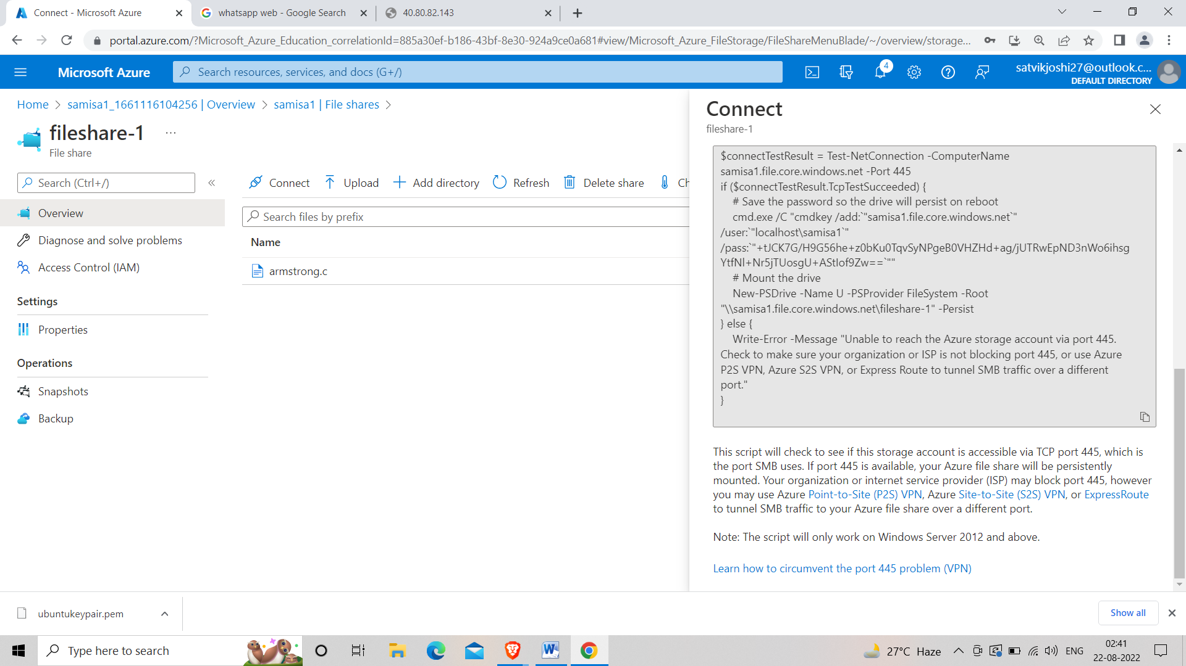

**Step 6 :- Paste the content into the windows power shell and press enter.**

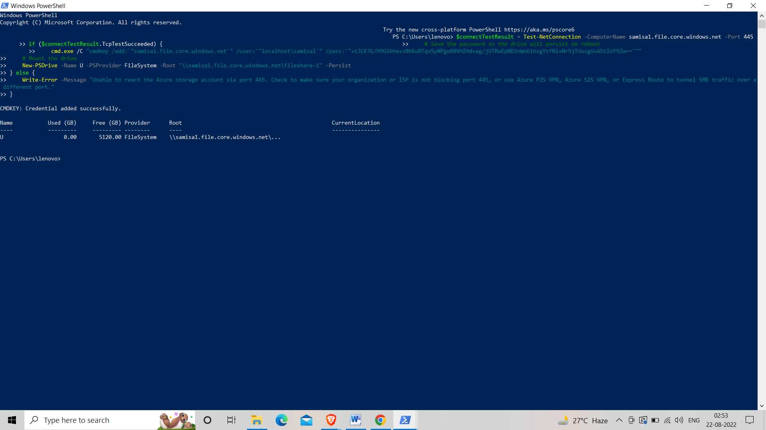

**Step 7 :- Go to this PC and you’ll find your newly made disk in it.**

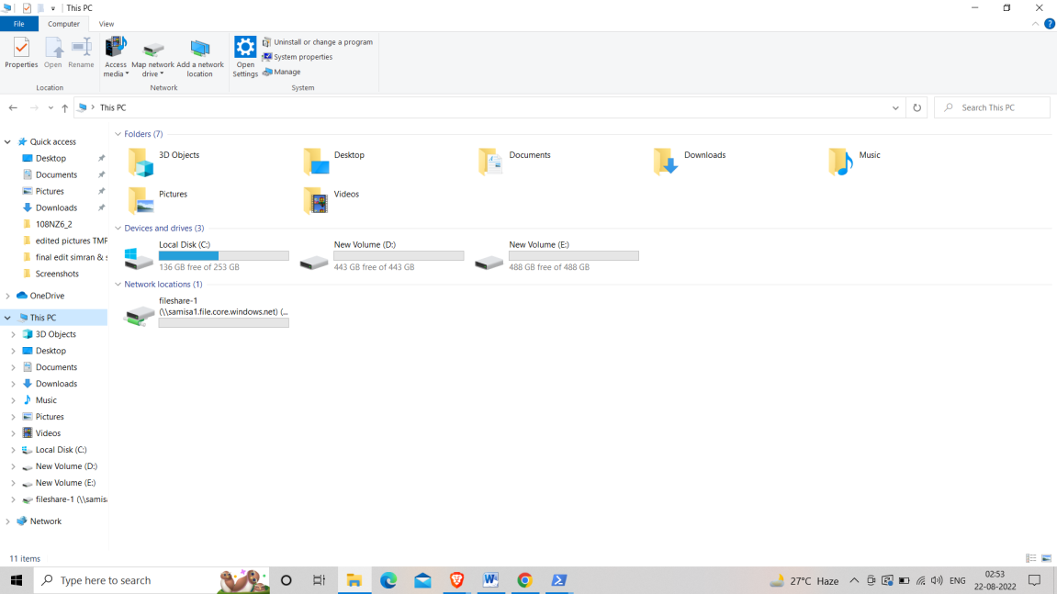

**Task 15**

**Task15**

* Create a Virtual Machine and install google chrome.
* Generalize the Virtual Machine and create managed image.
* Create VM from managed image.

**Step 1 :- Create a windows virtual machine of your favorable size and location, choose RDP port.**

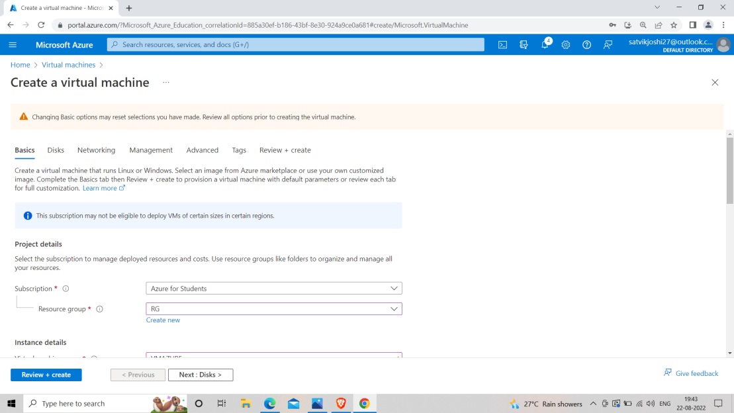

**Step 2 :- Install Google chrome setup in your desktop and paste it in the remote window of the virtual machine made in step 1 via connecting the VM through RDP.**

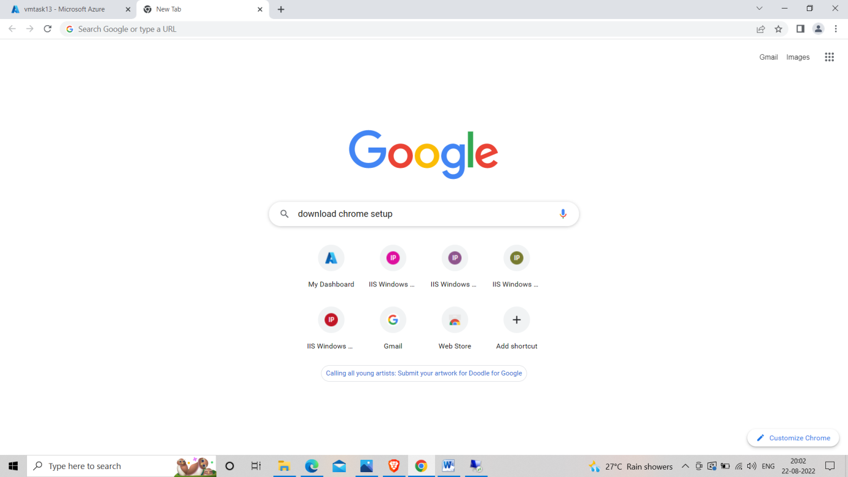

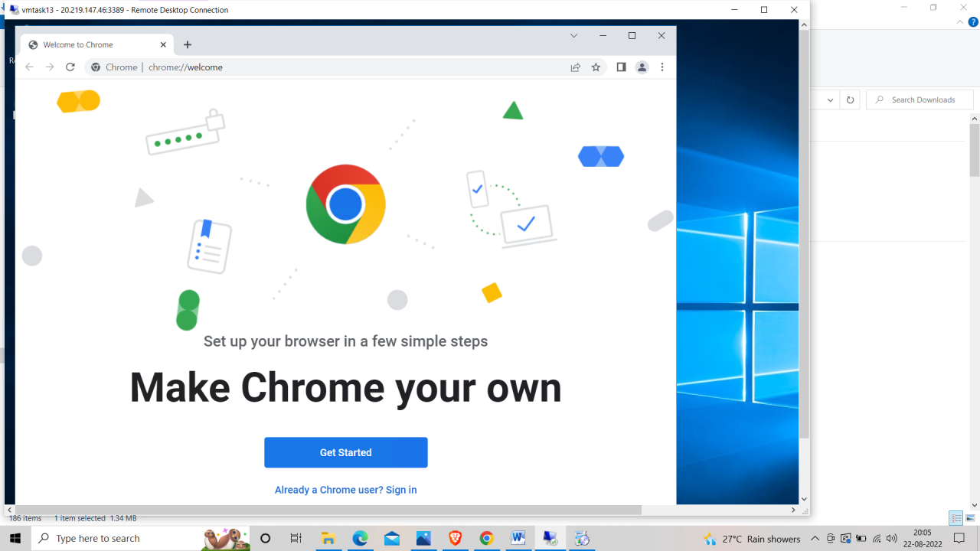

**Step 3 :- Go to Azure portal and search “Create an Image”.**

**Step 4 :- Choose resource group, name, region and set share image to NO.**

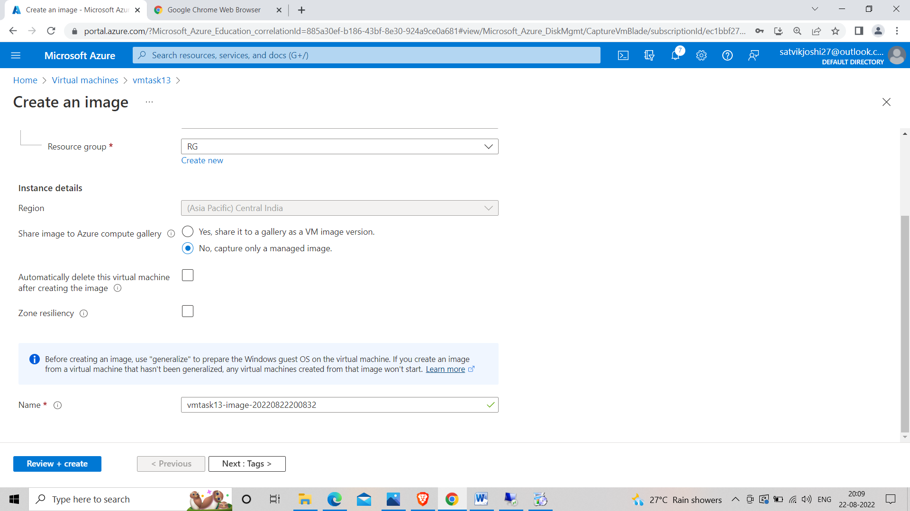

**Step 5 :- Review and Create.**

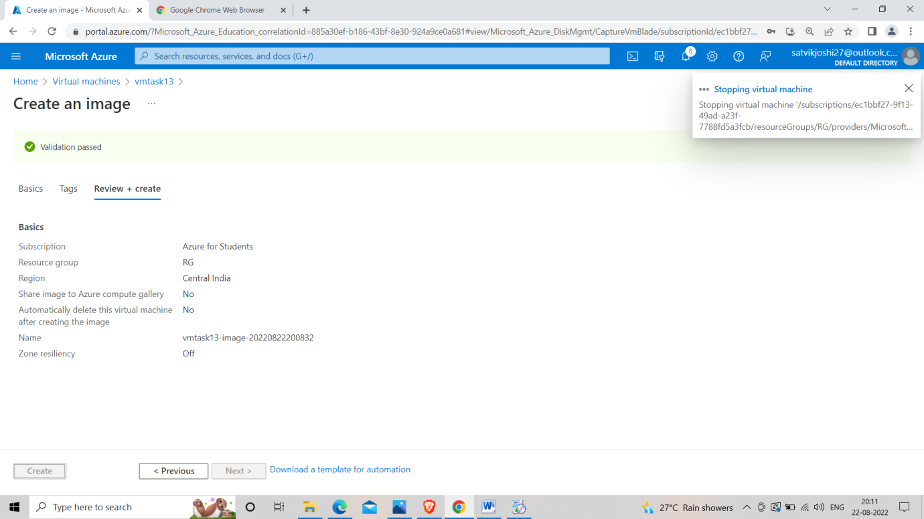

**Step 6 :- Go to Resource Group and there you’ll find the name of your image .**

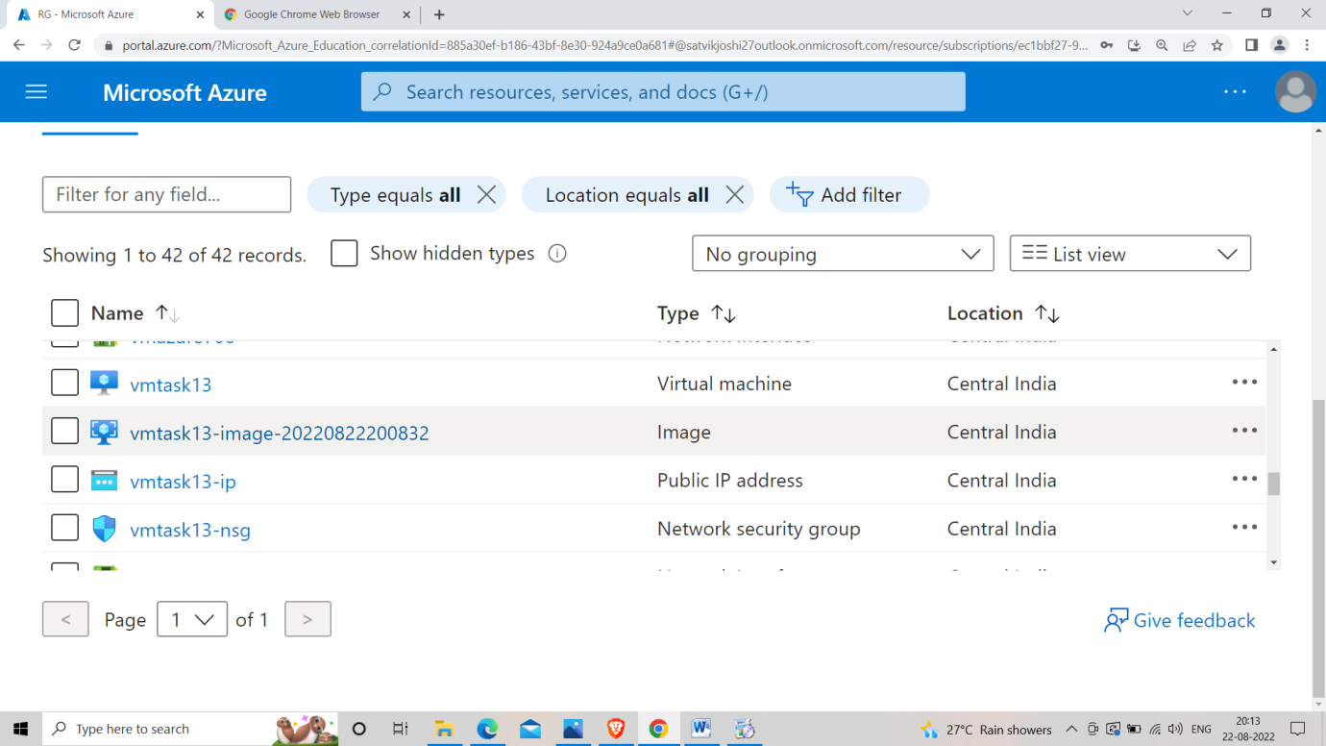

**Step 6 :- Create a virtual machine in this resource group.**

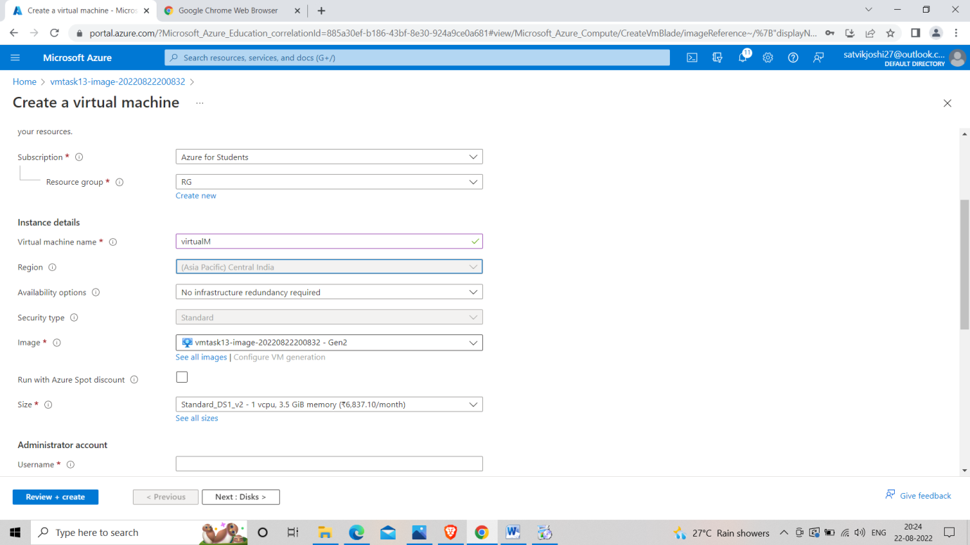

**Step 7 :- Connect the VM through RDP and open the Remote desktop.**

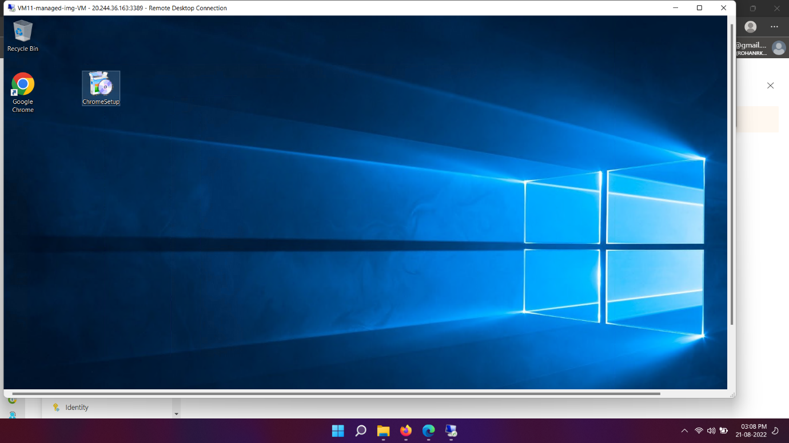

**Task 16**

**Task16**

* Create a Virtual Machine
* Install FTP server on the Virtual Machine
* Try to connect to it using FileZilla

**Step 1 :- Start Creating a Virtual Machine in Azure portal.**

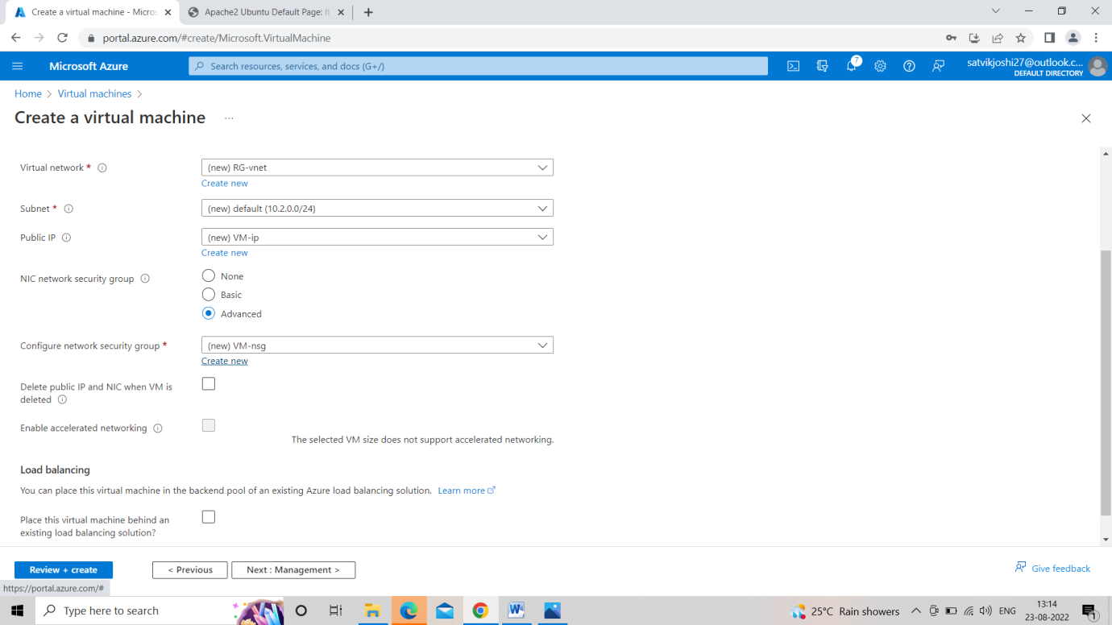

**Step 2 :- In networking add Network security group and add Three inbound rules .** 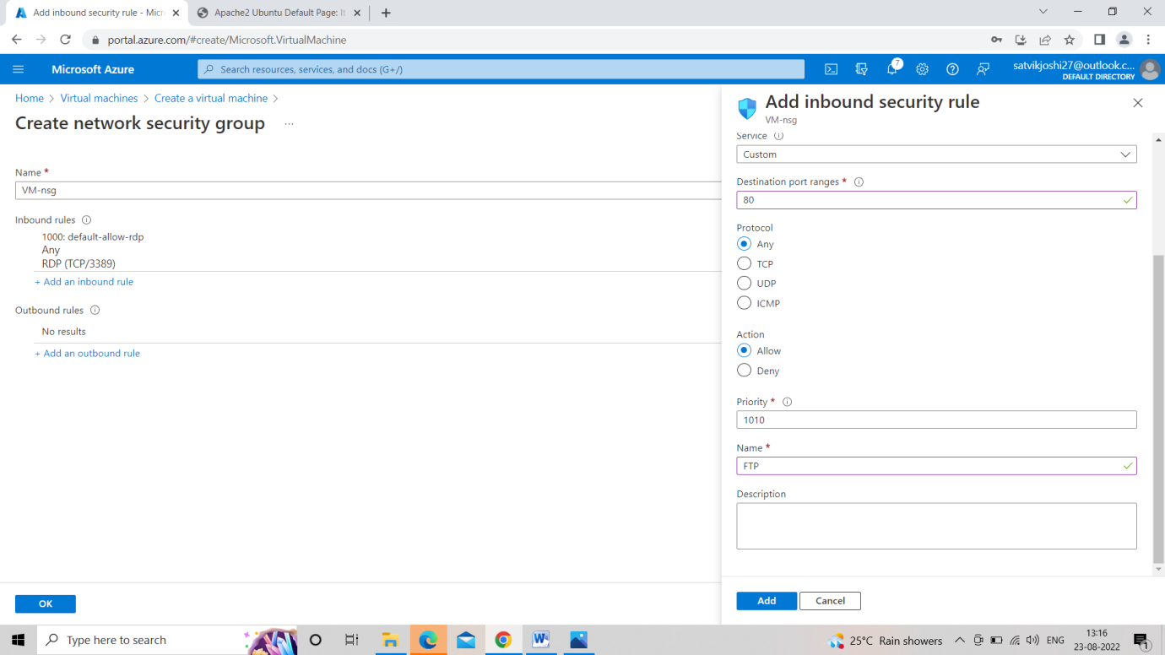

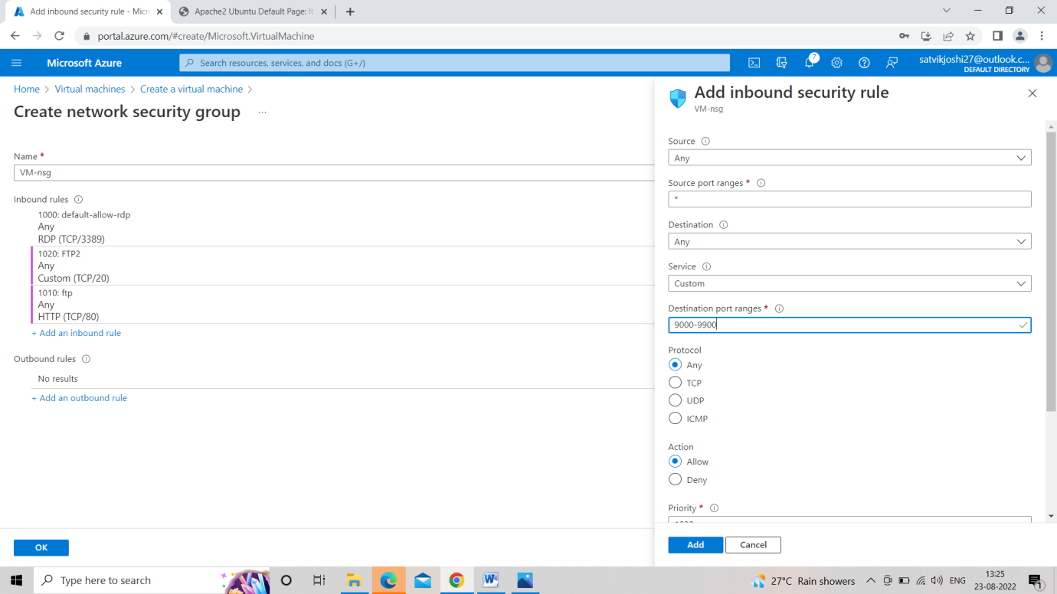

**Step 3 :- Complete the creation of virtual machine and connect it through RDP.**

**Step 4 :- Go to server manager in the remote desktop and add IIS service .**

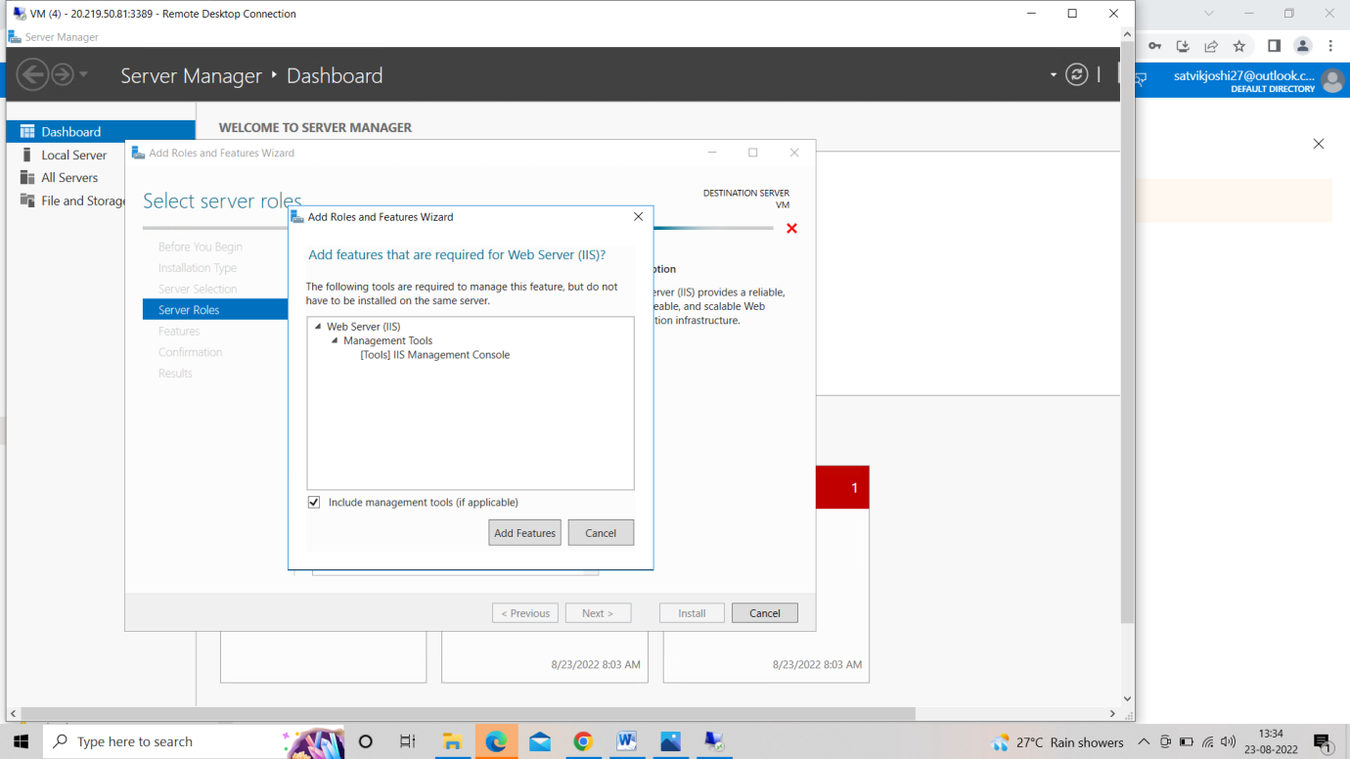

**Step 5 :- Role services<<FTP Service << FTP Extensibility<< next << install.**

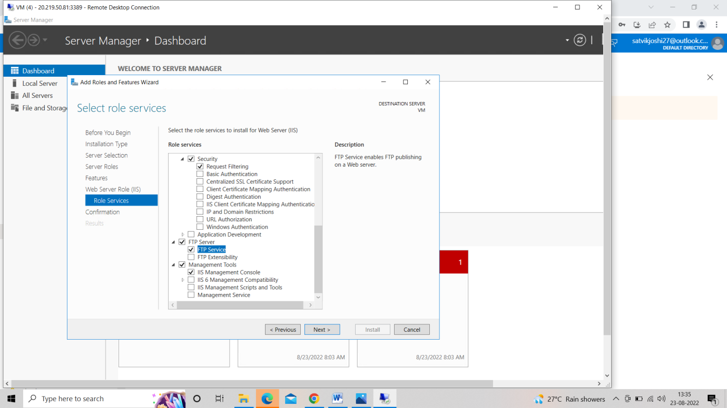

**Step 6 :- Server manager << tools <<IIS manager << sites << Remove default website and add FTP site.**

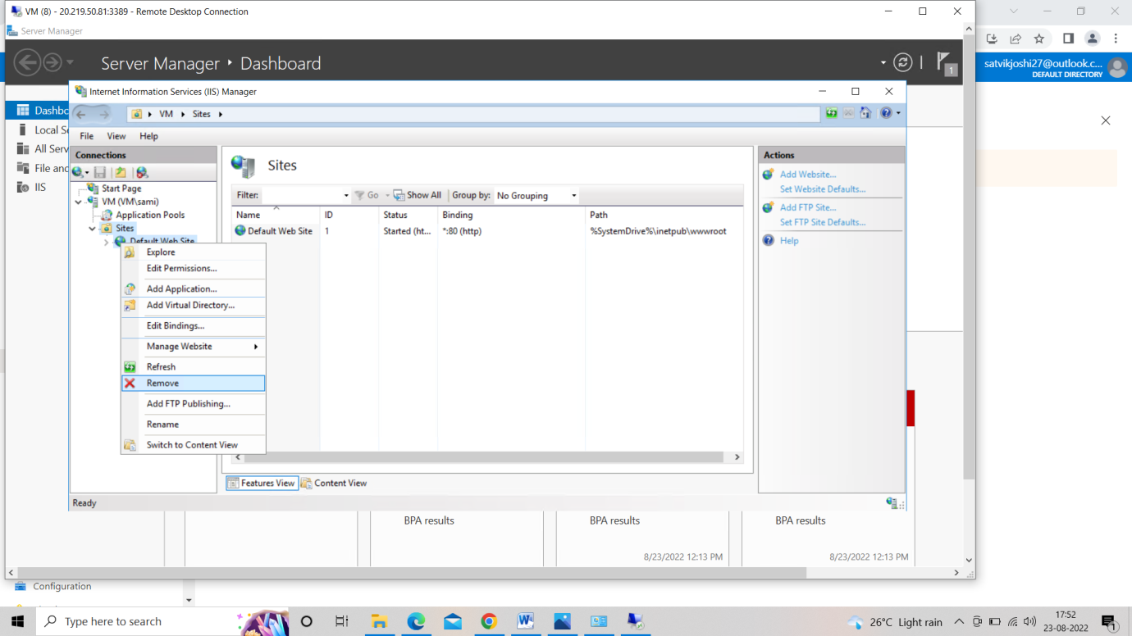

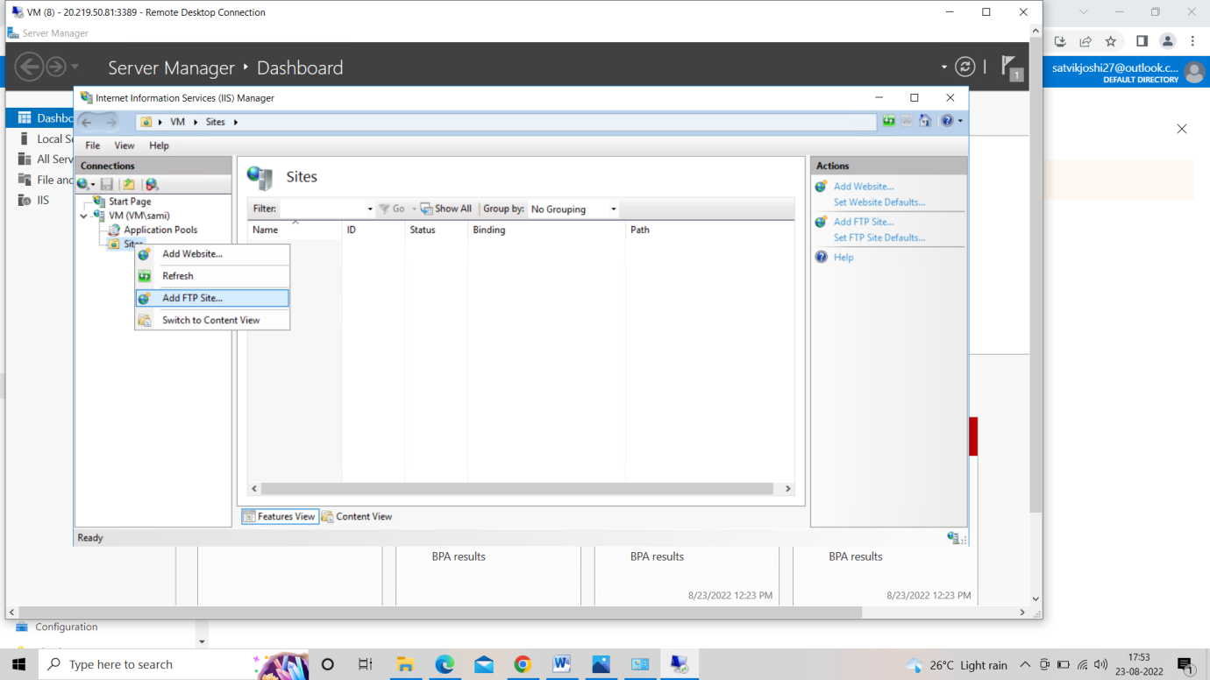

**Step 7 :- Give physical path to the site in C folder<<inetpub<<wwwroot.**

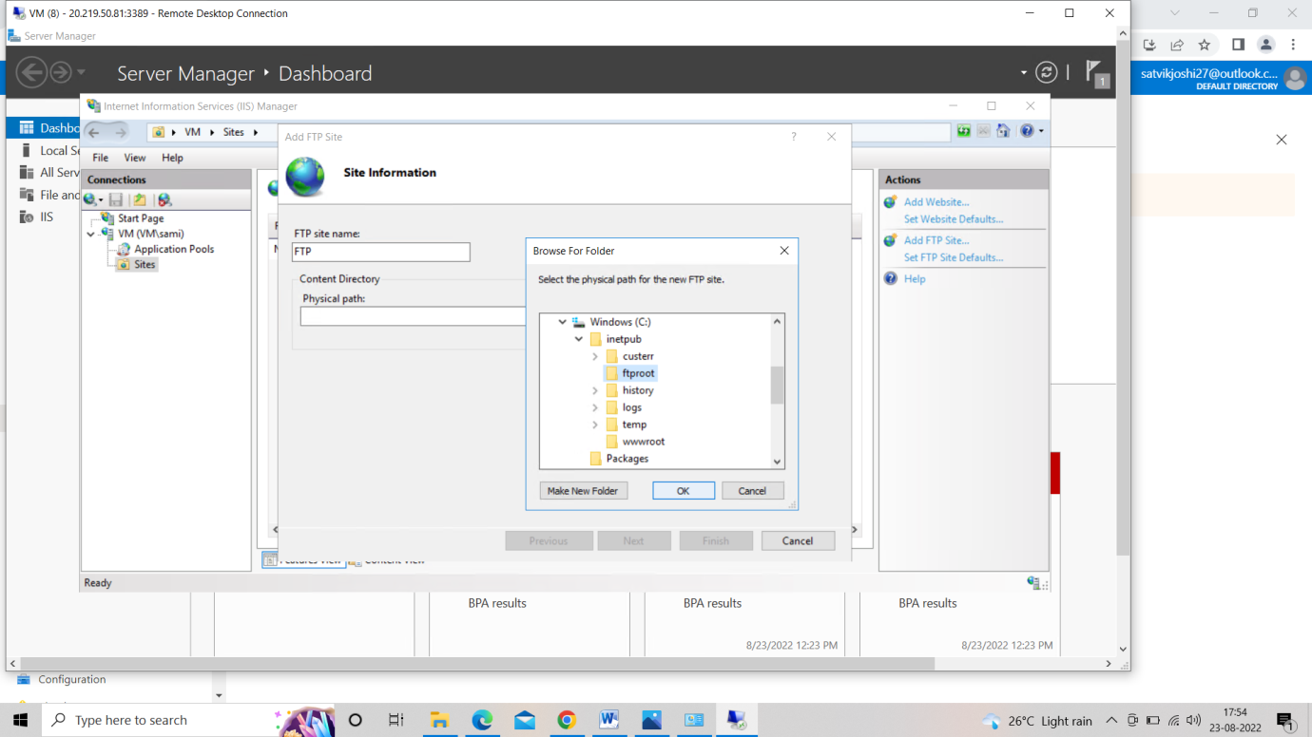

**Step 8 :- IP address = all unassigned<< ssl = no ssl .**

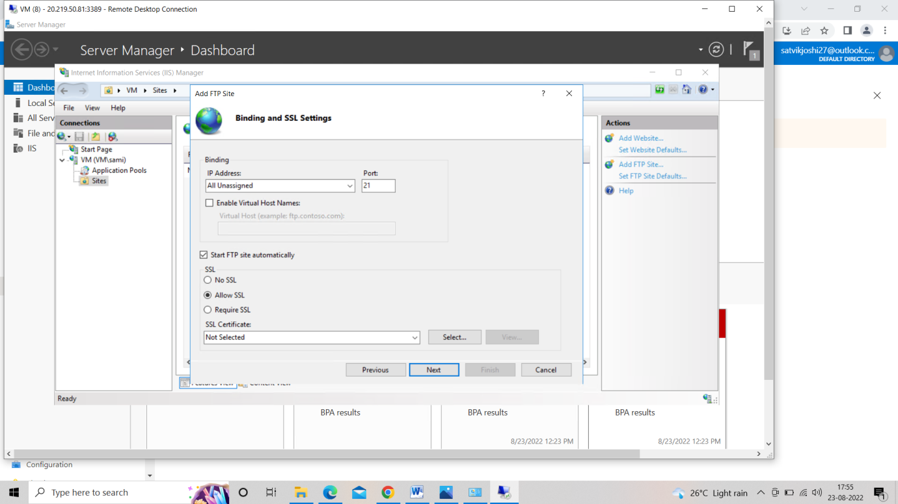

**Step 9 :- Authentication = Basic<< permission = read and write.**

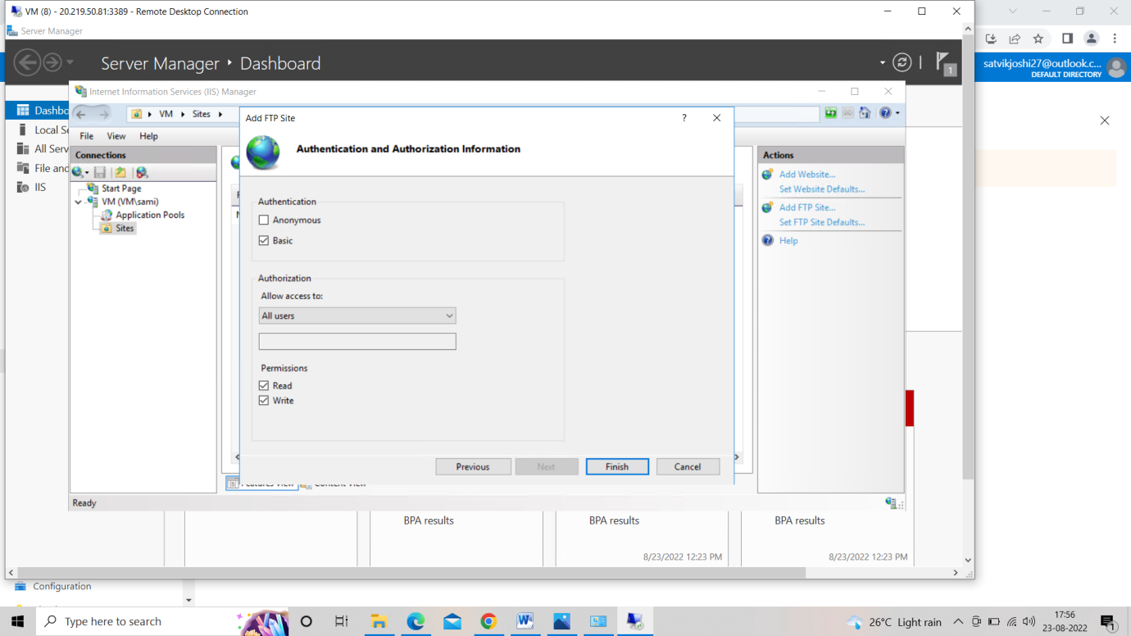

**Step 10 :- Go to FTP firewall support and change data channel port range to 9000-9900.**

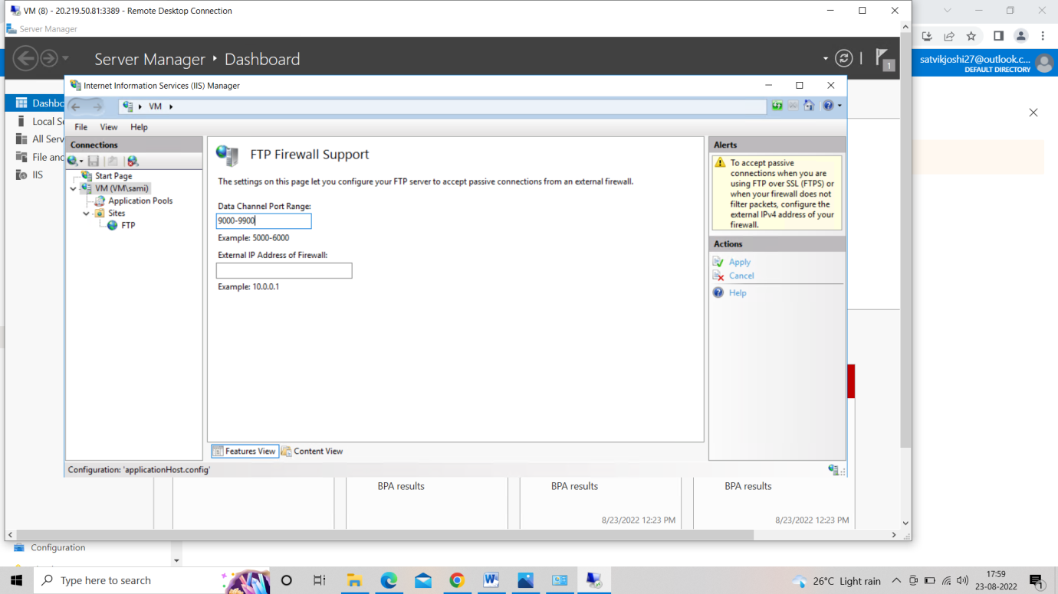

**Step 11 :- Go to CMD of Remote window and run the following command.**

net start ftpsvc

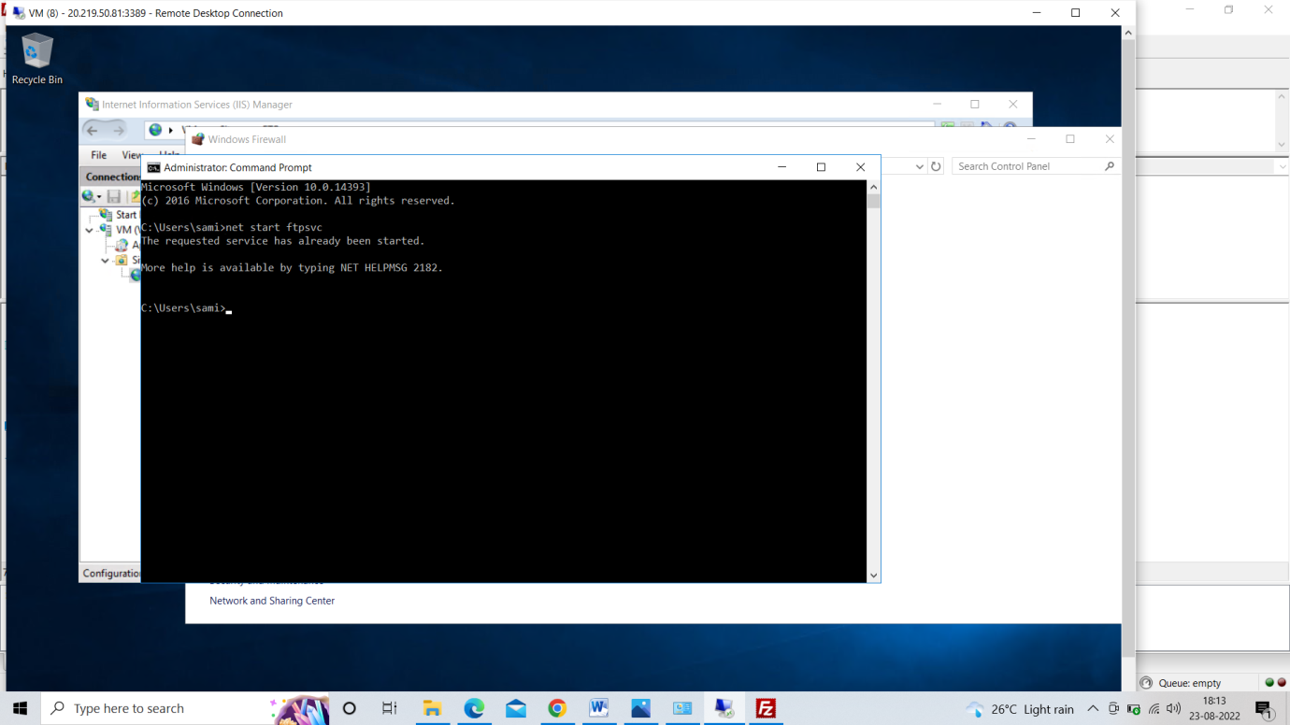

**Step 12 :- Install filezilla in your desktop and in Host enter the IP of remote session and it will be connected and the welcome message will appear.**

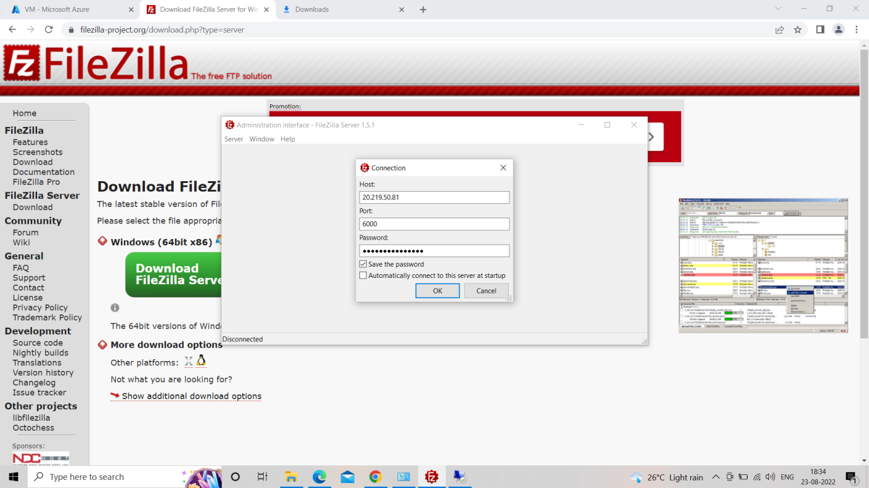

**Task 18**

**Task18**

* Install Terraform on windows using PowerShell
* Verify if terraform is installed.
* Try to create a resource group using Terraform.

**To install Terraform on windows using PowerShell we have to first install chocolatey.**

* + **But to install all these we need to know the execution policy status of PowerShell.**

Get-ExecutionPolicy

* + **And if it says ‘Restricted’ type in the following command as shown below, all on the PowerShell with administrator privileges.**

Set-ExecutionPolicy AllSigned

* + **Run PowerShell as administrator and write following commands:**

Set-ExecutionPolicy Bypass -Scope Process -Force; [System.Net.ServicePointManager]::SecurityProtocol = [System.Net.ServicePointManager]::SecurityProtocol -bor 3072; iex ((New-Object System.Net.WebClient).DownloadString(‘https://chocolatey.org/install.ps1’))

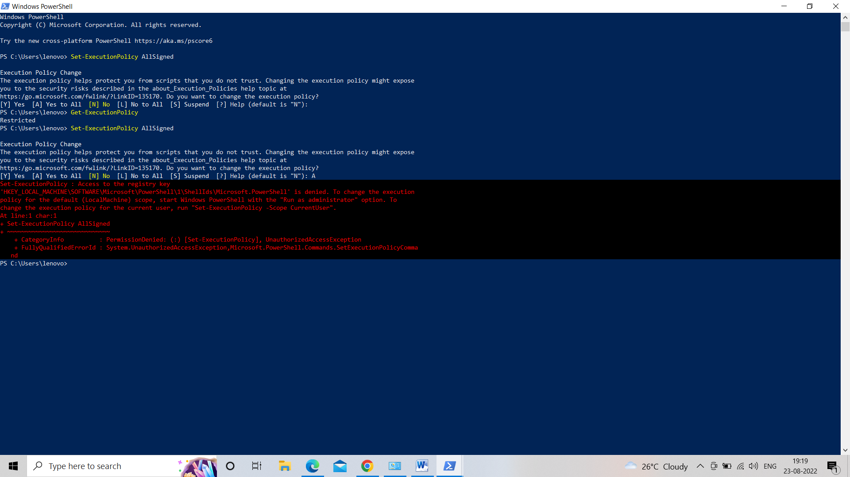

* **And we will see that installation has been started.**
* **Now we need to install terraform. To install terraform run the following command in PowerShell.**

choco install terraform

* **And it will ask for yes and type yes to install terraform.**

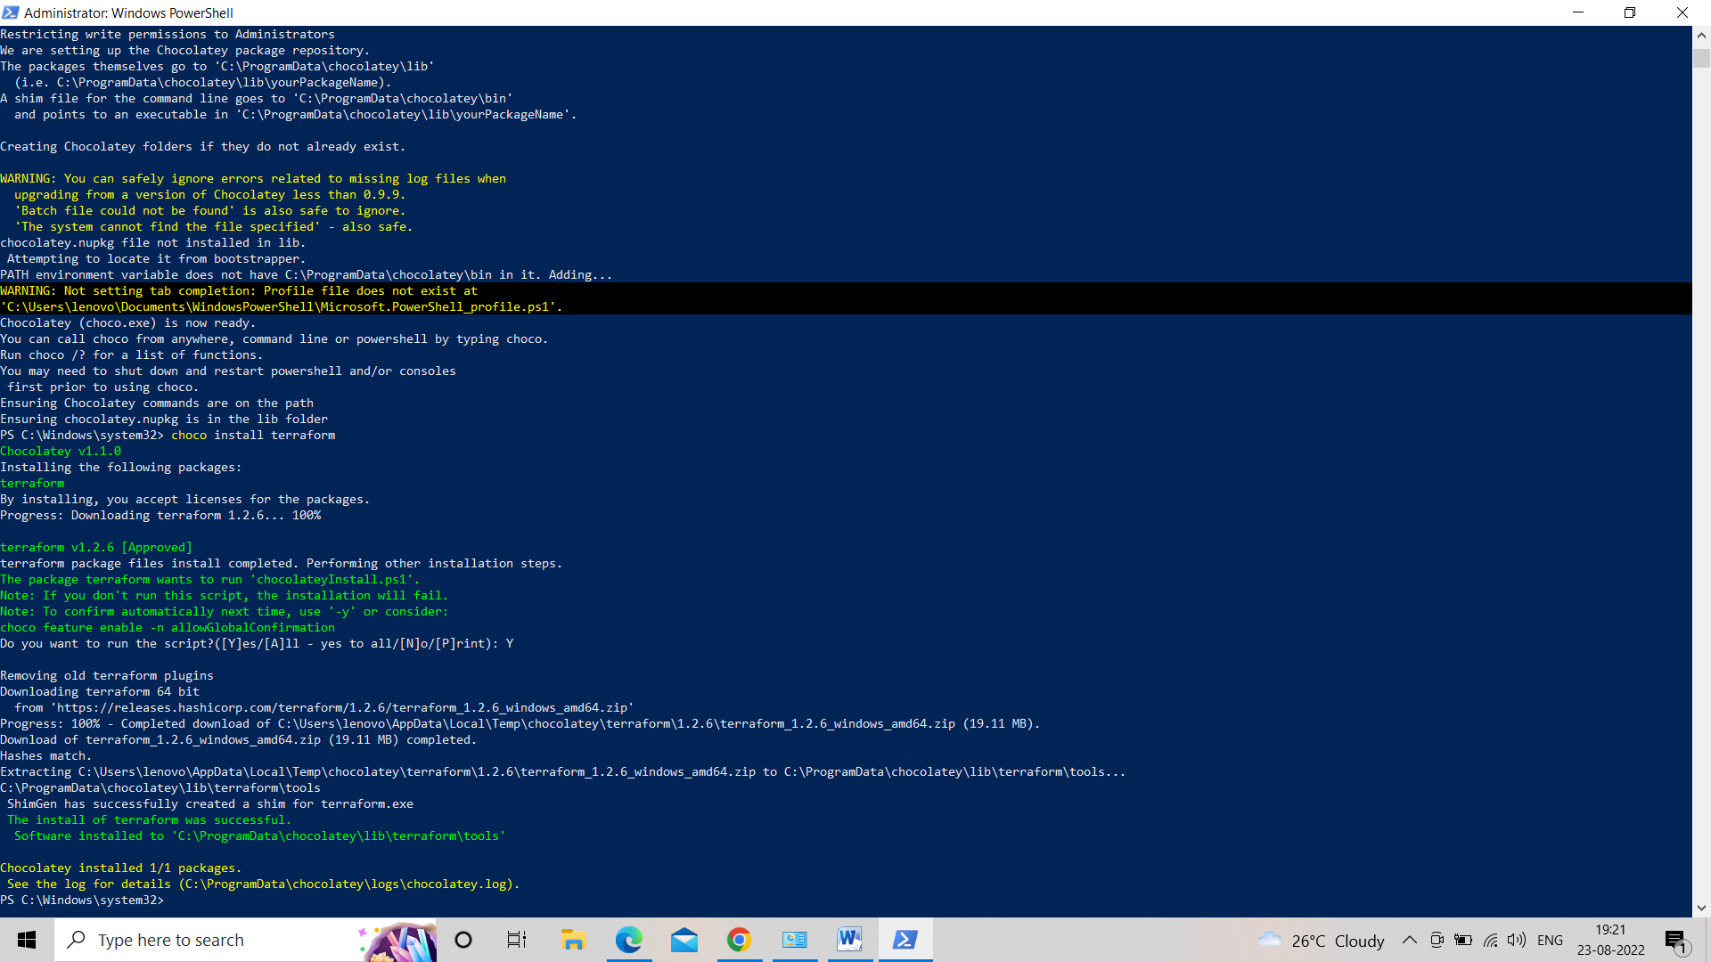

1. **Now we will Install Azure CLI.**
   * **Start PowerShell as administrator and run:**

Invoke-WebRequest -Uri https://aka.ms/installazurecliwindows -OutFile .\AzureCLI.msi; Start-Process msiexec.exe -Wait -ArgumentList '/I AzureCLI.msi /quiet'

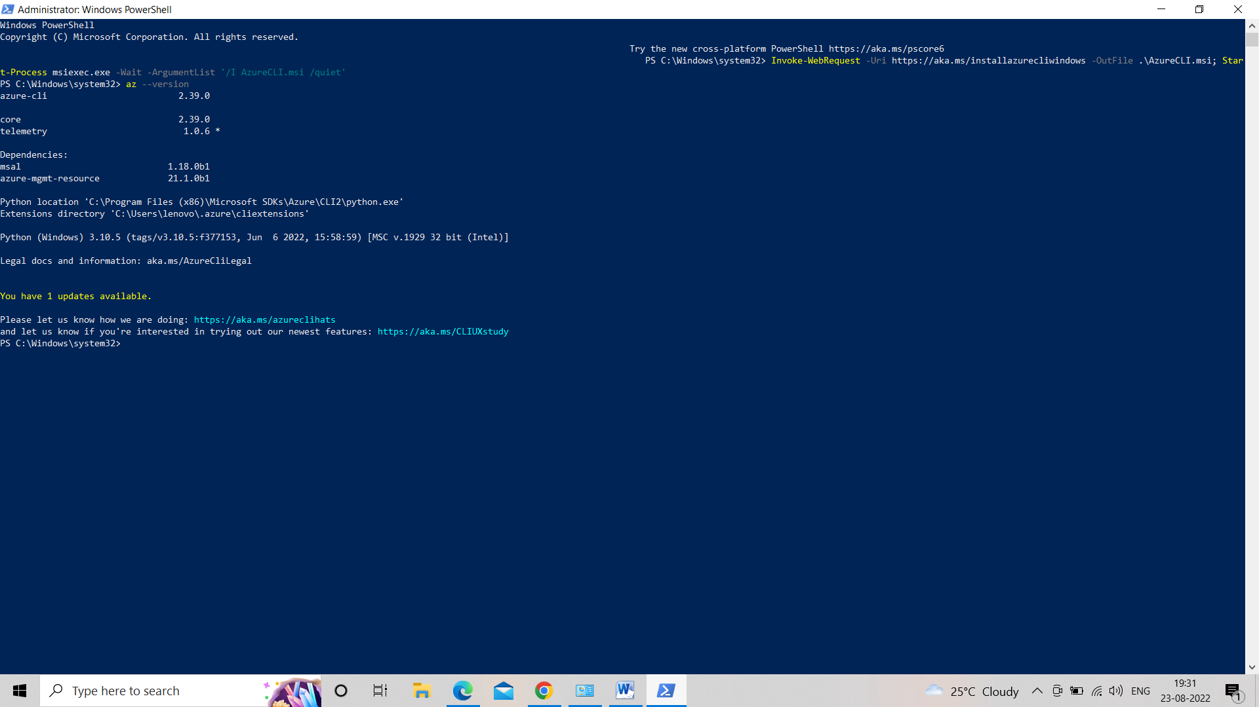

1. **Now we will verify that terraform is installed. To check we will run following command to check for terraform.**

terraform version

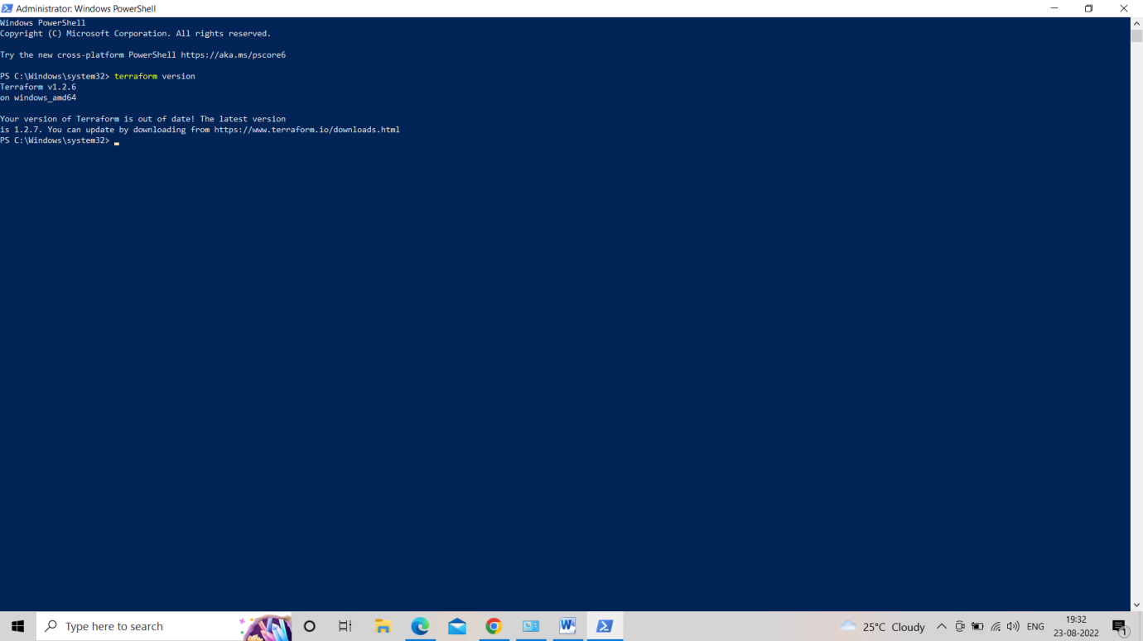

* **And if it shows the version our terraform is successful installed.**

1. **Next, we have to Create a resource group.**
   * **We have to login into AZ CLI. To do that type following command.**

az login

* + **It will open popup Brower where it will ask you to signup to your azure account.**

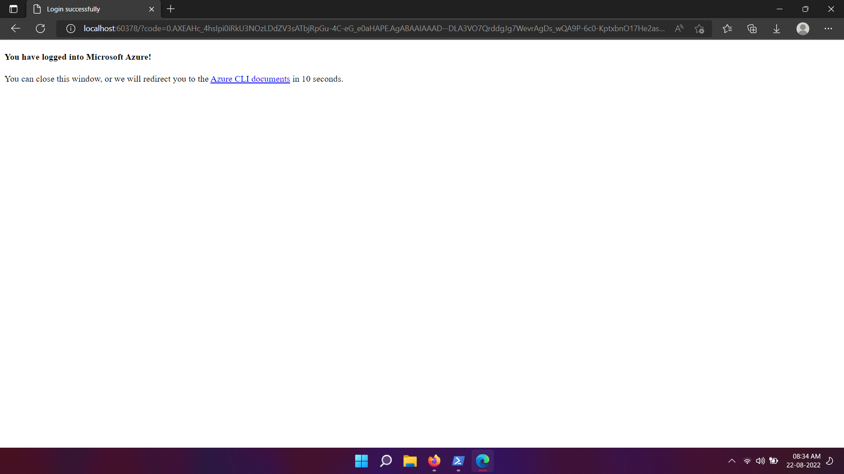

* + **After you enter you credential it will divert you back to you PowerShell. And it will show you your credential like your subscription nd you’re your email id.**

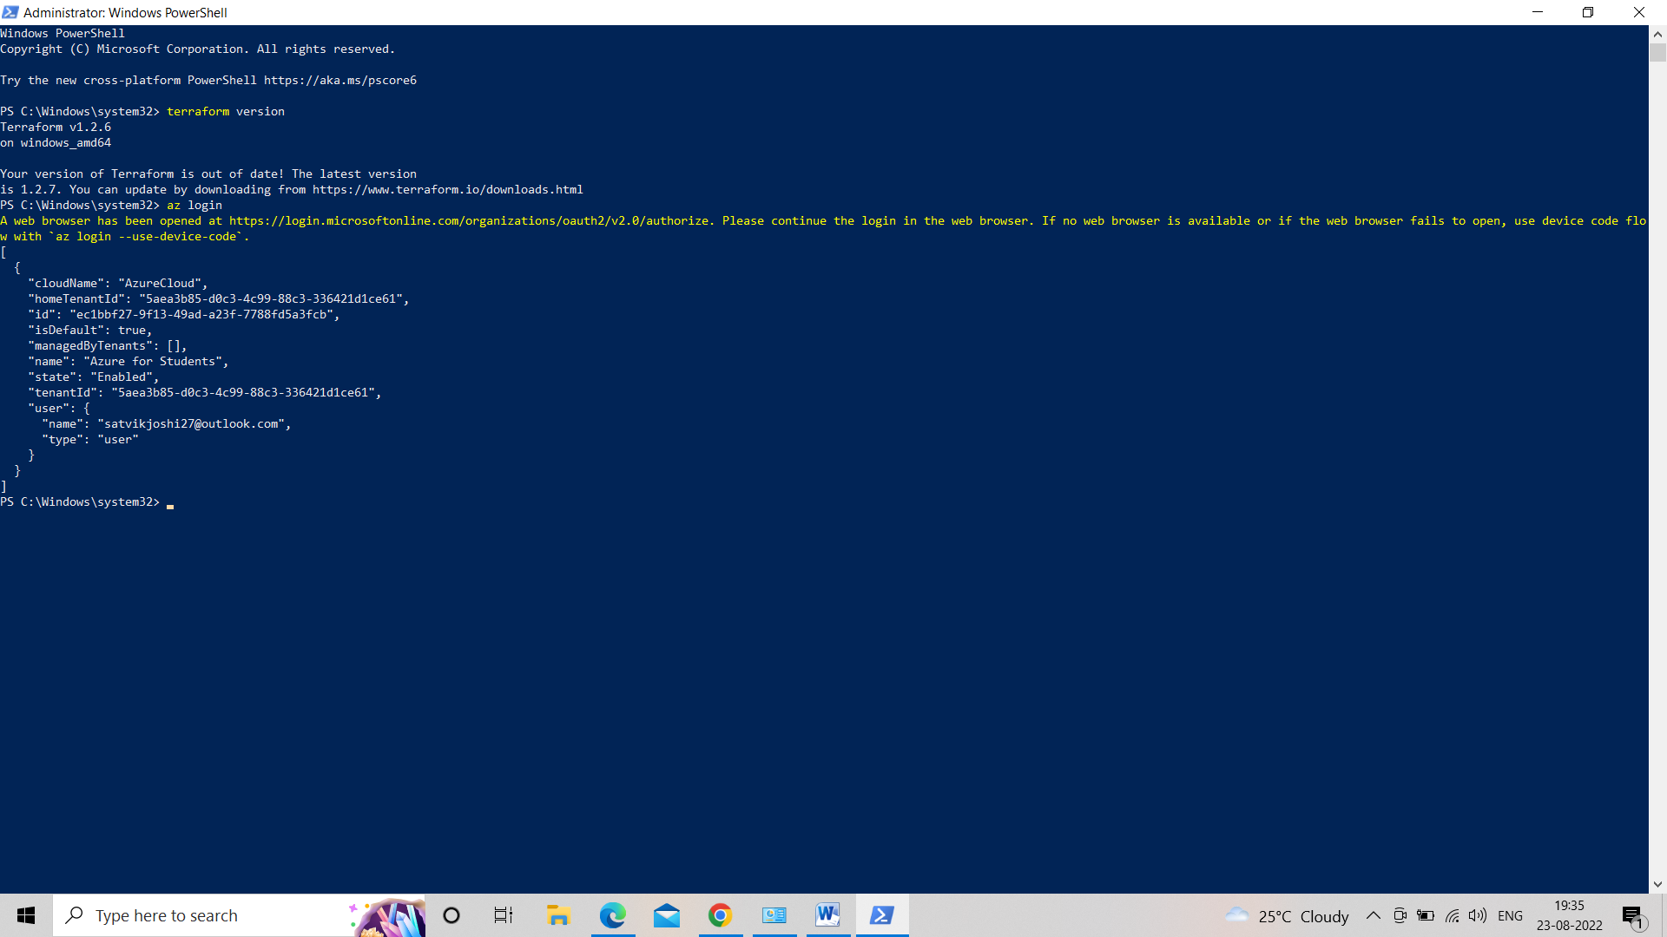

1. **To create resource group.**
   * **We have to create a folder and Copy terraform.exe from ‘C:\ProgramData\chocolatey\lib\terraform\tools’ to your new folder.**
   * **And Add following files in that folder:**
     1. **provider.tf**

terraform {

required_version = ">=0.12"

required_providers {

azurerm = {

source = "hashicorp/azurerm"

version = "~>2.0"

}

}

}

provider "azurerm" {

features {}

}

* + 1. **main.tf**

resource "random_pet" "rg-name" {

prefix = var.resource_group_name_prefix

}

resource "azurerm_resource_group" "rg" {

name = random_pet.rg-name.id

location = var.resource_group_location

}

* + 1. **variable.tf**

variable "resource_group_name_prefix" {

default = "rg"

description = "Prefix of the resource group name that's combined with a random ID so name is unique in your Azure subscription."

}

variable "resource_group_location" {

default = "eastus"

description = "Location of the resource group."

}

* + 1. **output.tf**

output "resource_group_name" {

value = azurerm_resource_group.rg.name

}

* + **Now we initialize the configuration in the power shell, run:**
  + **Next, we validate and plan:**

terraform init

terraform validate  
terraform plan

terraform apply

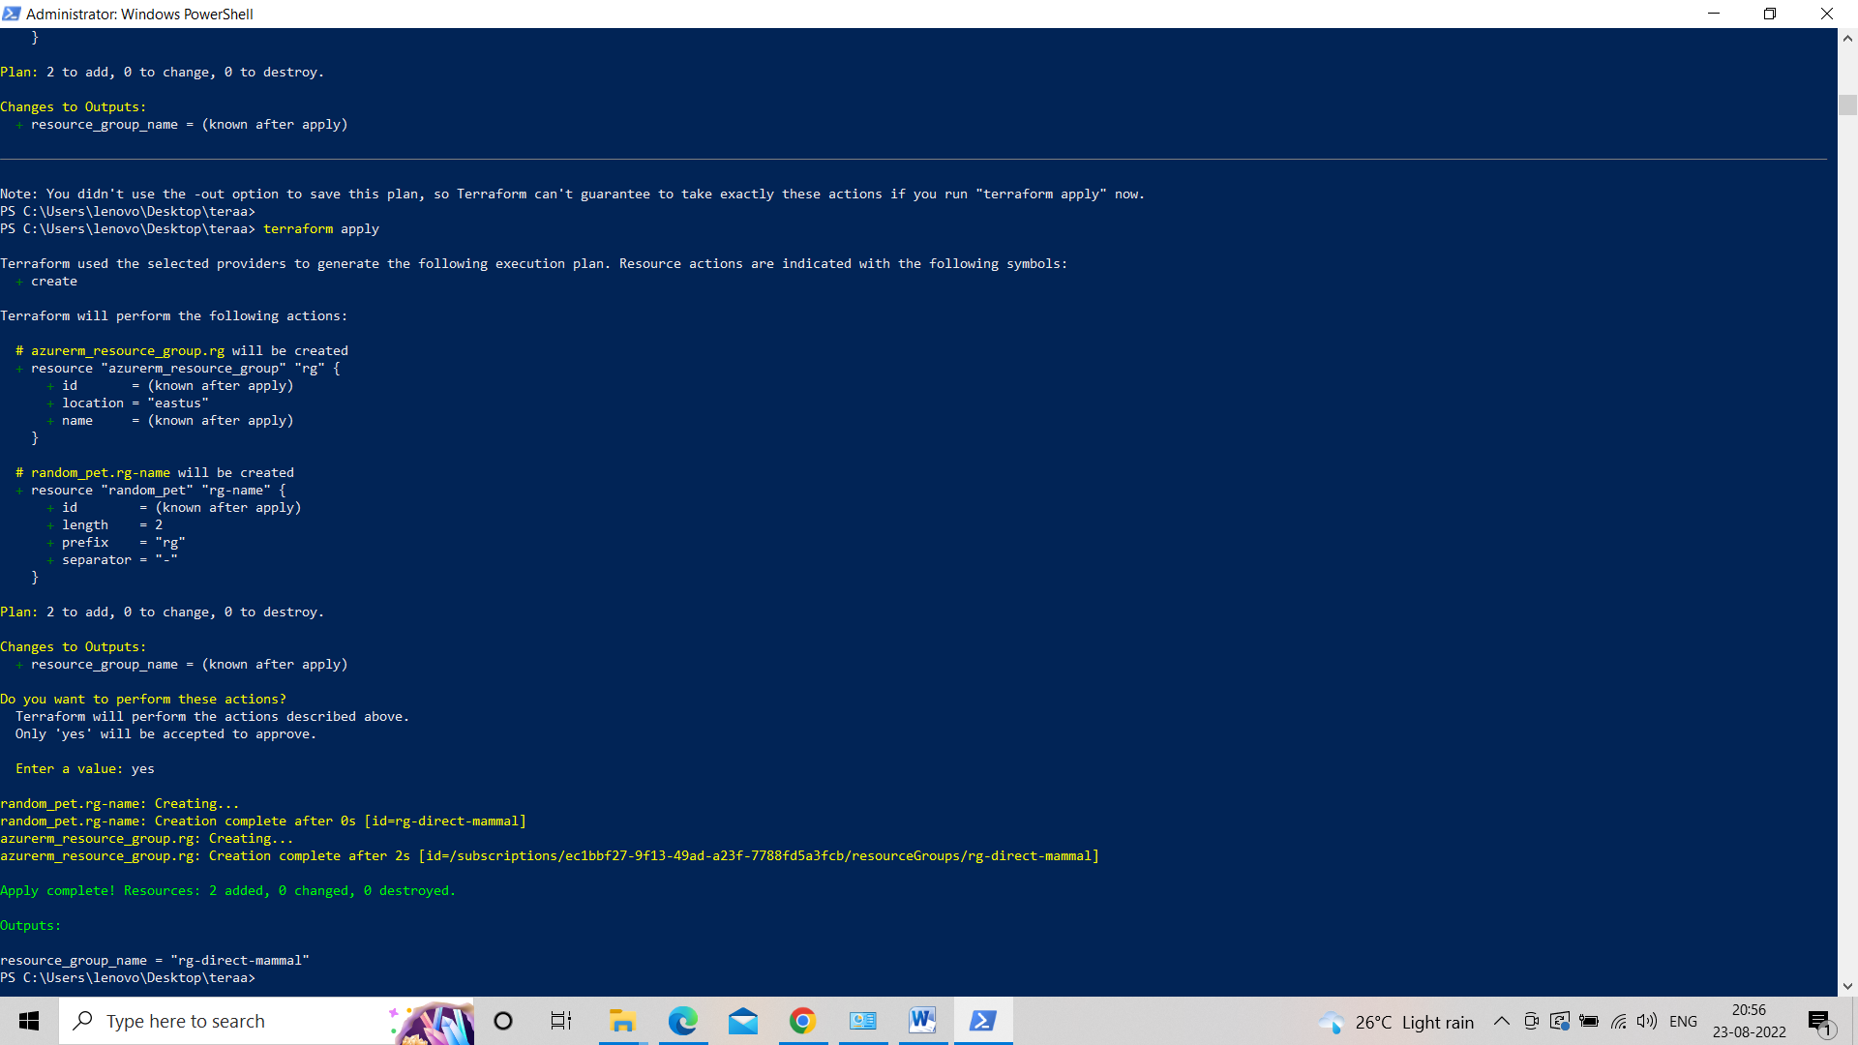

* **Hence a new resource group is created named “rg-wanted-worm”.**
* **Navigate to the Azure portal to verify.**

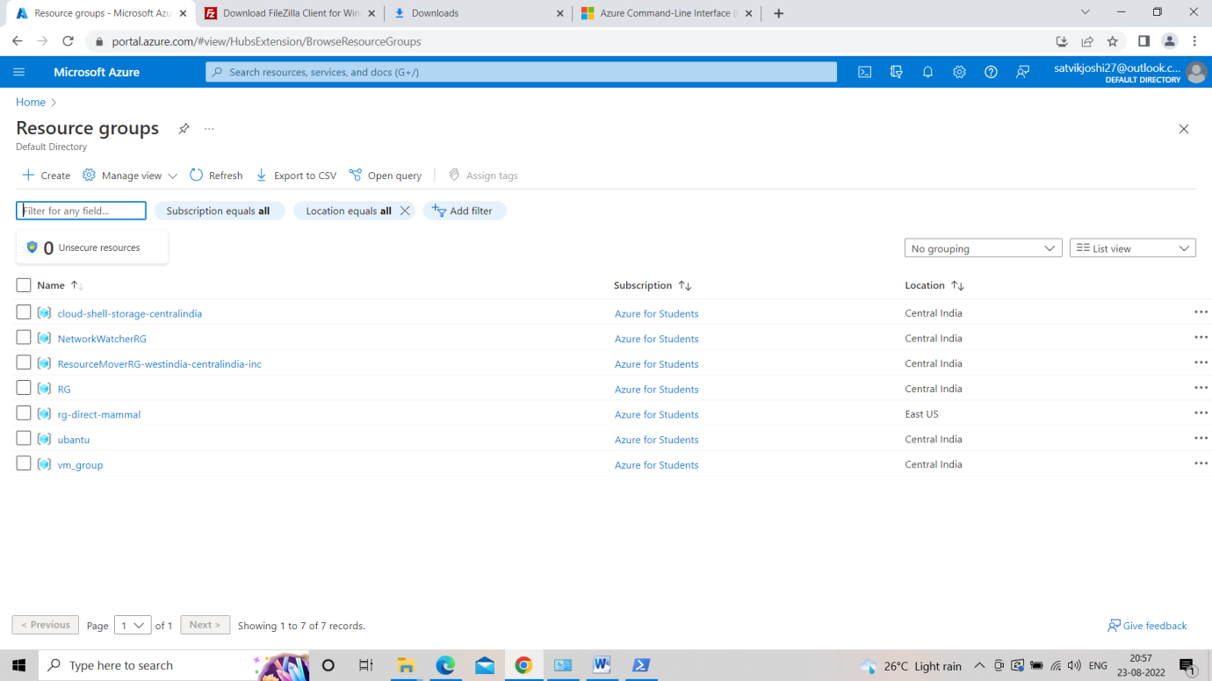

**Task 19**

**Task19**

* Learn about terraform.
* Create a single tier architecture.

Consisting of Virtual Network, Subnet, NSG, Virtual Machine.

**Step 1:- Install Terraform and Azure CLI.**

**Step 2 :- Now run “az login” to authenticate via PowerShell running as an administrator.**



**Step 3:- Now we have to Configure the architecture.**

* + **In order to create an architect, we first need to write configuration files.**
  + **In the same folder add a few files.**
    1. **provider.tf**

terraform {

required_version = ">=0.12"

required_providers {

azurerm = {

source = "hashicorp/azurerm"

version = "~>2.0"

}

}

}

provider "azurerm" {

features {}

}

* + 1. **main.tf**

resource "random_pet" "rg-name" {

prefix = var.resource_group_name_prefix

}

resource "azurerm_resource_group" "rg" {

name = random_pet.rg-name.id

location = var.resource_group_location

}

# Create virtual network

resource "azurerm_virtual_network" "myterraformnetwork" {

name = "myVnet"

address_space = ["10.0.0.0/16"]

location = azurerm_resource_group.rg.location

resource_group_name = azurerm_resource_group.rg.name

}

# Create subnet

resource "azurerm_subnet" "myterraformsubnet" {

name = "mySubnet"

resource_group_name = azurerm_resource_group.rg.name

virtual_network_name = azurerm_virtual_network.myterraformnetwork.name

address_prefixes = ["10.0.1.0/24"]

}

# Create public IPs

resource "azurerm_public_ip" "myterraformpublicip" {

name = "myPublicIP"

location = azurerm_resource_group.rg.location

resource_group_name = azurerm_resource_group.rg.name

allocation_method = "Dynamic"

}

# Create Network Security Group and rule

resource "azurerm_network_security_group" "myterraformnsg" {

name = "myNetworkSecurityGroup"

location = azurerm_resource_group.rg.location

resource_group_name = azurerm_resource_group.rg.name

security_rule {

name = "SSH"

priority = 1001

direction = "Inbound"

access = "Allow"

protocol = "Tcp"

source_port_range = "*"

destination_port_range = "22"

source_address_prefix = "*"

destination_address_prefix = "*"

}

}

# Create network interface

resource "azurerm_network_interface" "myterraformnic" {

name = "myNIC"

location = azurerm_resource_group.rg.location

resource_group_name = azurerm_resource_group.rg.name

ip_configuration {

name = "myNicConfiguration"

subnet_id = azurerm_subnet.myterraformsubnet.id

private_ip_address_allocation = "Dynamic"

public_ip_address_id = azurerm_public_ip.myterraformpublicip.id

}

}

# Connect the security group to the network interface

resource "azurerm_network_interface_security_group_association" "example" {

network_interface_id = azurerm_network_interface.myterraformnic.id

network_security_group_id = azurerm_network_security_group.myterraformnsg.id

}

# Generate random text for a unique storage account name

resource "random_id" "randomId" {

keepers = {

# Generate a new ID only when a new resource group is defined

resource_group = azurerm_resource_group.rg.name

}

byte_length = 8

}

# Create storage account for boot diagnostics

resource "azurerm_storage_account" "mystorageaccount" {

name = "diag${random_id.randomId.hex}"

location = azurerm_resource_group.rg.location

resource_group_name = azurerm_resource_group.rg.name

account_tier = "Standard"

account_replication_type = "LRS"

}

# Create (and display) an SSH key

resource "tls_private_key" "example_ssh" {

algorithm = "RSA"

rsa_bits = 4096

}

# Create virtual machine

resource "azurerm_linux_virtual_machine" "myterraformvm" {

name = "myVM"

location = azurerm_resource_group.rg.location

resource_group_name = azurerm_resource_group.rg.name

network_interface_ids = [azurerm_network_interface.myterraformnic.id]

size = "Standard_DS1_v2"

os_disk {

name = "myOsDisk"

caching = "ReadWrite"

storage_account_type = "Premium_LRS"

}

source_image_reference {

publisher = "Canonical"

offer = "UbuntuServer"

sku = "18.04-LTS"

version = "latest"

}

computer_name = "myvm"

admin_username = "azureuser"

disable_password_authentication = true

admin_ssh_key {

username = "azureuser"

public_key = tls_private_key.example_ssh.public_key_openssh

}

boot_diagnostics {

storage_account_uri = azurerm_storage_account.mystorageaccount.primary_blob_endpoint

}

}

* + 1. **variable.tf**

variable "resource_group_name_prefix" {

default = "rg"

description = "Prefix of the resource group name that's combined with a random ID so name is unique in your Azure subscription."

}

variable "resource_group_location" {

default = "eastus"

description = "Location of the resource group."

}

* + 1. **output.tf**

output "resource_group_name" {

value = azurerm_resource_group.rg.name

}

output "public_ip_address" {

value = azurerm_linux_virtual_machine.myterraformvm.public_ip_address

}

output "tls_private_key" {

value = tls_private_key.example_ssh.private_key_pem

sensitive = true

}

**Step 3:- Now we will start Creating the single tier architecture.**

* + **On the PowerShell running as an administrator**

terraform init

terraform validate

terraform plan

terraform apply

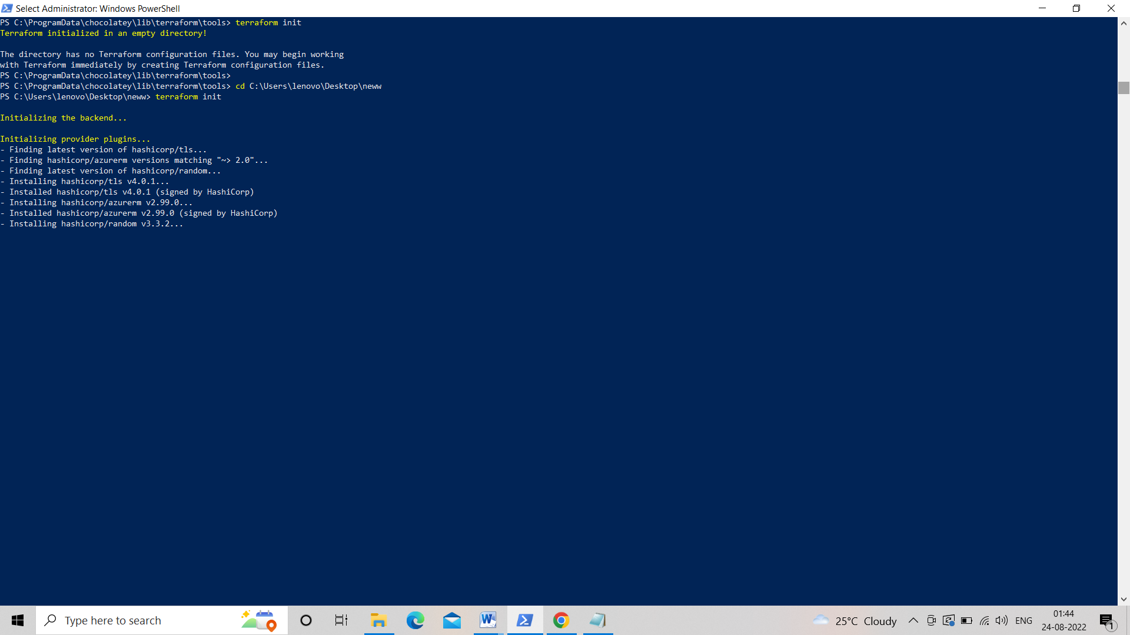

1. **And finally, we will see that our single tier architecture has been finally created. And in single tier architecture we have Virtual network, Public IP, NSG, Storage account, Subnet and Virtual machine.**
2. **We can also verify it by going in the azure portal.**

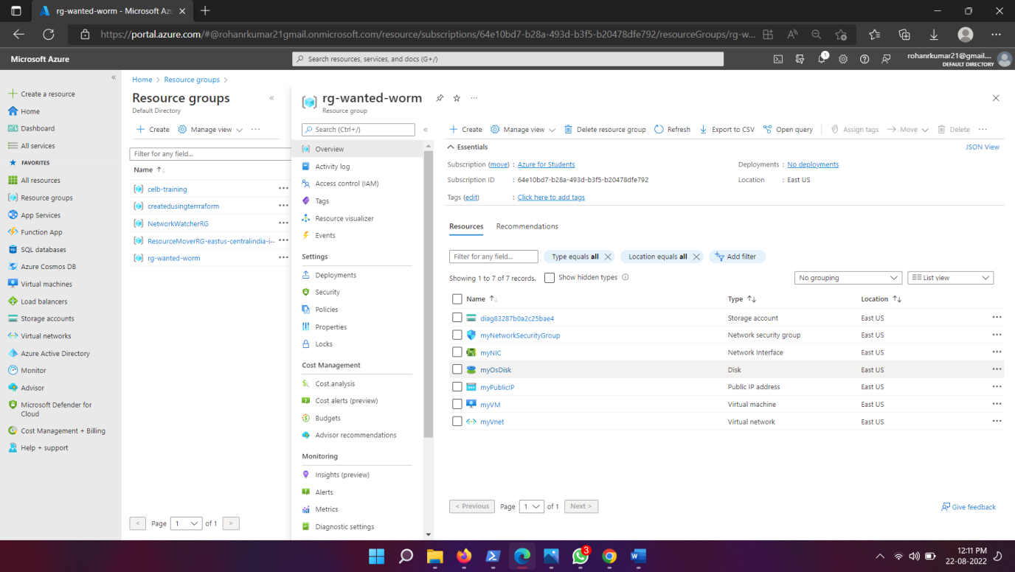

**Task 20**

**Task20**

* Learning Azure AD
* Enable Azure AD Multi Factor Authentication setup.
* When you login to Azure portal it should authenticate using MFA.

**Azure Active Directory (Azure AD) is a cloud-based identity and access management service. This service helps your employees access external resources, such as Microsoft 365, the Azure portal, and thousands of other SaaS applications. Azure Active Directory also helps them access internal resources like apps on your corporate intranet network, along with any cloud apps developed for your own organization.**

**Step 1 :- Search Azure AD in Search bar.**

**Step 2 :- On left column click at users.**

**Step 3 :- Open users and select the one on which you want to apply MFA.**

**Step 4 :- click on per user MFA present on Top ribbon.**

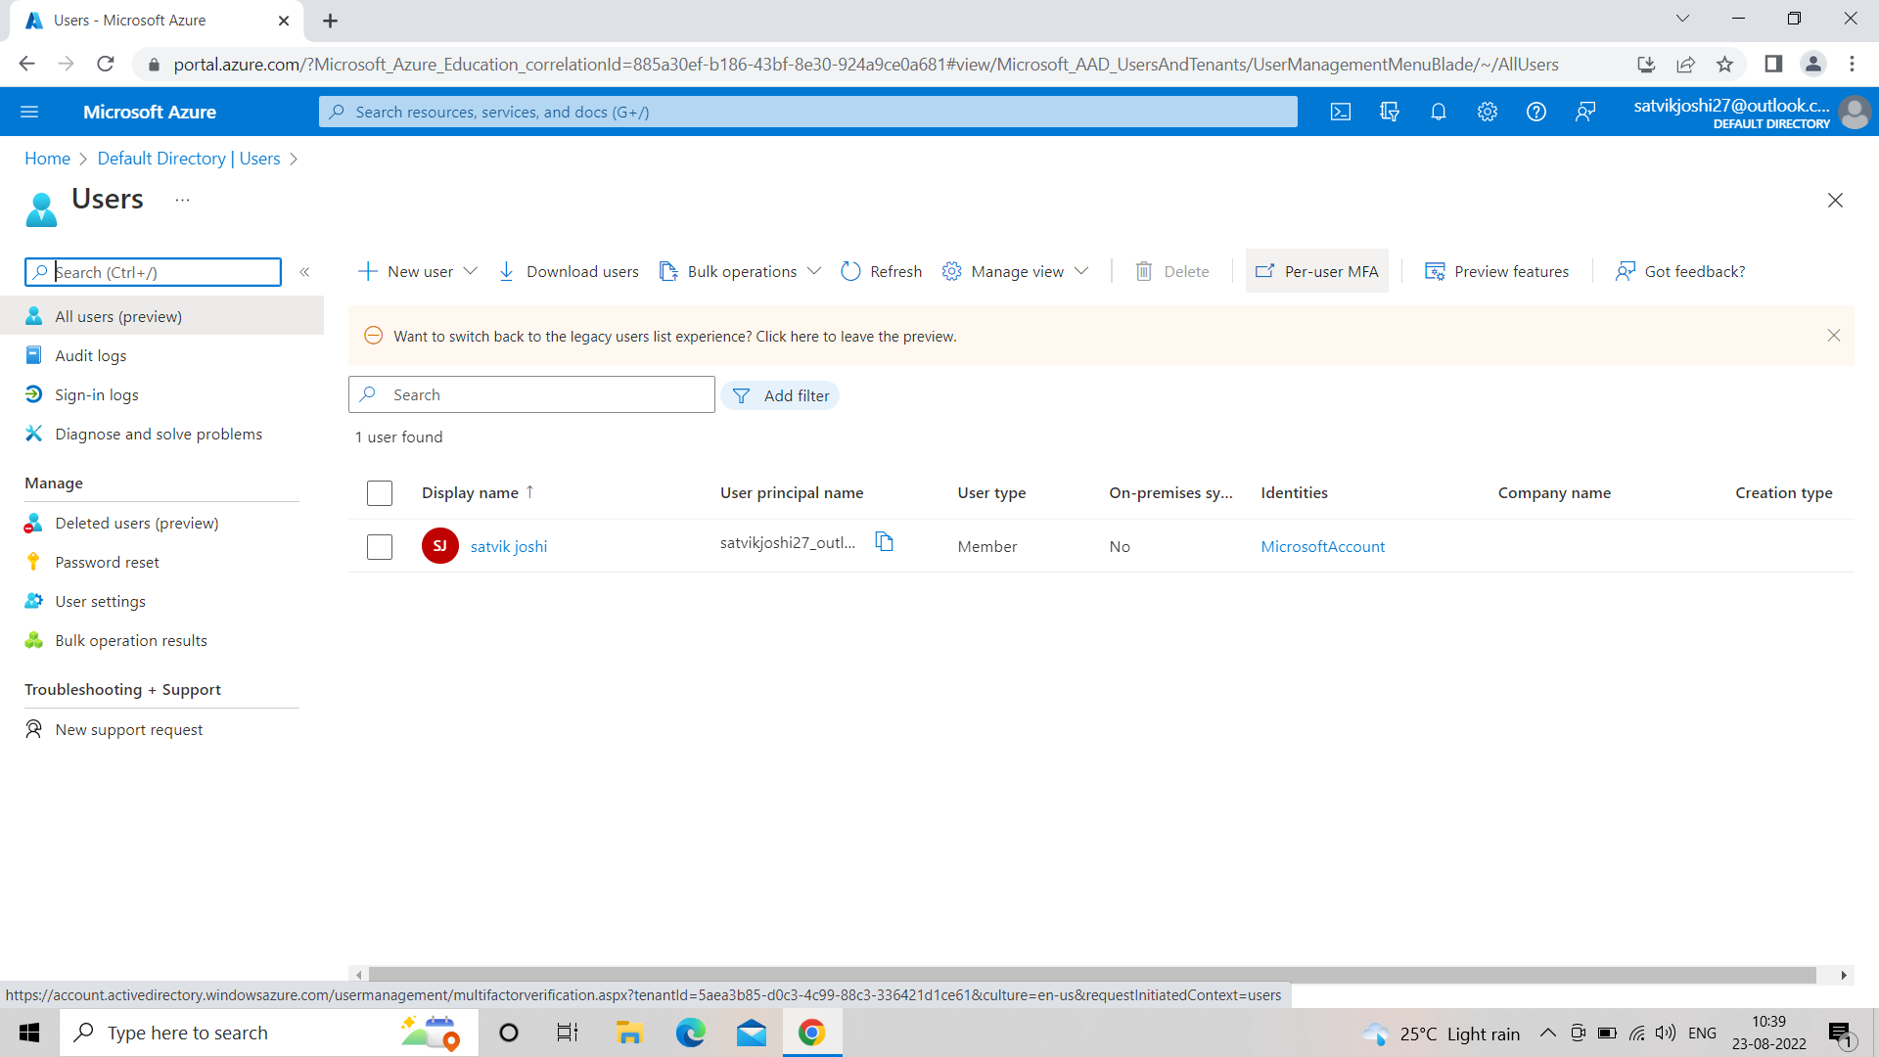

**Step 5 :- Click enable available under quick steps.**

**Step 6 :- confirm Multi-factor auth**

**Step 7 :- Now login via MFA**

**. Log out of azure**

**. Download Authenticator app in your phone**

**. Log in in PC and select approve Request on Authenticator App.**

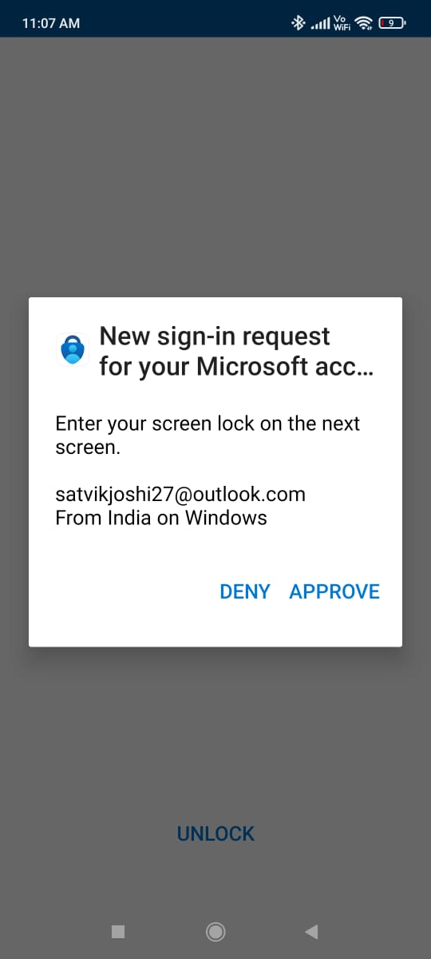

**Task 21**

**Task 21**

* Create a Virtual Machine
* Install SQL server on the Virtual Machine
* Access the SQL Server using SSMS (SQL Server Management System).

**Step 1 :- Create a Virtual Machine and open its RDP and connect the remote window.**

**Step 2 :- follow the following steps to install SQL sever in the VM .**

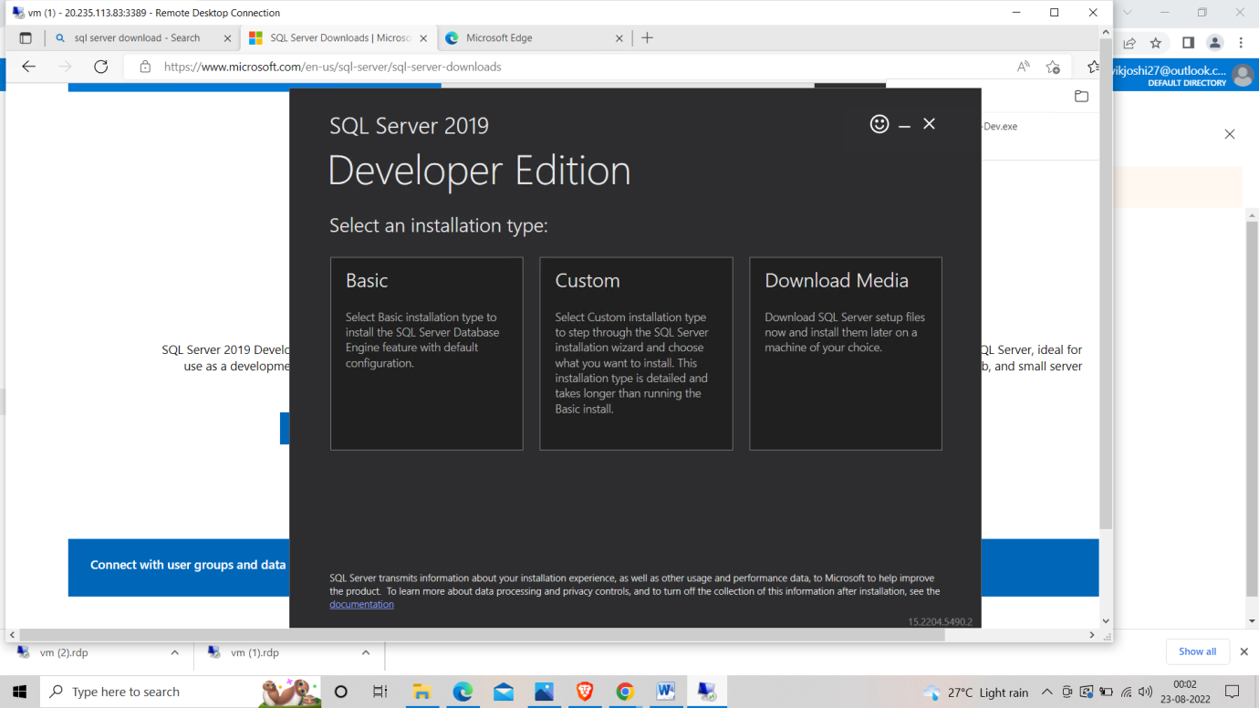

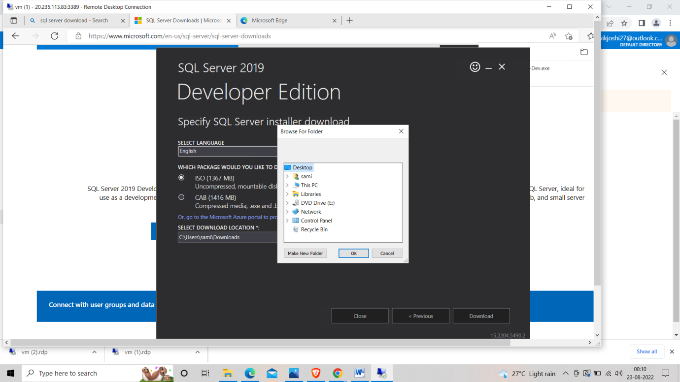

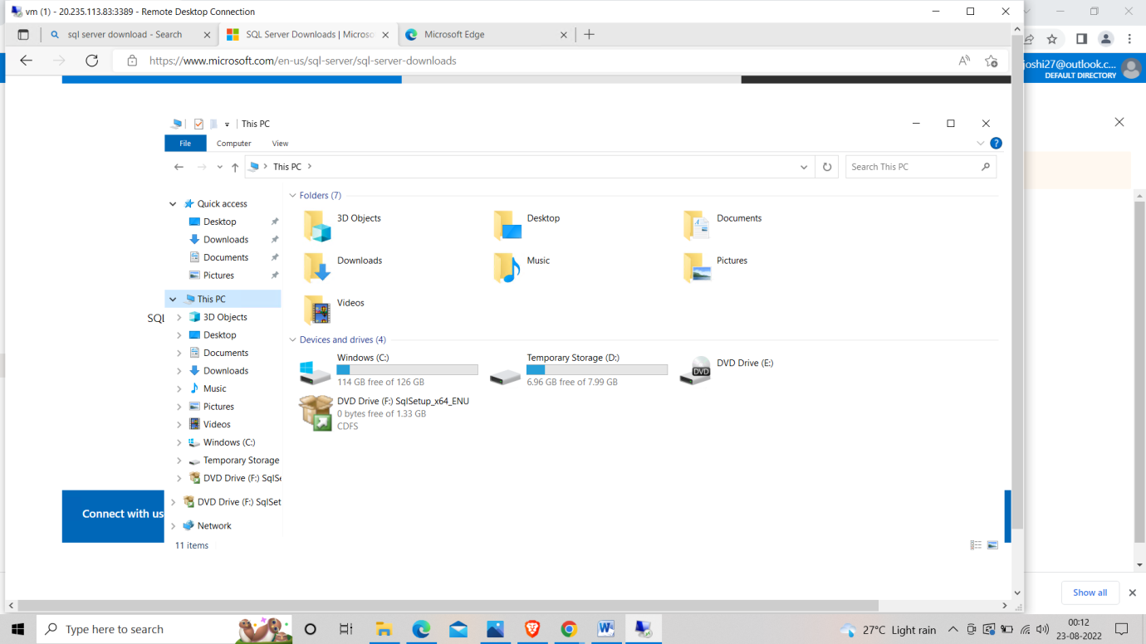

**Step 3: Run as administrator and follow the steps.**

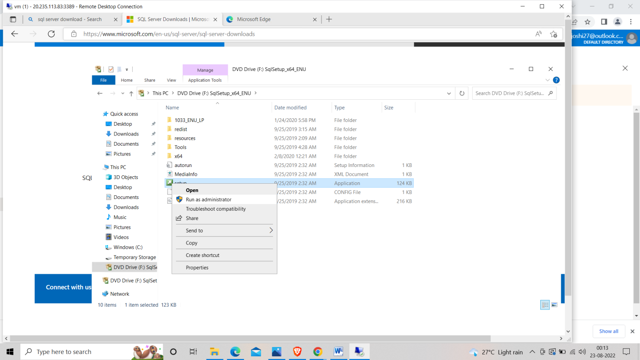

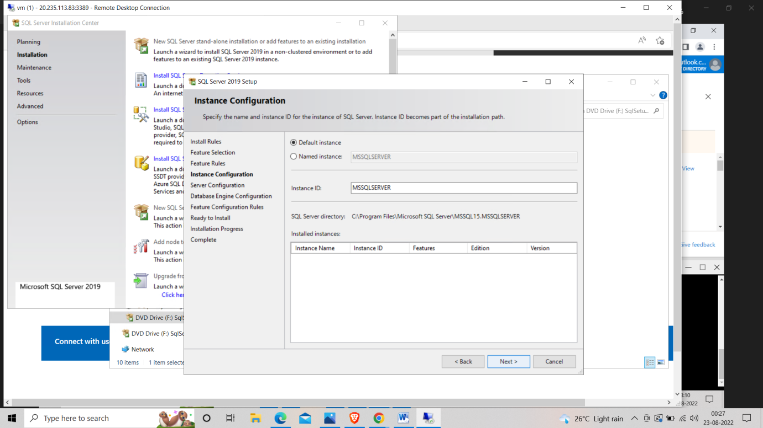

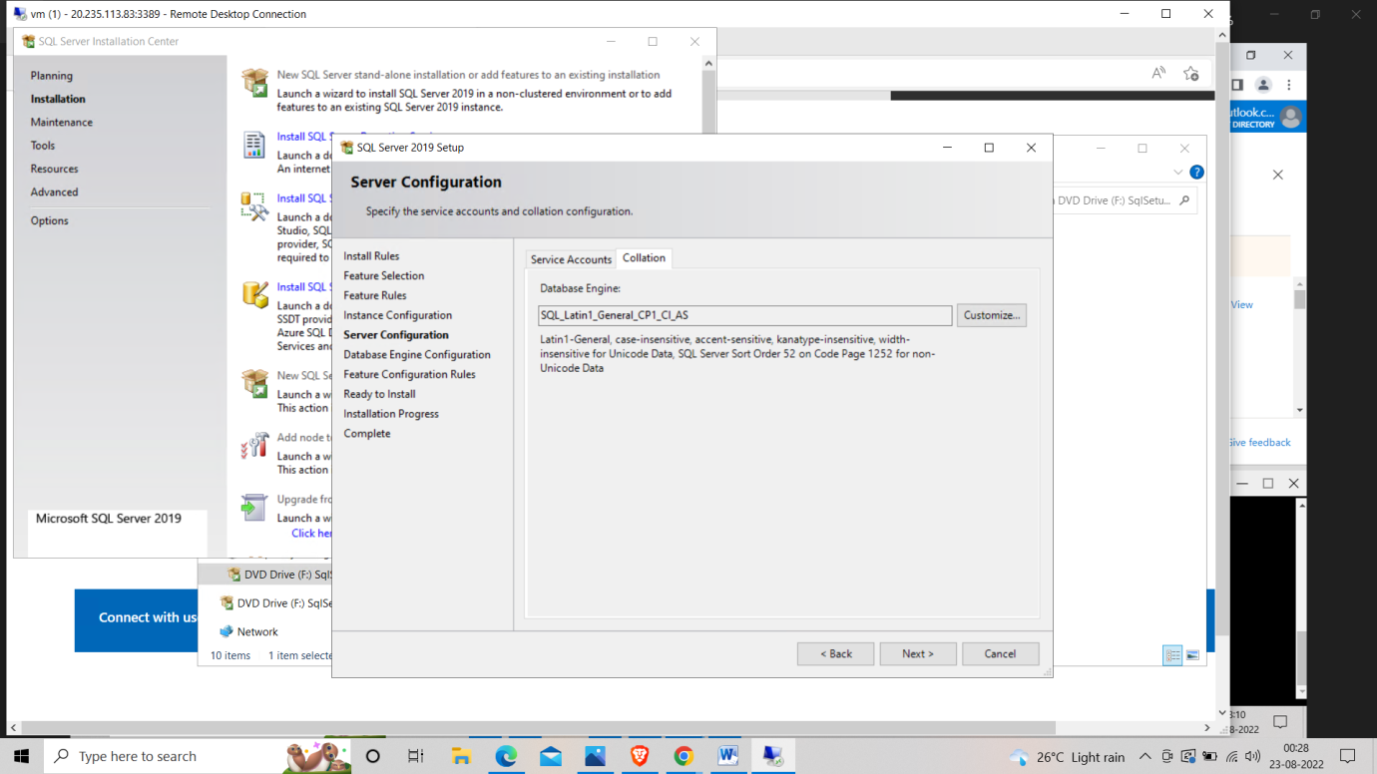 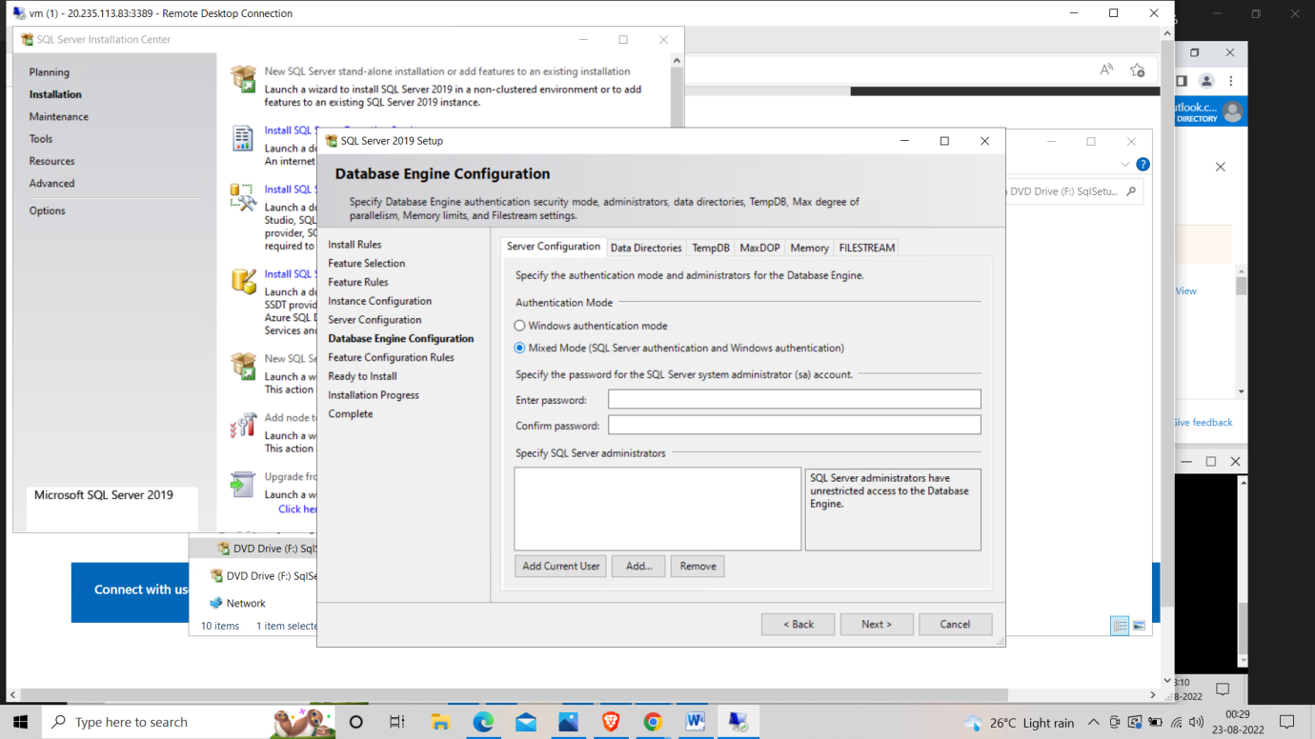 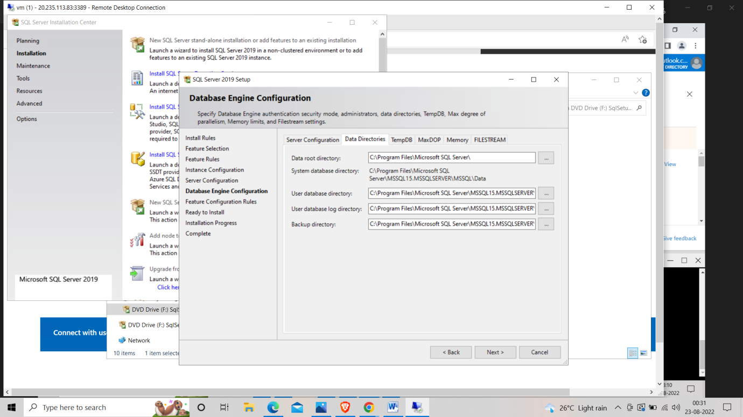

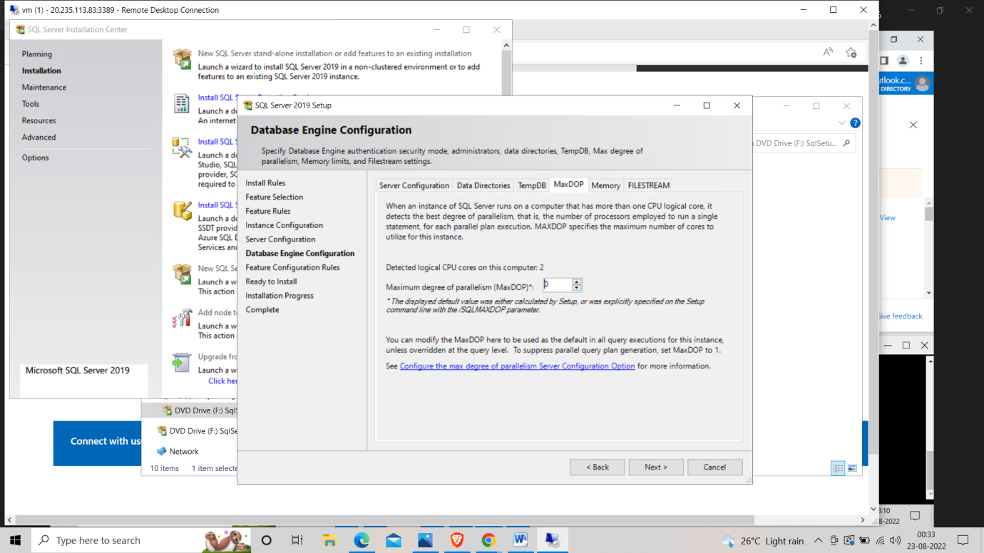 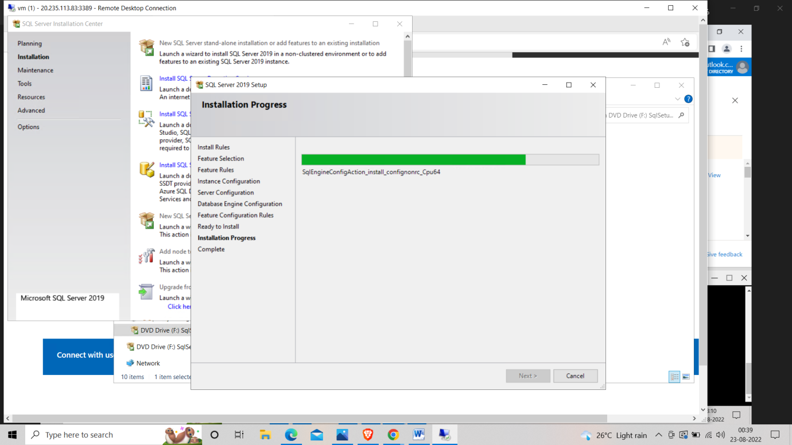

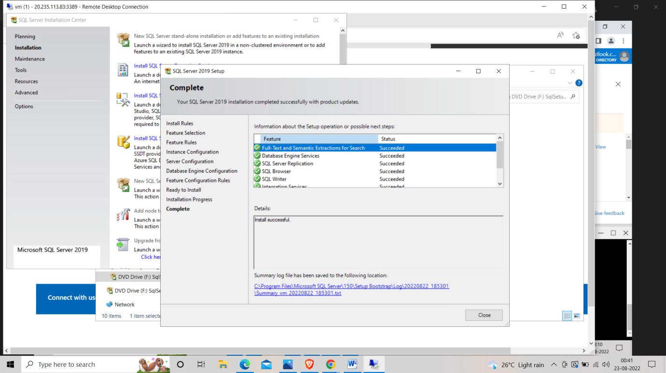

**Step 3 :- Install SSMS**

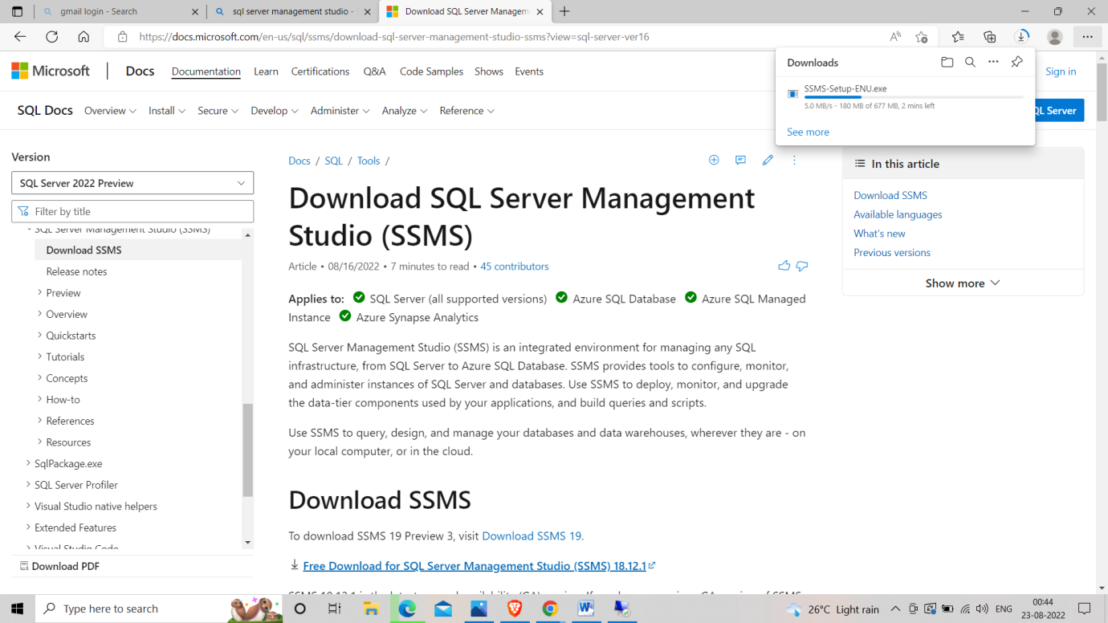

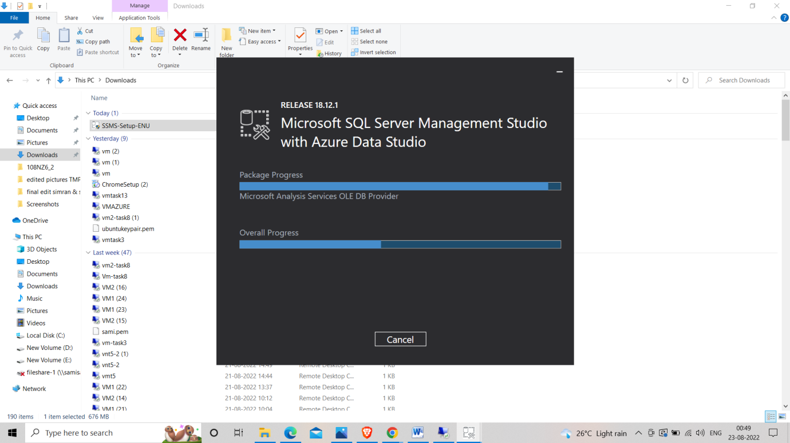

**Step 4 :- Go to SQL server manager and repeat the following steps.**

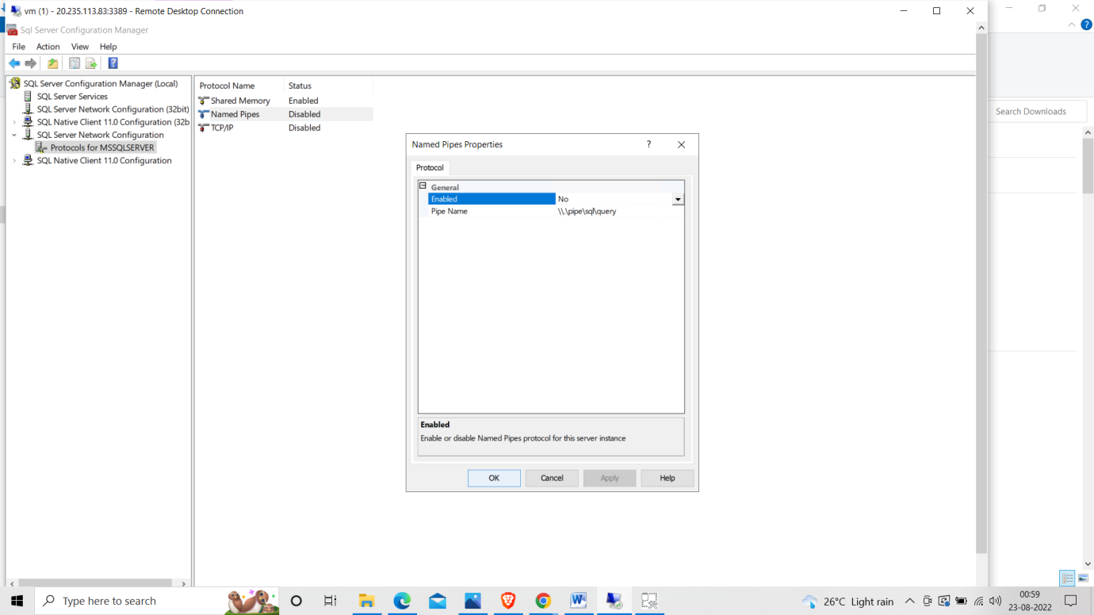

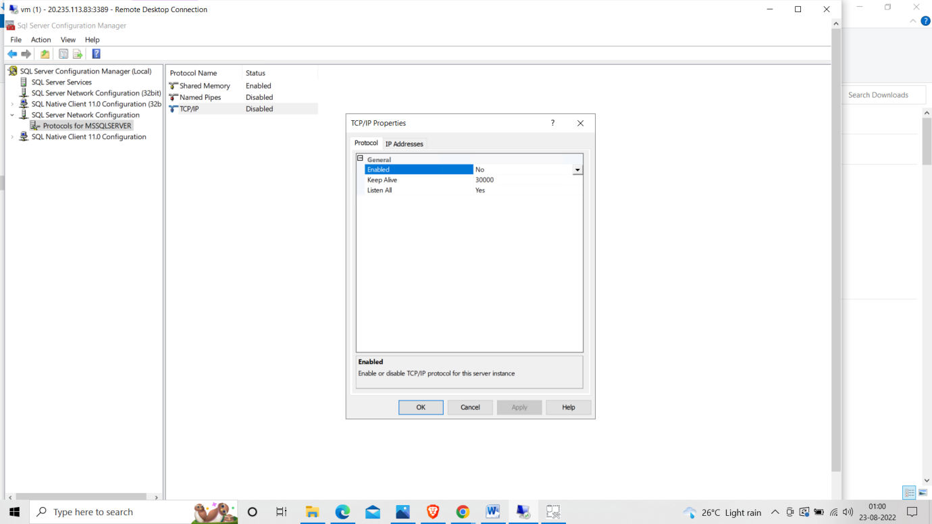

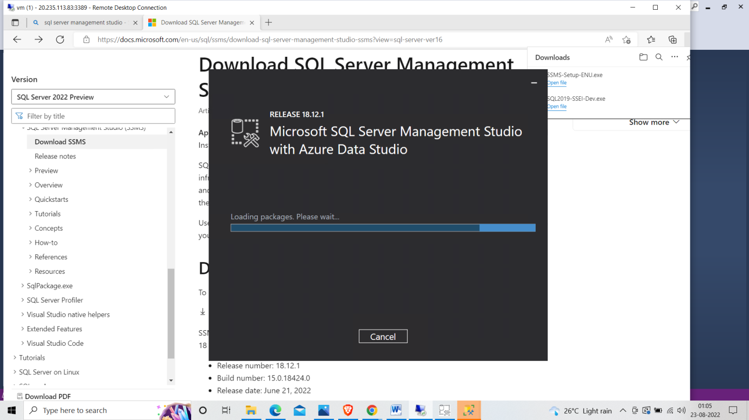

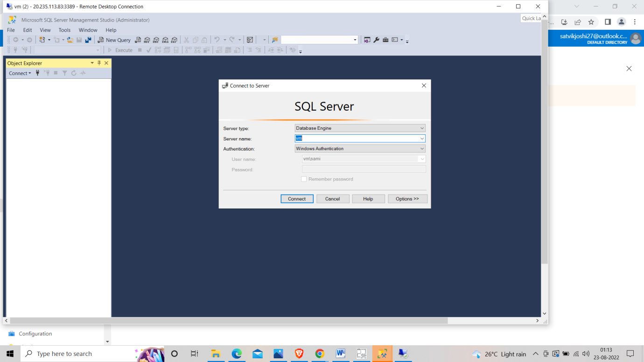

**Step 5 :- Run the query and execute it.**

